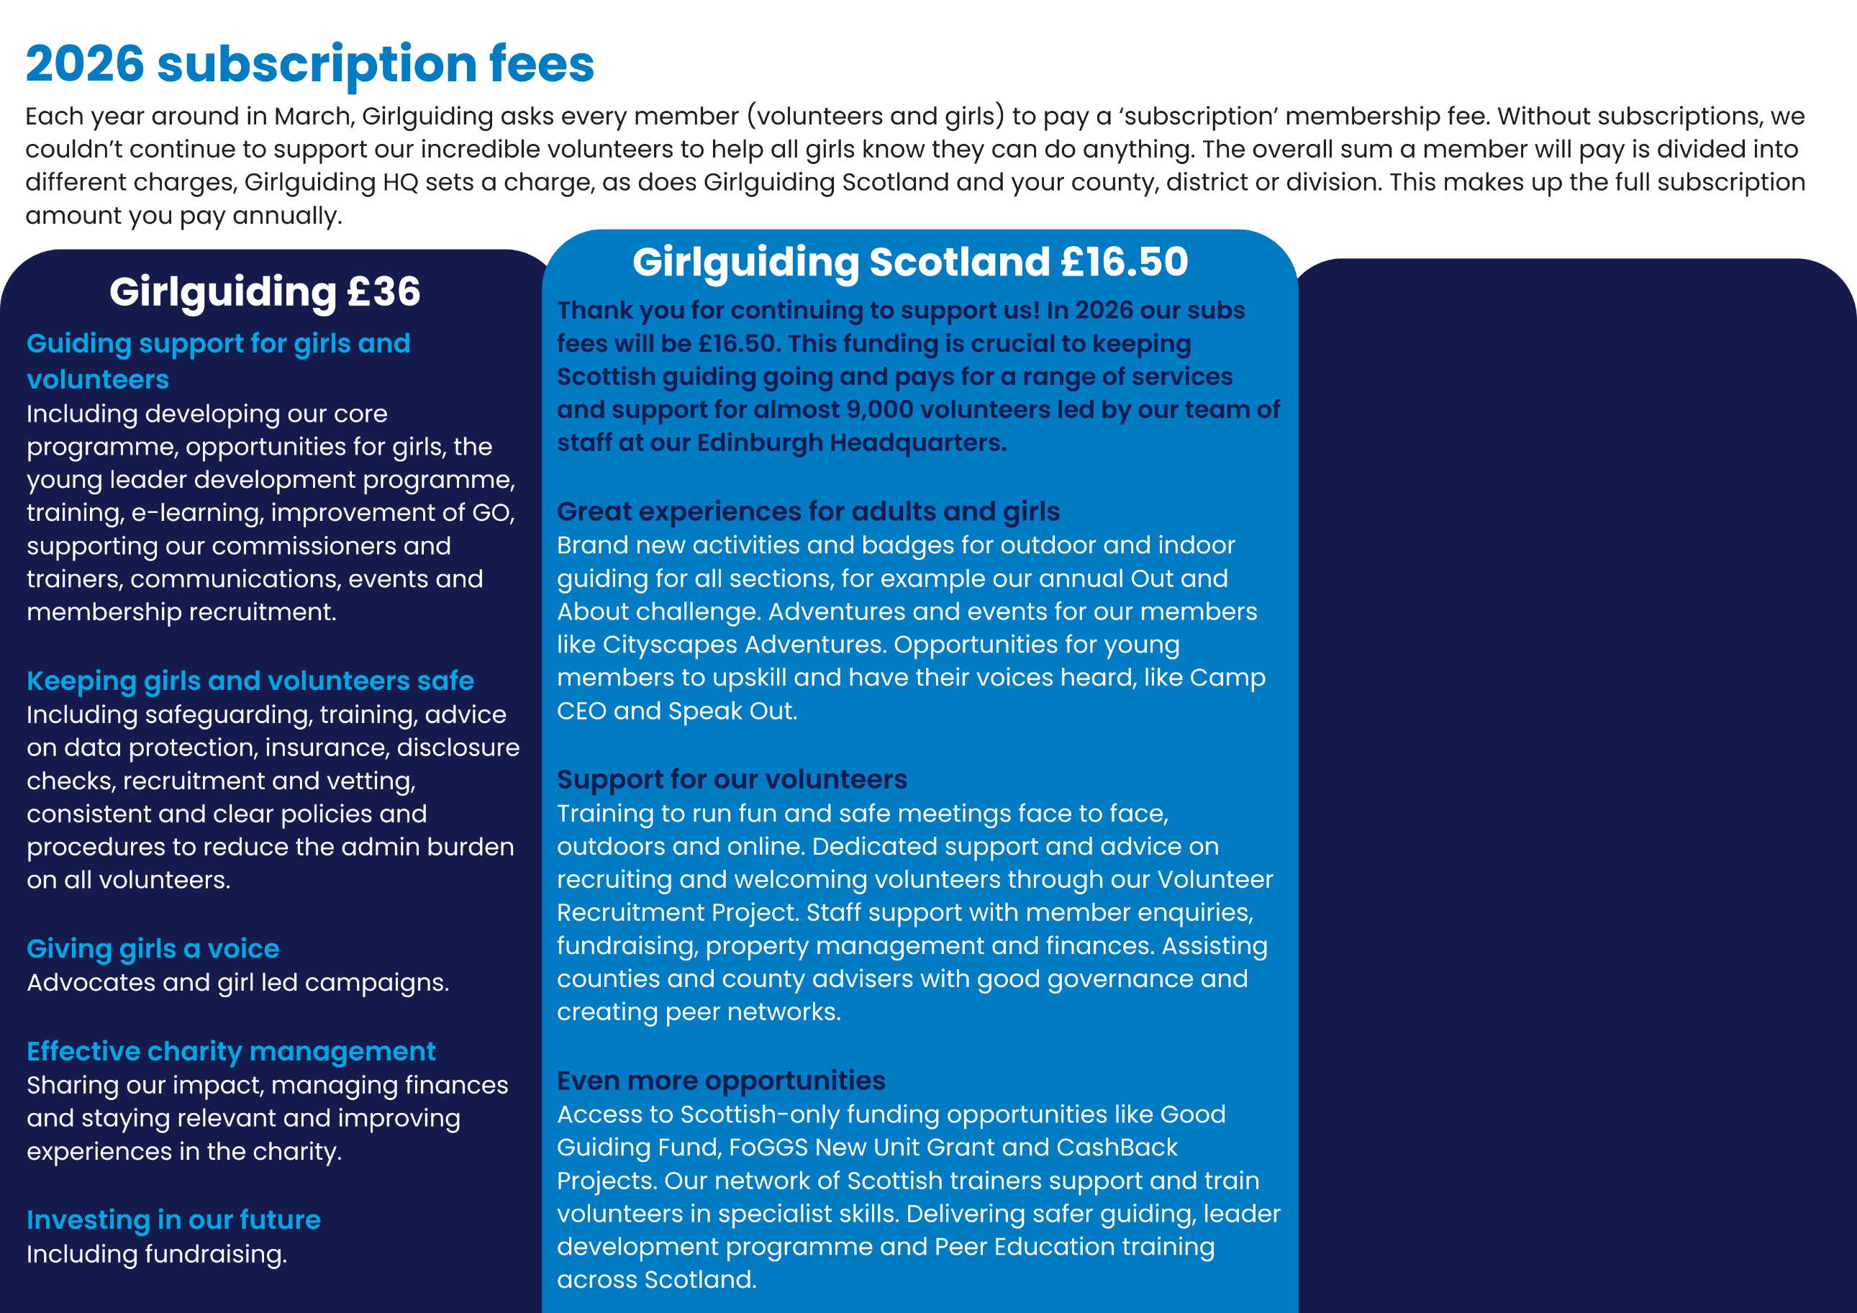
Add in information about your county and local subs

Add more context here
Highlight key things your subs charge covers here.

