Creating a Culture of Belonging

Inclusion means giving all girls the same chance.
It is achieved by creating a safe environment where girls feel an equal sense of belonging and receive tailored support so they can reach their maximum potential.

Universal barriers
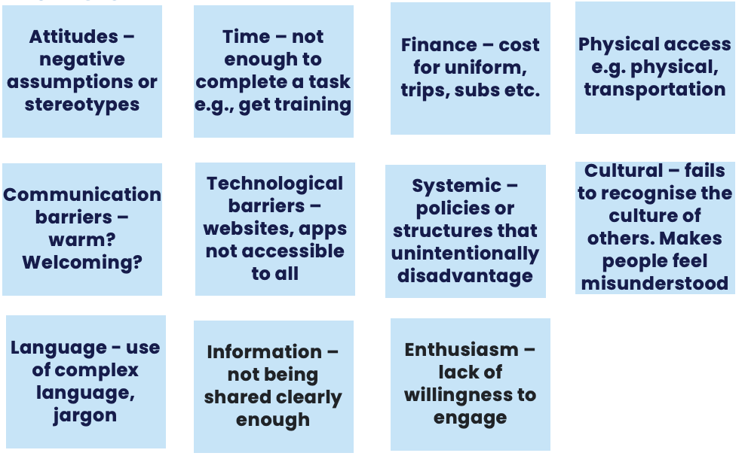
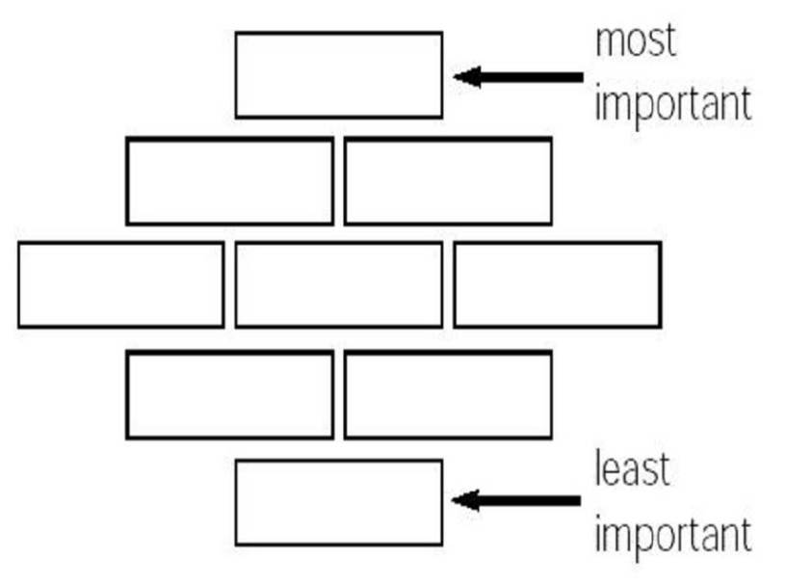
Local barriers that you, your team, people coming into Girlguiding at the level you volunteer at might be facing:

Scenario 1: The Warm Welcome That Missed the Mark
A new volunteer, Aisha, joins your local Girlguiding unit. She’s very enthusiastic but quiet at first. The existing team greets her warmly but quickly moves into discussing upcoming camps and unit logistics. Most of the conversation happens in shorthand and inside jokes, and Aisha seems lost but doesn’t say anything. After a few weeks, she stops coming.
Discussion prompts:
- What might have gone wrong here?
- How could the team have made Aisha feel more included from day one?
- What practical actions could improve onboarding and team culture?

Scenario 2: The Cost of Belonging
Your unit is planning a weekend away. Participation costs £60 per person. One new volunteer, Sarah, mentions she might not be able to go due to “family commitments.” Another leader later wonders if cost might actually be the issue.
Discussion prompts:
- How could the team approach this sensitively?
- What assumptions might be at play?
- What strategies can units use to reduce financial barriers (for both girls and volunteers)?

Scenario 3: Communication Breakdown
Maria, a volunteer whose first language isn’t English, often misses updates because important information from her District Commissioner is shared quickly in WhatsApp voice notes or informal chat messages full of abbreviations. She turns up to a meeting not realising plans had changed, and others seem frustrated with her.
Discussion prompts:
- What communication barriers do you notice?
- How could the group make communication more inclusive and accessible for everyone?
- What are good practices for sharing information across diverse teams?

Scenario 4: Policy vs. Practice
During a team meeting, a volunteer raises a question about including a girl who has additional support needs. Another leader responds, “We don’t really have the right training for that, and it might not be safe.” The unit decides not to take her on for now.
Discussion prompts:
- How does this align (or not) with Girlguiding’s values and inclusion policies?
- What could the leaders have done differently?
- What support might volunteers need to feel confident in inclusive practice?

Scenario 5: The Overlooked Volunteer
Jane, a new volunteer who uses a wheelchair, joins the team. The venue has an accessible entrance, but activities often require quick movement between rooms or outdoor areas that aren’t easy to navigate. The other volunteers tend to just do those parts themselves “to save time.”
Discussion prompts:
- What’s the impact of these small exclusions?
- How could the team plan more inclusively?
- What assumptions about ability might be showing up here?

Scenario 6: The Jargon Jungle
At the first district meeting, a new volunteer hears terms like “GO,” “Safer Guiding,” and “Division Commissioner,” without any explanation. She feels too embarrassed to ask what they mean and leaves unsure what’s expected of her.
Discussion prompts:
- How does jargon create barriers for new or returning volunteers?
- What could teams do to make processes and roles clearer?
- How might this scenario feel for someone from outside the Girlguiding culture?

Scenario 7: Cultural Awareness in Action
A volunteer suggests holding a unit celebration with pizza and hot dogs. Another volunteer mentions that one of the new helpers, Layla, is Muslim and doesn’t eat pork. Someone jokes, “Oh, she can just pick it off.” Layla laughs awkwardly but seems uncomfortable.
Discussion prompts:
- What are the cultural understanding issues here?
- How could the team handle this more thoughtfully?
- What does “inclusion” look like in day-to-day social moments like this?

Scenario 8: The Invisible Barriers
Your unit hasn’t had many new volunteers lately. When asked why, one leader says, “We just don’t get people from diverse backgrounds in this area.” However, a nearby community centre has lots of local parents from different cultural backgrounds volunteering in other youth projects.
Discussion prompts:
- What might be causing the lack of diversity?
- How could the unit reach out differently?
- What assumptions or barriers might exist unintentionally in how you recruit or welcome people?

Sources of support
Learning Platform: Including all training, Celebrating Every Member, Race Equity
Some links to the website
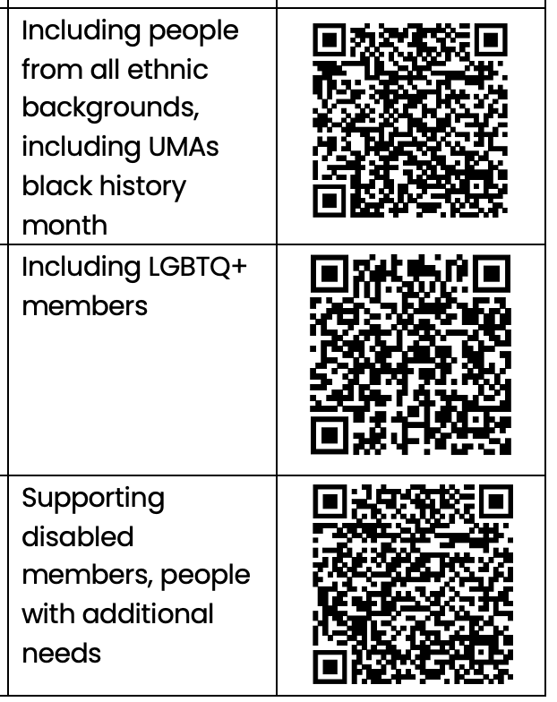
Reach out to your inclusion lead (county or for Scotland)

