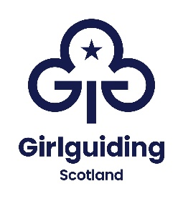

PRESS RELEASE
FOR IMMEDIATE RELEASE

GIRLGUIDING SCOTLAND SUPERSTAR FROM <REGION> RECEIVES NEW VOLUNTEERING AWARD

{insert date} A Girlguiding Scotland volunteer celebrated achieving Girlguiding Scotland’s Growing Guiding Award which recognises volunteers who have helped the charity achieve their access goals by making a difference in their local community.

<name>, <age>, from <region/area>, was presented with her Growing Guiding award <details of presentation e.g. alongside other dedicated Girlguiding Scotland members from the local area at an event in <location>.

<name> was nominated by <name> after <reasons for nomination and action taken>.

<quote> <name> said: <quote speaking about some of the actions she took, any challenges she faced and the result of her actions>.

If you’re interested in becoming a volunteer or know a girl who would like to join guiding, please visit girlguidingscotland.org.uk.
ENDS

Notes to Editors:
Photograph attached is of <insert details of photographs>.

For further information, images, interview requests please contact chloe@girlguiding-scot.org.uk or press@girlguiding-scot.org.uk

About the Growing Guiding award:

The Growing Guiding Award aims to recognise local efforts to encourage more girls and adults to join guiding or stay in guiding for longer.

To be eligible for the award, a nominee must hold an active volunteer role within Scotland.

More information on how to nominate a volunteer can be found at girlguidingscotland.org.uk/awards/growing-guiding-award/.

About Girlguiding Scotland
Girlguiding Scotland is a Scottish charity supporting almost 40,000 girls and young women and just under 9,000 amazing volunteers. Girls can do anything. We help them know that, whether they’re 4 or 18 or in between. All girls have a home at Girlguiding Scotland - whoever they are. We show them a world of possibilities, big and small. We help them think big and be bold in a space where they can be themselves, get creative, explore, and have fun. We’re a powerful collective voice – with girls, led by girls – changing the world for the better.
We’re made up of Rainbows, Brownies, Guides and Rangers from the Borders to the Highlands who come together to laugh, learn, explore and have adventures, in communities across Scotland and virtually. Our volunteers make guiding happen by giving their skills, time, talent and enthusiasm.
The Guide Association Scotland known as Girlguiding Scotland is a registered Scottish charity no. SC005548.

