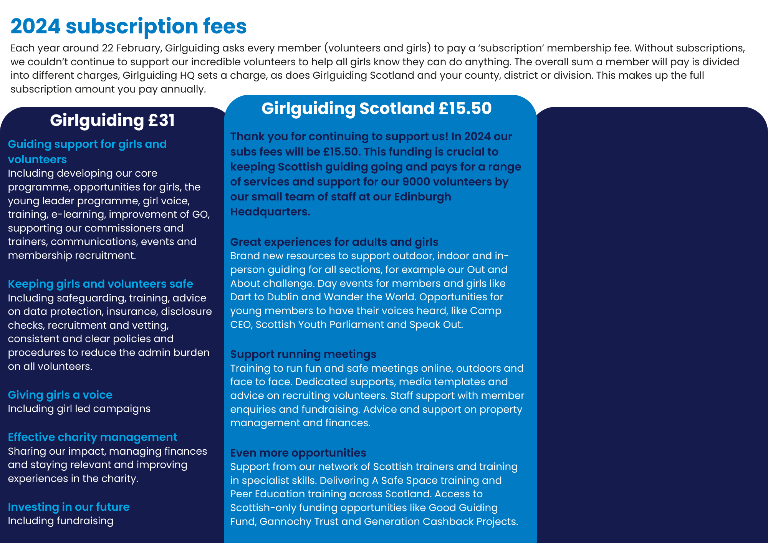

**Add in information about your county and local subs**

Add more context here

Highlight key things your subs charge covers here.