Using LinkedIn
Personal development and raising awareness
10 August 2023

Contents
1 Why use LinkedIn? 2
1.1 What can LinkedIn do for my employability? 2
1.2 Why put my Girlguiding experience on LinkedIn? 2
2 How to set up a LinkedIn account 3
2.1 Guides for setting up a LinkedIn account 3
3 How to add volunteer experience to your LinkedIn profile 4
3.1 Add Girlguiding to ‘Volunteering’ 5
3.2 Add Girlguiding to ‘Experience’ 7
4 Sharing successes on LinkedIn 11
4.1 Sharing a post about your volunteering 11
4.2 Writing an article about your volunteering 13
4.3 Using hashtags 15

Why use LinkedIn?

What can LinkedIn do for my employability?

LinkedIn is a free professional networking website. You can use LinkedIn to find the right job or internship, connect and strengthen professional relationships, and learn the skills you need to succeed in your career.

A complete LinkedIn profile can help you connect with opportunities by showcasing your unique professional story through experience, skills, and education.

Why put my Girlguiding experience on LinkedIn?

Skills gained through volunteering are a great way to show how you can bring value to a job role and to an employer. Many of the skills you have from volunteering are skills you would develop in the workplace too, like project management (organising a camp), resourcefulness (planning an activity last minute with what you have in the cupboard), and team work (volunteering within a unit team).

Highlighting skills that you’ve gained through voluntary positions shows your personal interests, and commitment to a cause. Girlguiding is an internationally recognised organisation, so linking Girlguiding Scotland on your LinkedIn is a valuable way to show the qualities and experiences you have.

Skills gained through volunteering are also particularly useful if you’ve taken a break from employment and you’re looking to return to work, or get into the workplace for the first time.

How to set up a LinkedIn account
1) Go to https://www.linkedin.com/ and click Join now in the top right corner
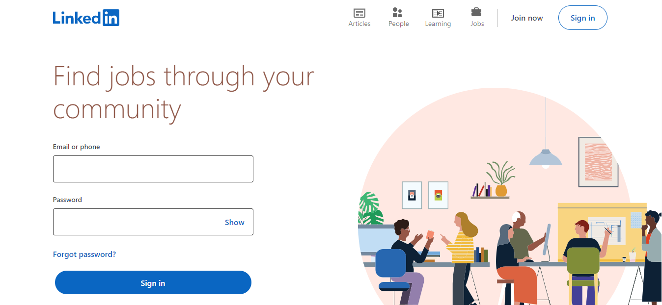
2) Enter your email address and a secure password
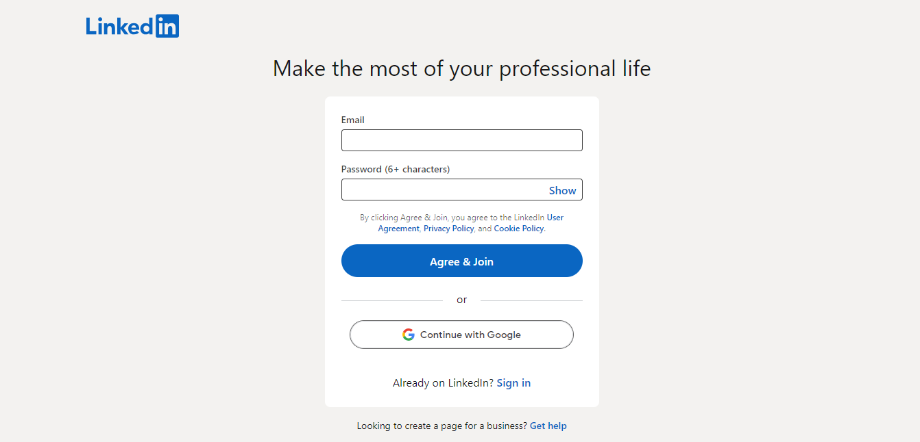

Guides for setting up a LinkedIn account
- (7) LinkedIn 101 | From Beginner to All-Star in 9 easy steps! | November 2020 | LinkedIn
- How Do I Create a Good LinkedIn Profile? | LinkedIn Help
- 20 steps to a better LinkedIn profile in 2023

How to add volunteer experience to your LinkedIn profile
There are 2 ways you can add your volunteer experience to your LinkedIn profile – under Volunteering, or under Experience. This table can help you decide which section to put your volunteering in:

Volunteering | Experience
Good if you already have lots of work positions under Experience | Good if you don’t already have lots of work positions under Experience
Clearly signposts this is something you have given up your free time to do | Your Profile Headline will appear at the top of your LinkedIn profile under your name, drawing more attention to your skills
Appropriate for more common roles within Girlguiding e.g. leader or unit helper | Appropriate for less common roles within Girlguiding e.g. district commissioner, GO coordinator or lead volunteer
Quick and simple to add to your LinkedIn profile | You can add Skills and Media, showcasing more of what you’ve done as a Girlguiding volunteer

Add Girlguiding to ‘Volunteering’

This can be used for any role within Girlguiding Scotland, such as leader and assistant leader, unit helper or young leader.

1) Go to your profile, scroll down until you find your Volunteering section. Click the + to add something new, or the pencil to edit an existing role.

2) To make the most impact, follow these suggestions for filling in the boxes below:
- Organisation – Girlguiding Scotland
- Role – Youth worker or Child and youth worker
- Cause – Children
- Description – try to be specific about what you do with Girlguiding Scotland, but avoid the jargon!
For example - I am volunteer team leader of a youth group with girls aged 10-14. In my role I am responsible for a group of 20 girls and managing my volunteer team. This involves planning weekly activities, delegating tasks like science experiments and games, budgeting and managing the account of the group, and liaising with parents/carers.
Other things you can include:
- I am responsible for organising several trips and events for the girls every year. This involves coordinating with the venues, parents/carers and other volunteers, risk assessments, sourcing equipment, and planning activities. In the past we’ve gone to see Christmas pantos, sleepovers at the aquarium and a week long camp in the Borders.
- I have qualifications in safeguarding children, first aid, budgeting and how to manage a team.
- As a volunteer team leader for the local area, I am responsible for managing 20 other volunteers. I use an online database to monitor new volunteers and new young members, organise recruitment events and I am equipped to deal with complaints and concerns.
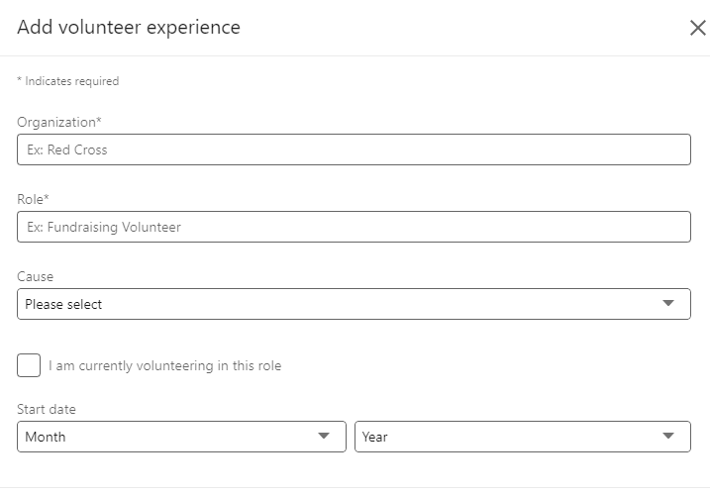
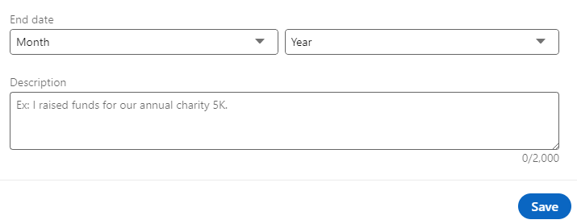

Add Girlguiding to ‘Experience’

This can be useful if you have a more specific role within Girlguiding Scotland, such as commissioner, enquiry coordinator, or lead volunteer.

1) Go to your profile, scroll down until you find your Experience section. Click the + to add something new, or the pencil to edit an existing role.

2) To make the most impact, follow these suggestions for filling in the boxes below:
- Title – Youth worker or Child and youth worker; Team leader or Team manager; Administrator or Database administrator (there’s lots more that might apply to you!)
- Employment type – Freelance (or leave blank)
- Company name – Girlguiding Scotland
- Industry – Non-profit organisations
- Profile headline – this will appear at the top of your LinkedIn profile under your name. Similar to title, this describes your role in Girlguiding but try to avoid unnecessary jargon. For example:
  - use area team leader instead of district commissioner
  - use database administrator instead of GO coordinator
  - use youth work leader instead of Brownie leader
  - use safeguarding trainer instead of Safe space trainer
  - use strategic manager instead of growth coordinator
- Skills – decide which skills best reflect your role. Here are a few good examples split into different categories:
  - Youth work skills – experience working with children, child development, youth work, youth empowerment
  - Analytical skills - problem-solving, critical thinking, data analysis
  - People skills – adaptability, collaboration, creativity, persuasion, time management, leadership, initiative taking
  - Communication skills – persuasion, writing, active listening
  - Management skills – delegating tasks, leadership, strategic planning
  - Information technology - databases
  - Marketing skills – social media, content strategy
- Media – leave blank or add media linked to your Girlguiding volunteering like a social media graphic you designed or a photograph from an event you participated in
- Description – try to be specific about what you do with Girlguiding Scotland, but avoid the jargon!
For example - I am volunteer team leader of a youth group with girls aged 10-14. In my role I am responsible for a group of 20 girls and managing my volunteer team. This involves planning weekly activities, delegating tasks like science experiments and games, budgeting and managing the account of the group, and liaising with parents/carers.
Other things you can include:
- I am responsible for organising several trips and events for the girls every year. This involves coordinating with the venues, parents/carers and other volunteers, risk assessments, sourcing equipment, and planning activities. In the past we’ve gone to see Christmas pantos, sleepovers at the aquarium and a week long camp in the Borders.
- I have qualifications in safeguarding children, first aid, budgeting and how to manage a team.
- As a volunteer team leader for the local area, I am responsible for managing 20 other volunteers. I use an online database to monitor new volunteers and new young members, organise recruitment events and I am equipped to deal with complaints and concerns.

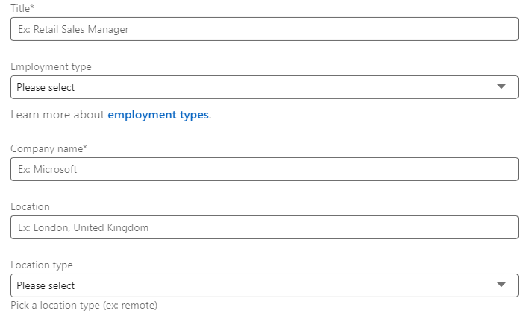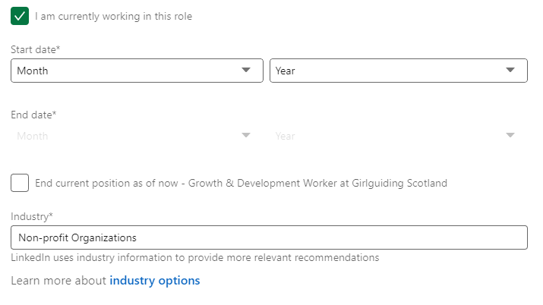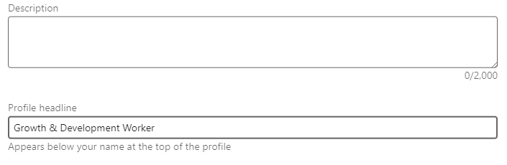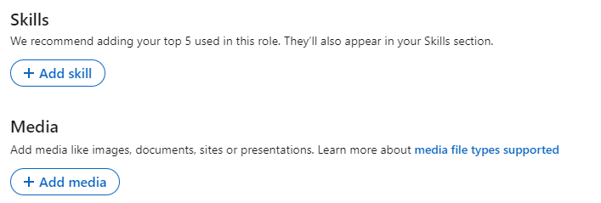

Sharing successes on LinkedIn
Why not share a post about your volunteering during Volunteers’ Week? Or share highlights from your volunteering when they happen, like after a big event or a camp, just like you would after completing a big project at work? Maybe you enjoy writing blogs about your experiences as a volunteer?
Here are some suggestions of how to share your successes on LinkedIn.

Sharing a post about your volunteering
At the top of the homepage, you can write a post to share straightaway! You can also share photos and videos of what you’ve been up to, and it can be up to 3,000 characters.
What makes a good post?
- A catchy opening line to grab the reader’s attention
- Clear language and simple sentences
- Avoid the jargon! Will people know what commissioner means, or would local area manager be better?
- Describe what you’ve been up to and show us why you want to share your success!
- Be personal, like you’re speaking to someone you know
- Tag @GirlguidingScotland
- Add something visual to make your post stand out

Example 1 – a post about becoming a district commissioner
I’m so excited to share that I will be supporting the empowerment of girls and young women in a new role in @GirlguidingScotland! My new position as district commissioner means I will manage my local area of XXX to make sure our team of volunteers offers as many girls and young women as possible the chance to grow, be challenged, and know that they can do anything. I’m grateful for this opportunity, and thrilled to be working with a team of brilliant volunteers. We’ll be focusing on strategies for growth, exploring new ways of utilising social media, and ideas to improve volunteer recruitment and retention. How do you approach engaging potential volunteers? I’m always open to new tips and tricks!
Add a photo of you in uniform, you with your volunteer team, your district logo or a LinkedIn image from the online design centre.

Example 2 – a post about an event you helped organise
Absolutely buzzing after our county fun day for @GirlguidingScotland!
Over 200 girls aged 5 to 10 years old getting up to all sorts, from face painting to football, circus skills to science experiments!
All those risk assessments, phone calls to the venue managers, spreadsheets and creative brainstorming were worth it. Couldn’t have done it without my fantastic team of volunteers. Such a privilege getting to organise events like this for girls in the community, and I can’t wait until next year!
Add a photo of you at the event (if you have photo permission).

Example 3 – a post for Mental Health Awareness Week (May)
Did you know it’s Mental Health Awareness Week?
One of the most important ways I look after my mental health is by getting out there and helping other people. I’m a volunteer with @GirlguidingScotland, and being part of a team dedicated to empowering girls and young women has given me a community, a purpose, and a lot of laughs!
I would encourage everyone to try volunteering. It’s helped me through a lot of bad days, and given me too many good days to count!
Add a photo of you with your volunteer team, or a positive quote related to mental health.

Example 4 – a post for Volunteers’ Week (June)
For Volunteer’s Week, I want to say thank you to the @GirlguidingScotland volunteers I work with to help all girls and young women in our community know they can do anything!
Together we’ve run summer camps, aquarium sleepovers, attempted to build bird boxes, gone axe throwing, hosted our own bake off, and that’s not even half of it.
Being a volunteer with Girlguiding Scotland has given me friends for life, a way to empower girls and young women, and an unforgettable night sleeping underneath a fish tank!!
If you like fun and adventure, come along and join us. You won’t regret it!
Add a photo of you with your unit (if you have photo permission), or you and your volunteering team doing an adventure or activity.

Writing an article about your volunteering
At the top of the homepage, you can write an article to share on your profile! Like a blog, you can go into more detail about your volunteering, what it means to you and what skills and experience you’ve achieved.
Add a cover image of what you’re writing about to make it eye-catching. When you’re finished, click ‘Next’ at the top of the page, and you can publish your article!
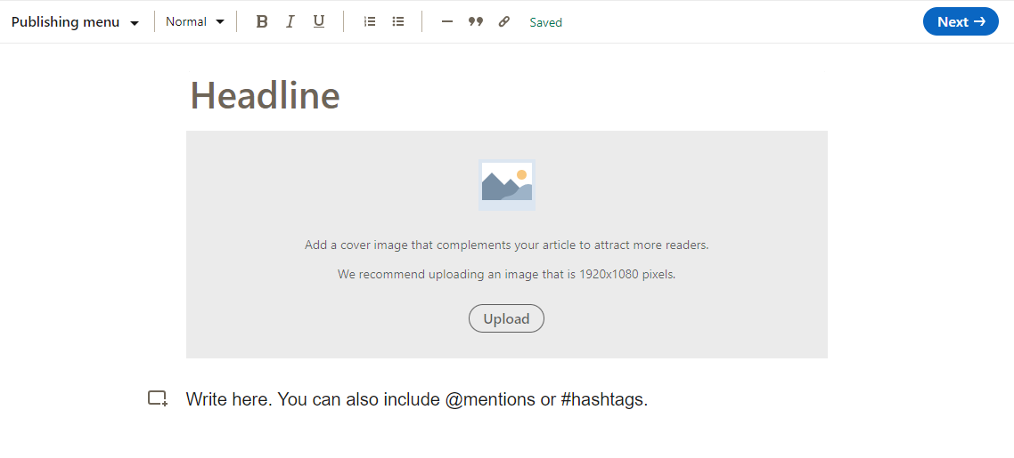
What makes a good article?
- A catchy title
- Clear language and simple sentences
- Avoid the jargon! Will people know what commissioner means, or would local area manager be better?
- Describe what you’ve been up to and show us why you want to share your success! An article lets you go into much more detail than a post
- Be personal, like you’re speaking to someone you know
- Tag @GirlguidingScotland
- Add something visual to make your post stand out
- It can be a few paragraphs, or a list of 5 ways volunteering has changed your life. Be creative!

Example paragraph 1 – your responsibilities
Although Girlguiding is a national charity, with a staff team who do fantastic work to support us, we are a volunteer led organisation with all of the work done at a grassroots level by volunteers. My local Girlguiding area effectively operates as a small charity with volunteers coordinating everything from the accounts to social media, fundraising to risk management as well as the day-to-day activity of running events and activities for over 100 girls and young women aged 5-18 in our community.

Example paragraph 2 – the impact of volunteering on your professional life
It was becoming a volunteer with Girlguiding Scotland and redefining my idea of success that transformed my professional life. I wanted to gain fulfilment and satisfaction, and that wasn’t happening in my current job. So, it was time to find a new one. If I’m honest, I didn’t think I would get it. I didn’t have enough of the experience, and I was moving into a field I hadn’t worked in before. However. My experience being a volunteer with Girlguiding Scotland got me the job. Experience working with young people? Check. Training in understanding and using data? Check. Confidence in speaking to a room of people and communicating instructions clearly? Check. I didn’t have some of the requirements, but my experience with Girlguiding proved everything I had to offer, and I got the job!

Example paragraph 3 – a challenge you’ve overcome
As a youth work team leader for Girlguiding Scotland, I had to be organised on a weekly and daily basis, but I did not know the true meaning of organisation until I was faced with organising a visit to Holyrood for over 30 girls aged 10 to 18 years. Any trip involving young people involves risk assessments, financial spreadsheets, communications to the girls and to parents/carers, budgeting and funding applications, travel arrangements and back up travel arrangements! The trip was ultimately a success, and some of the older girls heading to university and college felt very inspired to take political action and get involved in shaping the world around them, the best sort of feedback. This experience taught me the importance of organisation, as my determination, creativity and commitment to empowering the young women around me will have impacts for their futures in ways I might never know!

Example paragraph 4 – a skill you’ve developed
This skills development took on a whole new level due to the pandemic. It all the more obvious how volunteering gives you so many skills and opportunities to advance them, and how transferable these skills are to life outside of volunteering. Adaptability was a big one – switching overnight to leading unit meetings via Zoom instead of in-person, at a time when young people needed that connection and escape more than ever. Creativity too, how do you engage young people through a computer? How do you bring fun to the table when they’ve been online schooling all day? And of course, resilience. Volunteering in youth work in the middle of a pandemic is not easy, but I was organised and realistic with my aims.

Using hashtags
Hashtags are important when sharing your Girlguiding volunteering on LinkedIn because they make your post and account more visible to other people. If people are looking for volunteering opportunities and search #volunteering, your post will come up if it has that hashtag and they can see all the amazing Girlguiding things you’ve done.

Top tips for using hashtags
- Use no more than 3 hashtags on a post
- Make sure spelling is correct and there are no spaces
- Make sure the hashtags are related to what your post is about

Hashtag suggestions
Definitely use | Maybe use
#Girlguiding | #MakingADifference
#Volunteering | #WomenEmpowerment
#Charity | #IWD (International Women’s Day)
#VolunteersMakeADifference | #STEM
 | #Opportunities
 | #Leadership
 | #EmpoweringGirls
 | #Community

