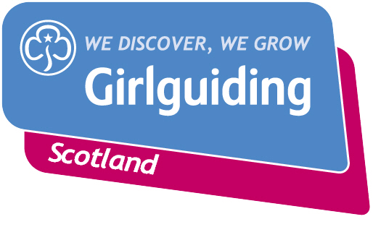
Create your own flexible guiding programme by picking and mixing activities from the Girlguiding programme, Adventures at Home and the Girlguiding Scotland flexible guiding games packs. This template is for a half-day session. The programme could be used for weekend meetings or to build up a series of half-day meetings over the holidays. Just adjust the timings to turn it into an afternoon session.

Example Start Time | Duration | Suggestion | Your plan | What equipment or resources will you need? | How much will this cost?
9.30am –9.45am | 15 mins | Welcome and quick game
9.45am – 10.30am | 45 mins | Whole group activity or games
10.30am – 11.00am | 30 mins | Activities from the Girlguiding programme  Split into two groups (part one)  Group one: Activity one  Group two: Activity two
11.00am – 11.15am | 15 mins | Break. Girls vote/choose games from short list to play later.
11.15am – 11.45am | 30 mins | Still in their two groups, (part two)  Group one: Activity two  Group two: Activity one
11.45am – 12.10pm | 25 mins | Games of girls’ choice
12.10am – 12.30pm | 20 mins | Group discussion time: songs, chat, feedback on what they liked, changes. What we can do next time
12.30pm finish

