Girlguiding Scotland Outdoor
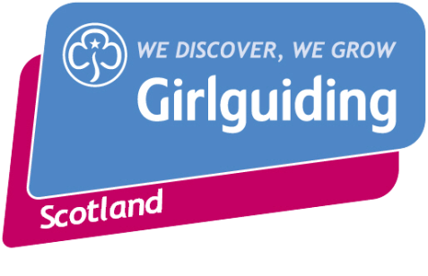
First Aid Course
Booking Form
11 November 2021 (on Zoom)
13 - 14 November 2021
South Newton Farm House, Kilmacolm, Renfrewshire PA13 4TE

Applications should be emailed to Ann-Marie at the address below by 15 October 2021, and she will provide bank transfer details for the £30 deposit. Alternatively, you can post a cheque made payable to ‘Girlguiding Scotland’ to the address at the bottom of the form.

Please note:
- Places will be allocated on a first come, first served basis and the event may sell out prior to the above deadline.
- You must send in the (non-refundable) £30 deposit as soon as possible after your form to secure your place, or it may be given to someone else.
- Do not send cash in the post – cheques can be replaced if they go missing but cash cannot.
- The full fee of £90 does not include travel to and from the event.
- This event is open only to members of Girlguiding Scotland aged 18+.
- You must be willing to follow any Covid-19 measurements put in place to protect all attending.
- Your contact details will be retained for 1 month after the event for contact tracing purposes.

Name
Membership Number
County
Mobile Number
Email
Do you have any dietary requirements?
Do you have any additional needs?
Accommodation is in shared rooms – is there anyone attending who you would prefer to share with?
Will you need picked up from the bus or train station in Johnstone? If so, what time?
If you are not comfortable sharing a room (no more than 2 to a room) then there is an option to camp, providing you bring all your own equipment. Would you like to take up this option?
Please include an emergency contact name and number below who will be available throughout the event.
Emergency contact name & relationship
Emergency contact number

Please return this form to: Ann-Marie MacRae Or ann-marie@girlguiding-scot.org.uk
Girlguiding Scotland
16 Coates Crescent
Edinburgh
EH3 7AH

PRIVACY NOTICE

What will you do with my data?
It’s simple. We need the information you share with us to run our exciting activities and to satisfy our legal responsibilities. We’ll keep it safe for as long as you are an active member.
We promise we’ll only share your information if:
- you ask us to
- the law requires us
- in order to comply with our policies so you can enjoy an activity safely
- we carry out market research
- it’s in the public interest
Don’t worry – we’ll never sell your data or share it for any other reason.

Girlguiding is the registered data controller* for all our members’ personal information, both in the UK and around the world.

Want to find out more about how we use your information – and your rights? Visit www.girlguidingscotland.org.uk/privacy-notice/

* The organisation that manages and looks after your data

