PVG Scheme Online
Guide for applicants

This is a guide to help applicants complete an online PVG scheme application. Please note that the existing PVG scheme online process is in Beta only.

Contents
1. Introduction 4
2. Scheme Record for joining the PVG scheme 7
Apply to join the PVG scheme 7
Your personal information 8
Check application details 9
Your full name and previous names 10
Your mother’s maiden name 12
Your date of birth 13
Your gender 14
Your place of birth 15
Your nationality 16
Your contact details 17
Your address history 18
Your current address 19
National Insurance number 22
Passport 24
Driving licence 26
Regulatory Body details 28
Check your answers 30
Declaration 31
Paying for this application 32
Thank you for your application 35
3. Apply for an Existing Scheme Record 36
Your personal information 37
Check application details 38
Your PVG scheme number 39
Your full name and previous names 40
Your date of birth 42
Your contact details 43
Your current address 44
National Insurance Number 46
Passport 48
Driving Licence 50
Regulatory body details 52
Review your application 54
Declaration 55
Paying for this application 56
Thank you for your application 59
4. Apply for an Existing Scheme Record Update 60
Your personal information 61
Check application details 62
Your PVG scheme number 63
Your full name and previous names 64
Your date of birth 66
Your contact details 67
National Insurance Number 70
Passport 72
Driving Licence 74
Regulatory body details 76
Review your application 78
Declaration 79
Paying for this application 80
Thank you for your application 83

Introduction

This guide explains the process for making a PVG application online. It includes screenshots that show the processes for:
- someone joining the PVG scheme – required for all new applicants joining the scheme

- someone requiring an Existing Scheme Record – required for existing PVG members applying to work with a new vulnerable group

- someone requiring a Scheme Record Update – required for existing PVG members changing employer, or for employers requesting a record update

As a demonstration, some fields are already filled in the screenshots. However, all fields will be blank at the start of your application.

The online application process has two parts:
- Part 1 - to be completed by the CSG
- Part 2 - to be completed by you, as the applicant

You will receive an email from Disclosure Scotland which includes a link to complete your part of the application.

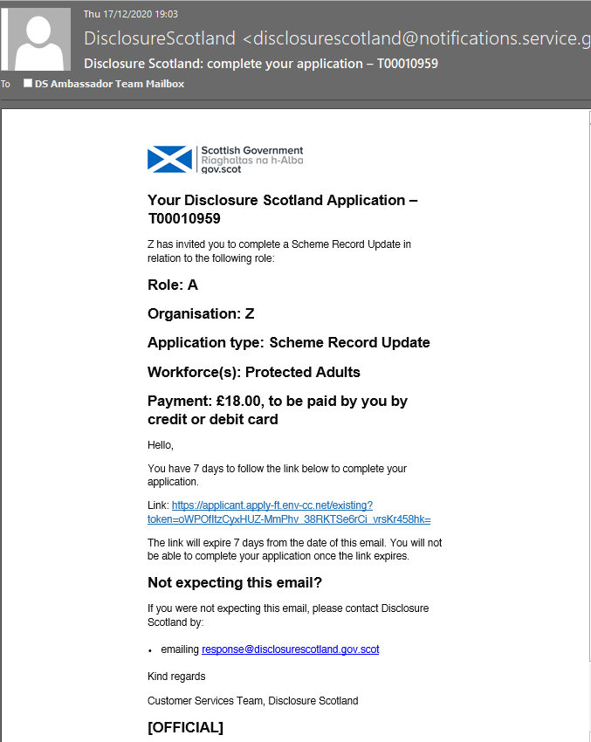

This email will contain the case reference. Please keep a note of this reference for future queries. It will also include details of the role, organisation, application type and workforce entered by the countersignatory. There is a unique link in the email which will take you to your online application.

The link will only work for seven days from the date of the email.

Once you have completed your part and submitted it to Disclosure Scotland, the countersignatory will receive an email confirmation.

If you have provided a valid email address you will receive an email confirmation.

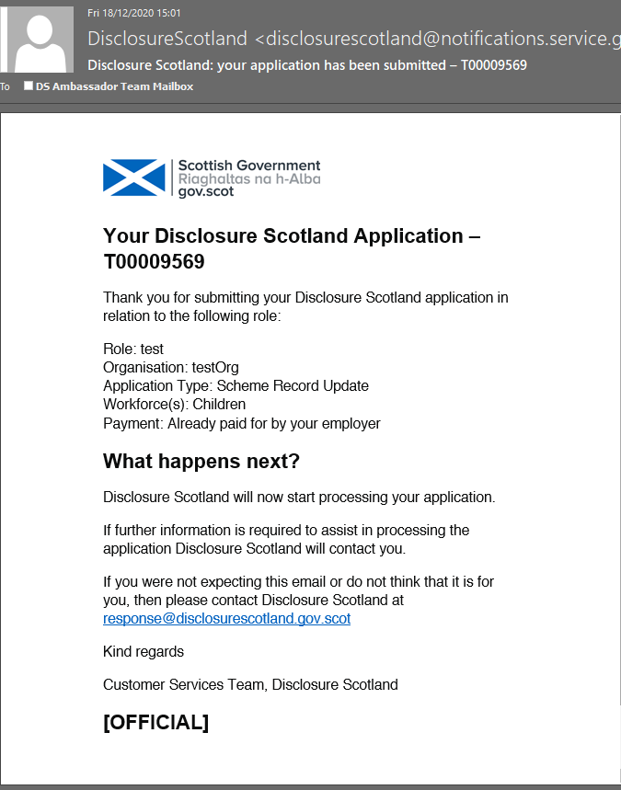

Scheme Record for joining the PVG scheme

These screenshots show the process for applying online to join the PVG scheme.

Apply to join the PVG scheme

This screen shows the product you are applying for and the identification details you will need to complete the application.

If you are responsible for paying for the application, there will be additional payment details displayed under the heading ‘paying for this application’.

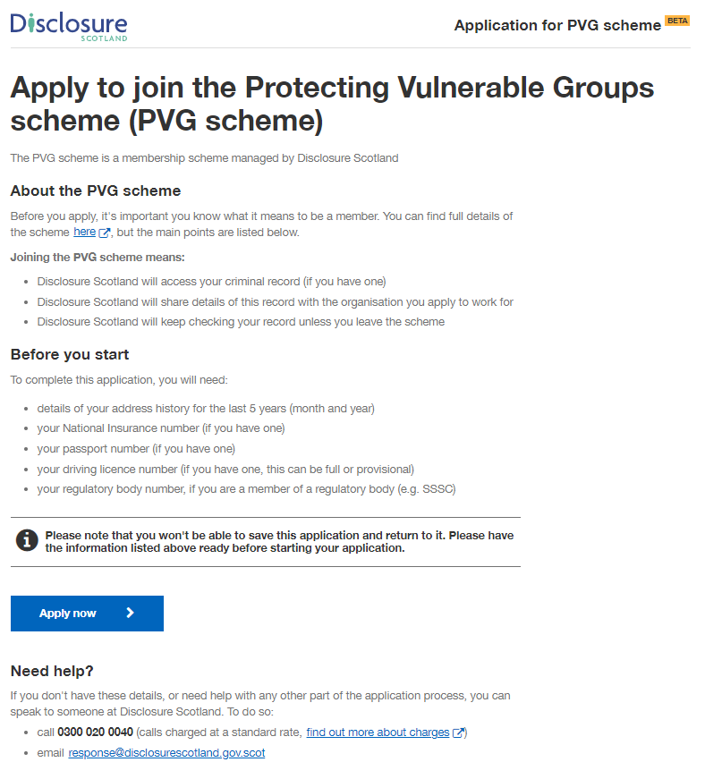

Your personal information

This screen details how we will use your personal information. To progress with the application, select the checkbox to give permission to Disclosure Scotland to keep and share your personal information for the purposes described.

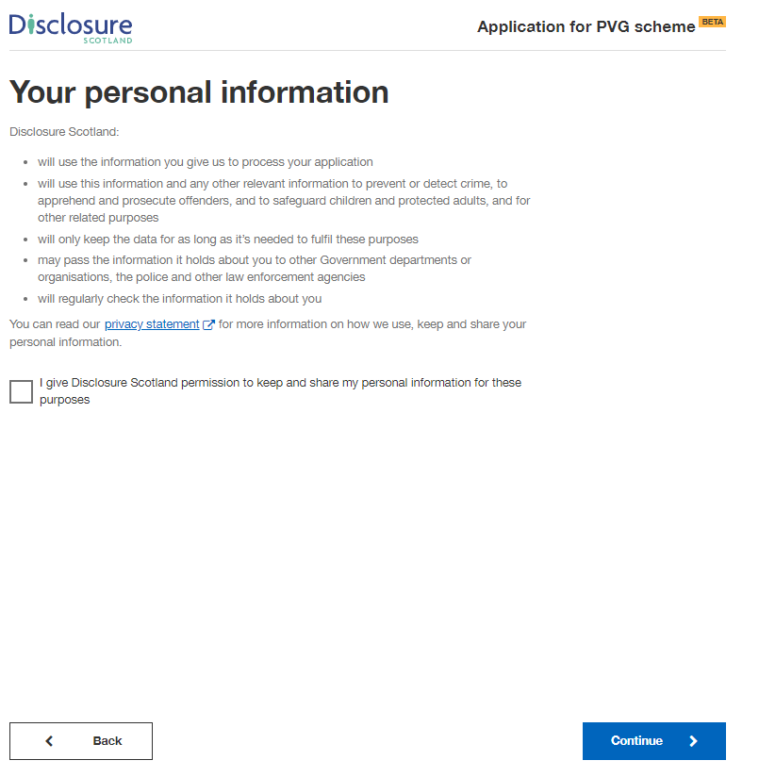

Check application details

This screen will show details of the position that the countersignatory has completed on your behalf.

These details cannot be edited. If these details are incorrect, please contact your countersignatory, not Disclosure Scotland.

If you are paying for your application, your employer will have selected the option for you to pay by card. The payment details will be selected as ‘£59 payable by yourself’

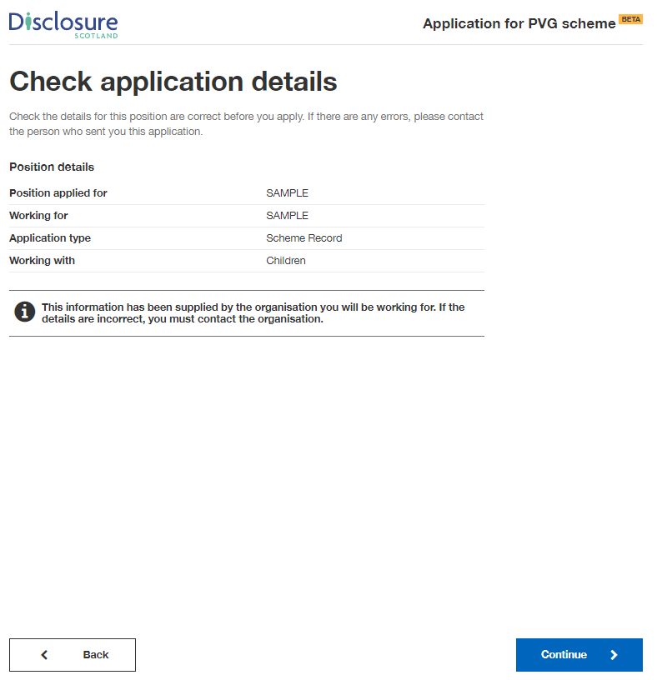’.

Your full name and previous names

On this screen, please enter your full name including any middle names. Please do not use initials.

If you’re transgender or non-binary, and are concerned about completing the form, please read the advice on the linked page.

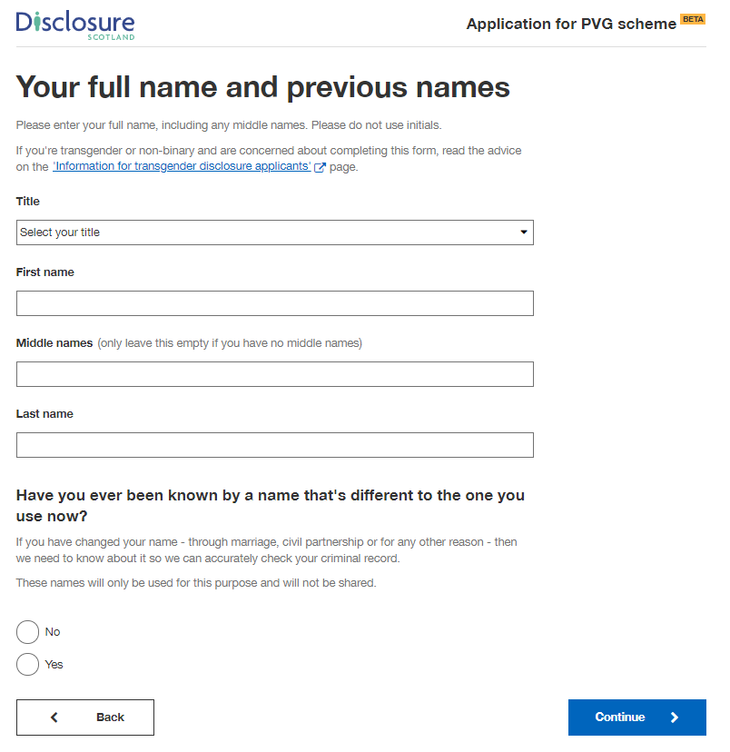

If you were previously known by another name, selecting ‘Yes’ will present additional fields for you to enter these other names.

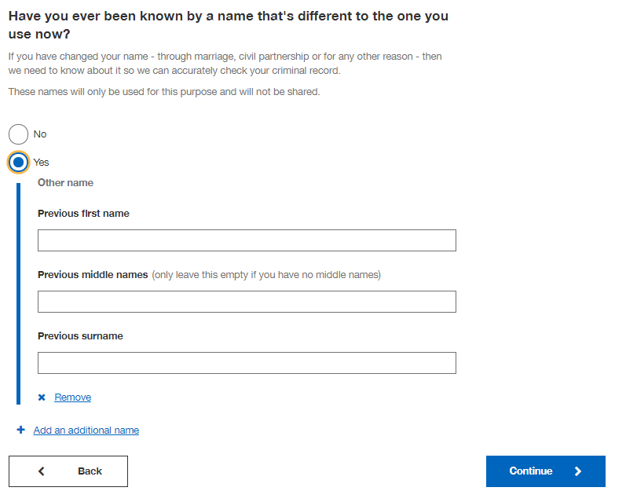

Your mother’s maiden name

Enter your mother’s maiden name on this screen. This should be the surname given to your mother at the time of her birth. Please don’t include any first or middle names.

If you were adopted, you can use your adoptive mother’s maiden name if you prefer.

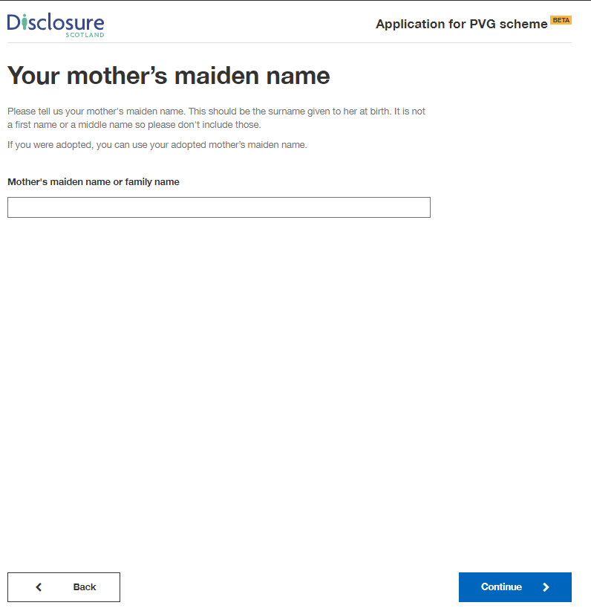

Your date of birth

Enter your date of birth on this screen. If you don’t know your date of birth, use the one on offical documents, such as your passport or driving licence.

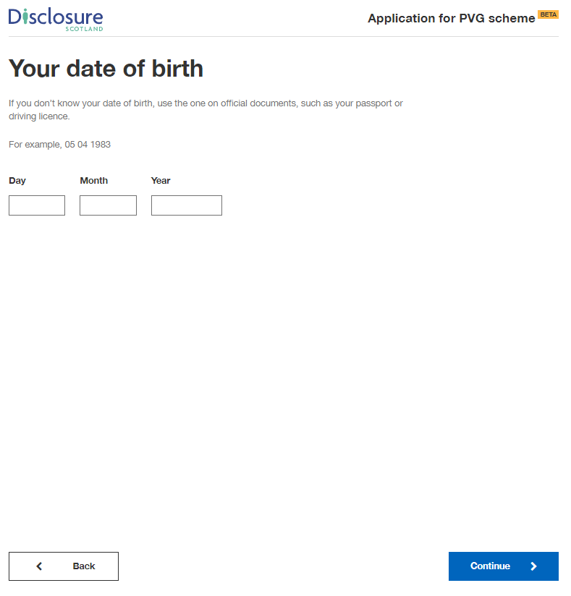

Your gender

Select your gender on this screen. If you’re transgender or non-binary, and concerned about completing this part, please read the advice on the linked page.

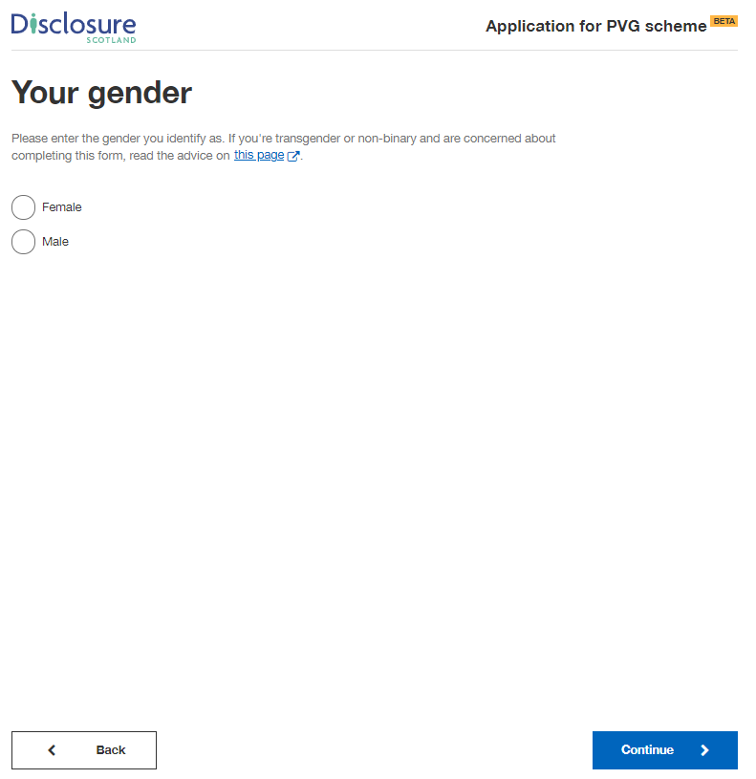

Your place of birth

Enter your place of birth on this screen.

If you don’t know your place of birth, use the one on official documents, such as your passport or driving licence.

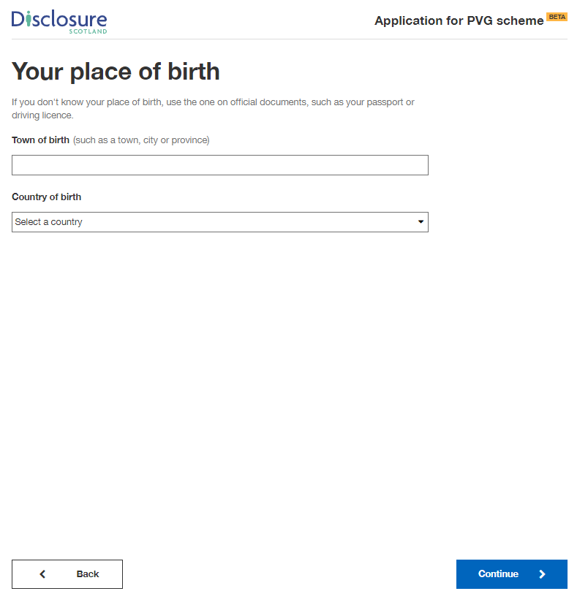

Your nationality

Select your nationality on this screen.

If you don’t know your nationality, use the one on official documents, such as your passport or driving licence.

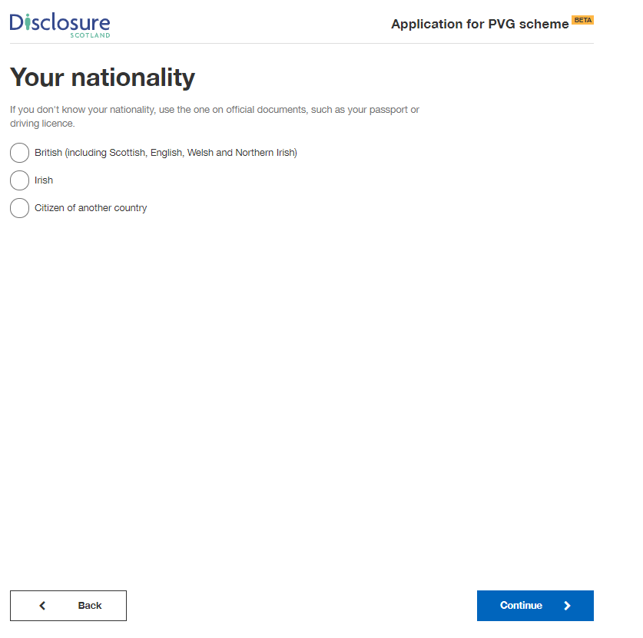

Your contact details

On this screen enter a valid email address and contact telephone numbers.

We may need to contact you to help process your application so please provide as many contact details as you can.

It may slow down your application if you do not provide both an email address and telephone number.

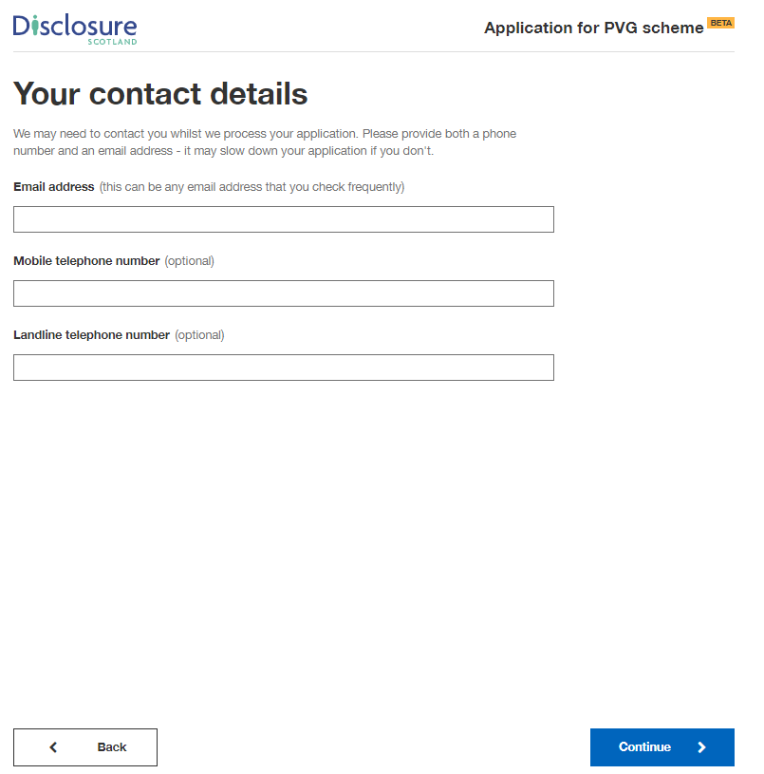

Your address history

This screen explains what we need to know about your address history.

We need to know where you have lived for the past five years.

If you have been a student during this time, enter all your term and vacation addresses.

If you have lived in emergency accommodation, please enter the name of the shelter you were living in.

If you have spent time travelling during this time, please tell us what town and country you were in.

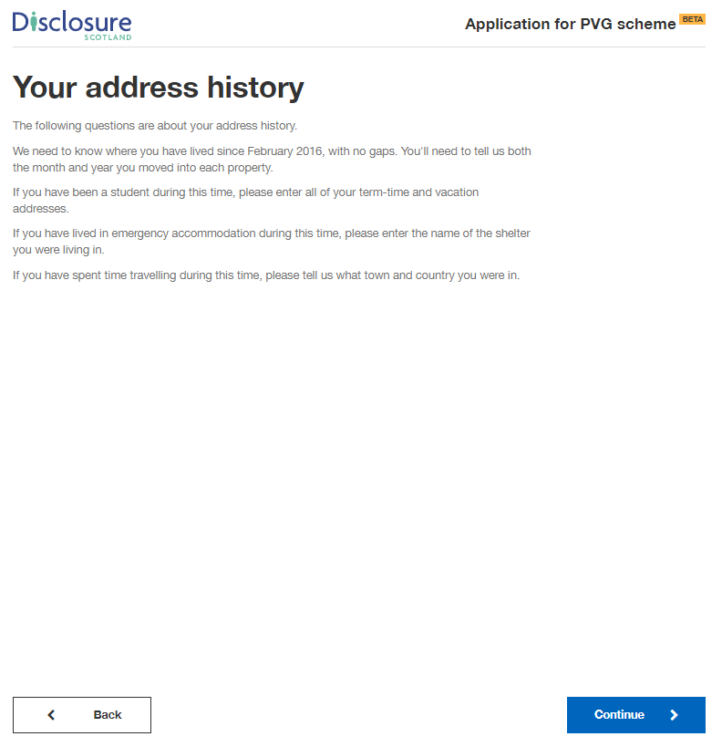.

Your current address

Please provide your current address and the month and year you moved there.

You can enter your postcode and select ‘Find UK address’ - this will display a list of addresses in your postcode, select the correct address from the list.

Alternatively, you can select the blue link below and enter your address manually.

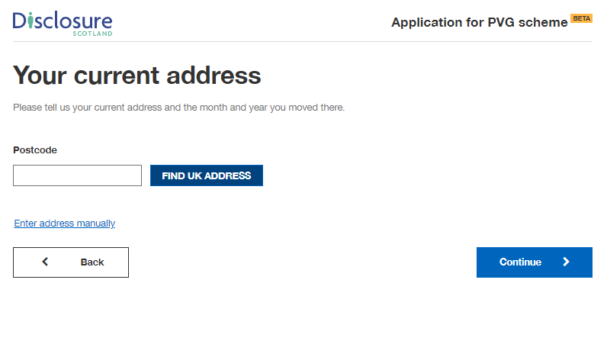

Once you have selected your address or entered it manually, you will be asked
‘When did you move here?’. Enter the month and year your moved to that address.

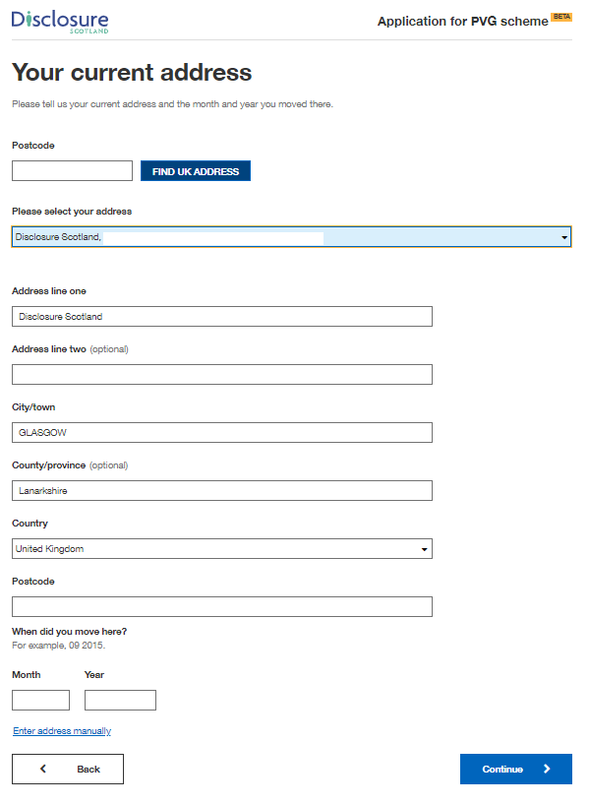

If you have given a five year address history, it will advise your address history is complete.

If you have not given a five year address history, it will ask you to update your address history before you can move on with the application.

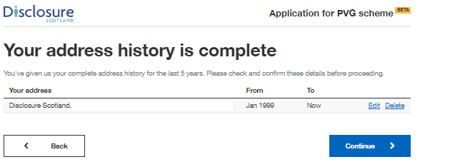

National Insurance number

This screen asks if you have a National Insurance number. Please provide this information if you have it. It will help us progress your application.

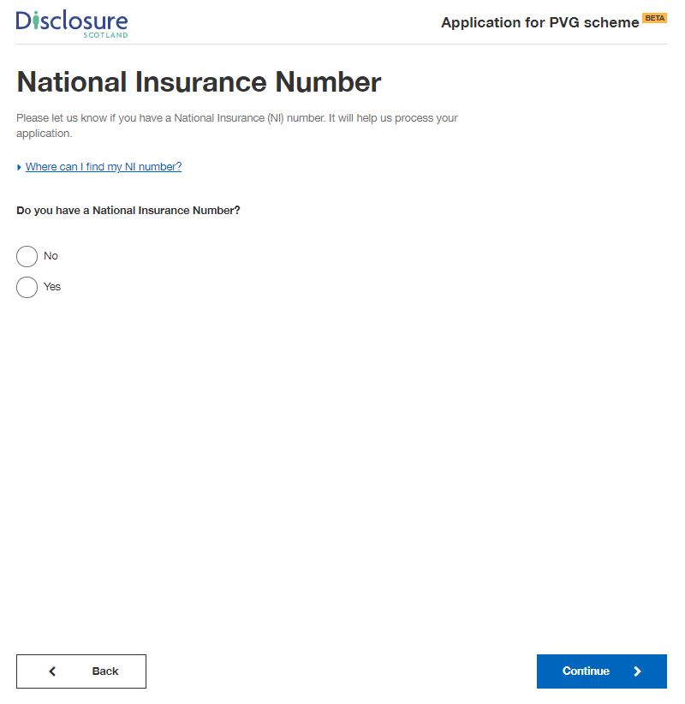

Selecting ‘Yes’ will present a field for you to enter your National Insurance number.

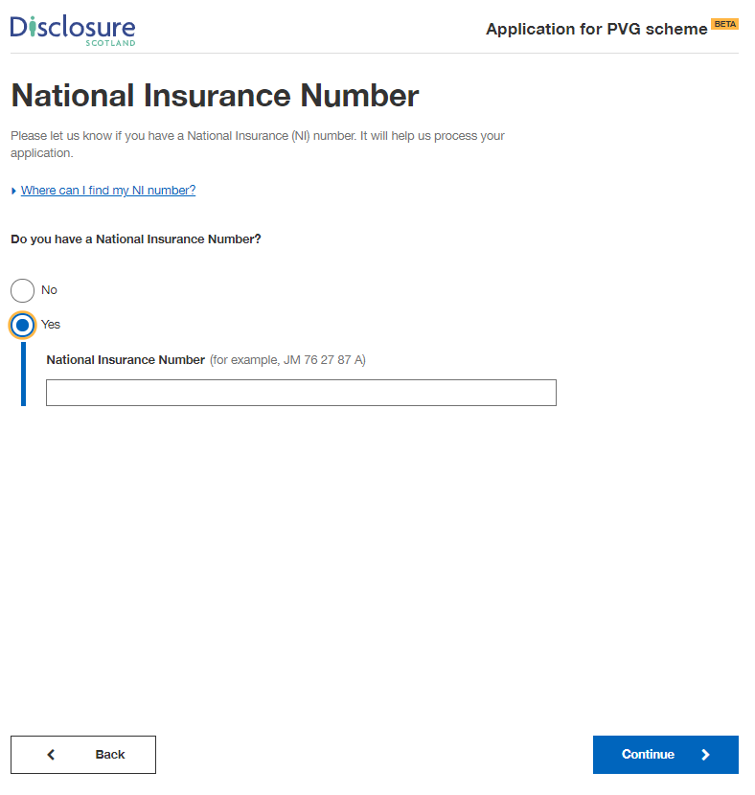

Passport

This screen asks if you have a passport.

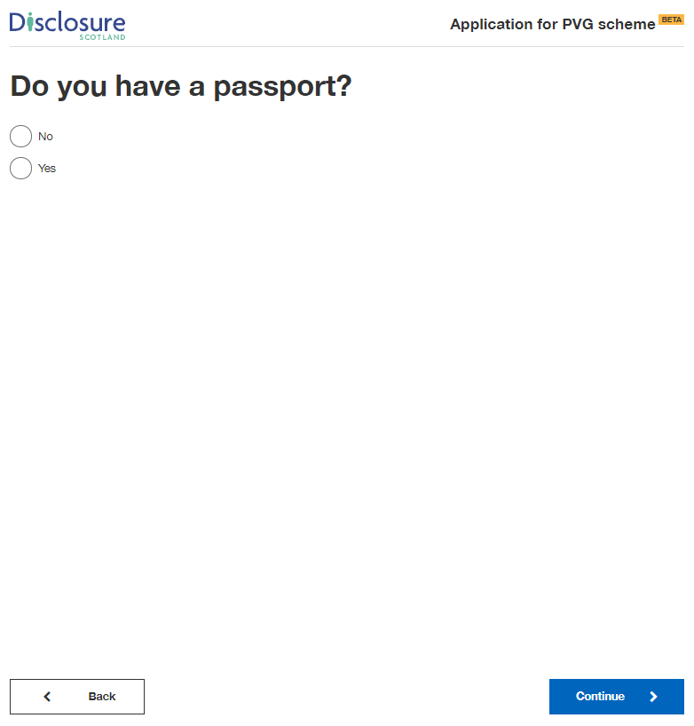

Selecting ‘Yes’ will present a field for you to enter your passport number.

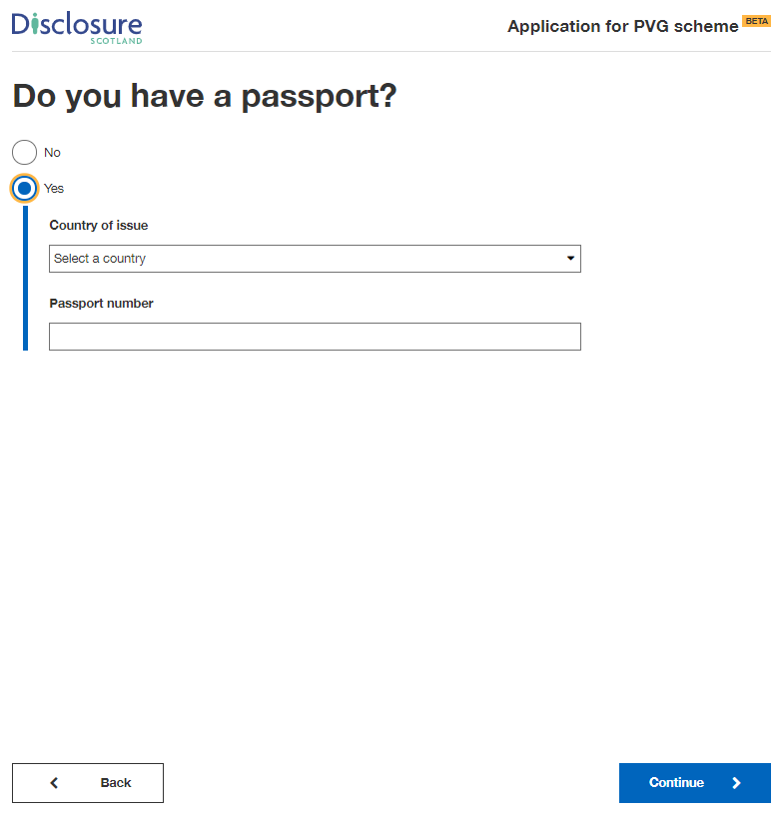

Driving licence

This screen asks if you have a driving licence.

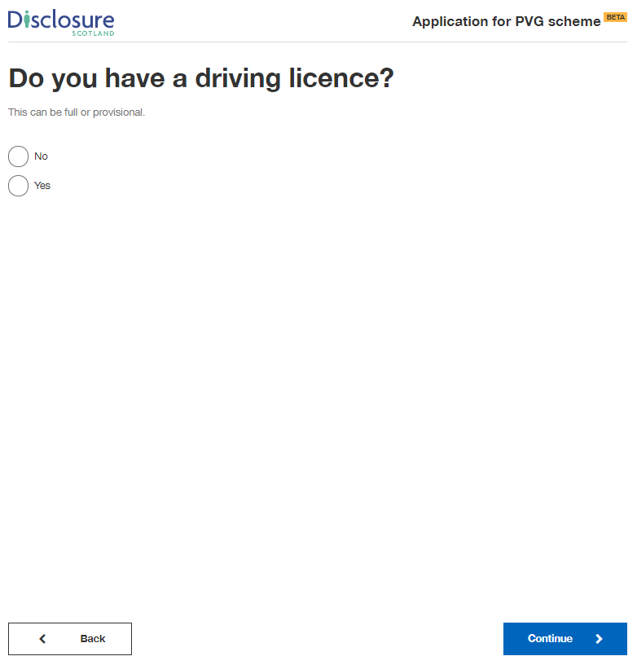

Selecting ‘Yes’ will present a field for you to enter your driving licence number.

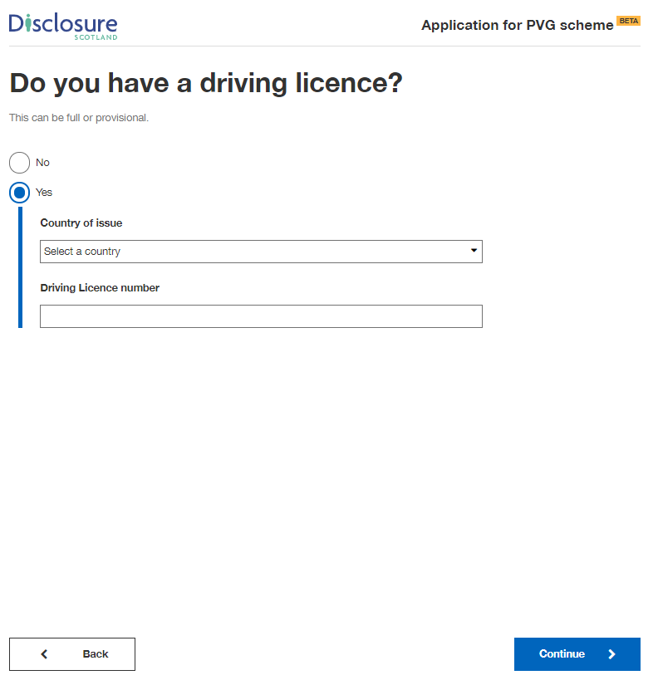

Regulatory Body details

This screen asks if you’re a member of any of the regulatory bodies listed.

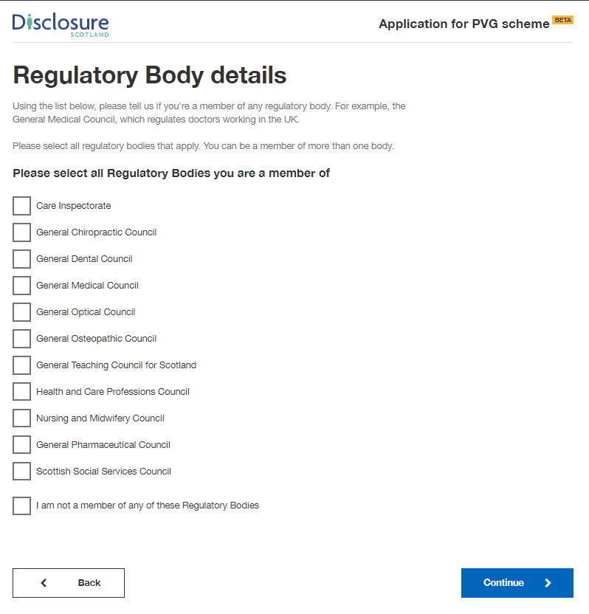

Selecting one of the regulatory bodies will present a field for you to enter your regulatory body registration number.

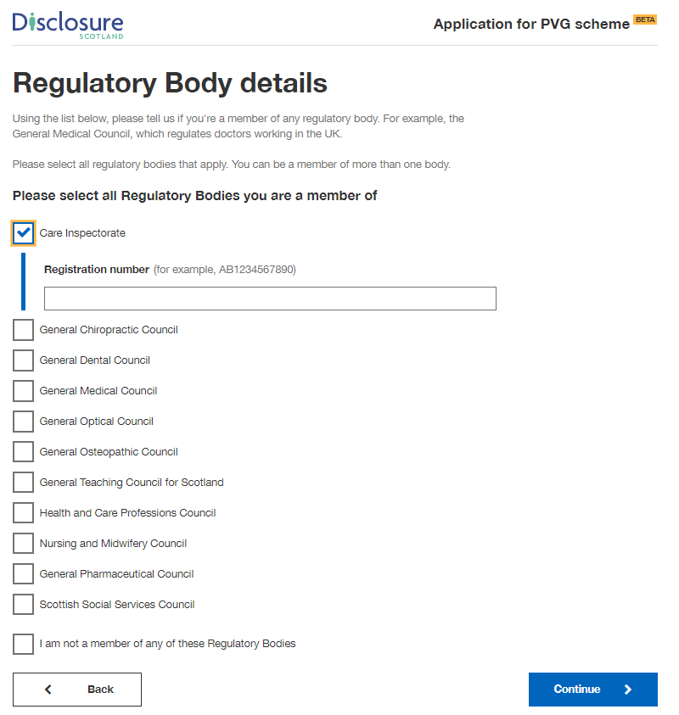

Check your answers

This screen gives you the opportunity to check your answers and make sure they are correct. If you need to change any of your details, change them at this stage by selecting the blue ‘change’ link on the right of the screen.
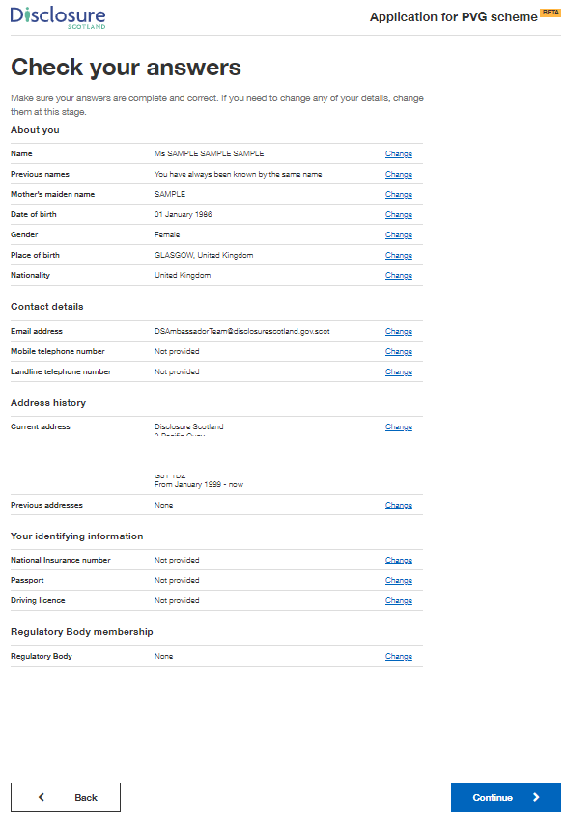

Declaration

This screen is the declaration. By selecting the checkbox you are declaring that the information you have given is complete and correct, and that you understand that to knowingly make a false statement in this application is a criminal offence. You declare that you will give any additional information that may be required to verify the information given and will immediately notify us of any changes to this information.

You need to select the checkbox before you can continue with the application.

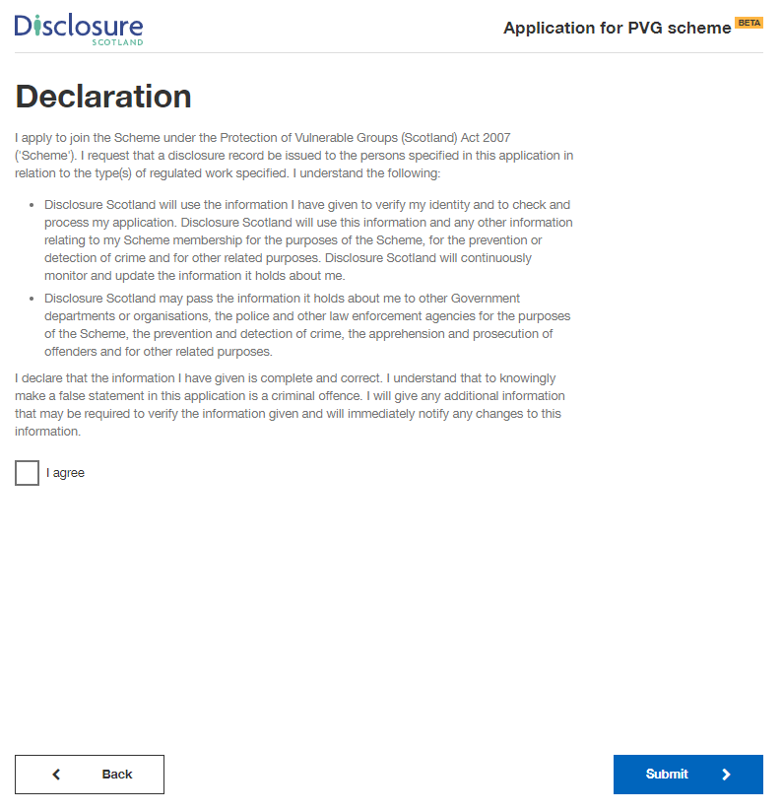

Paying for this application

You will be taken to this screen if your organisation selected the option where you are responsible for paying for the application by card. If not, you will be directed to the page - Thank you for starting this application

This screen explains that payment will be taken through GOV.UK Pay and also has a link to more information on refunds. Selecting ‘continue’ will take you to the GOV.UK pay screen.

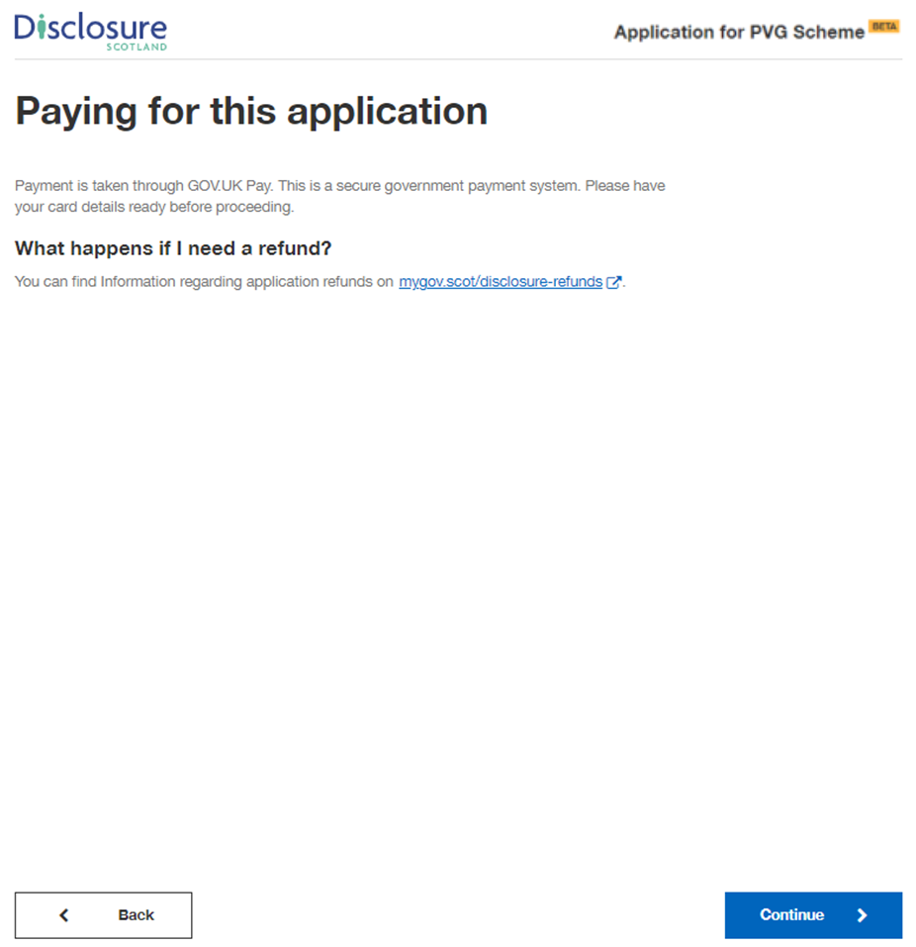

This screen is where you will enter you card details.

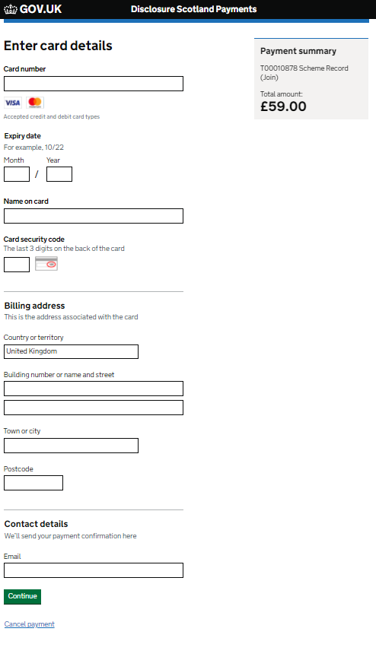
This screen asks you to confirm your payment. Select ‘Confirm payment’ to complete application and payment.

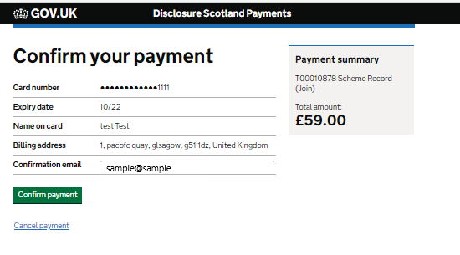

Upon successful payment you will receive a notification to the email address entered on the Disclosure Scotland payment screen.

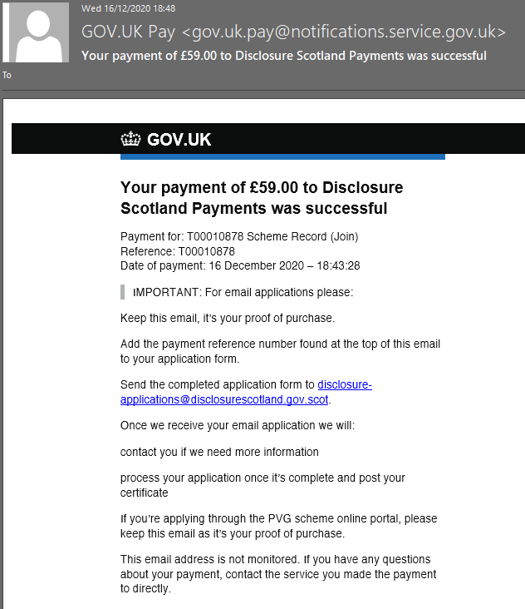

Thank you for your application

This is your confirmation screen. It lets you know you have successfully submitted your application to Disclosure Scotland.

It will show your unique reference number relating to your application. Please take a note of the reference number as it may be needed in the future.

It also explains what happens next and provides contact details for Disclosure Scotland.
There is an opportunity for you to provide feedback on the service.

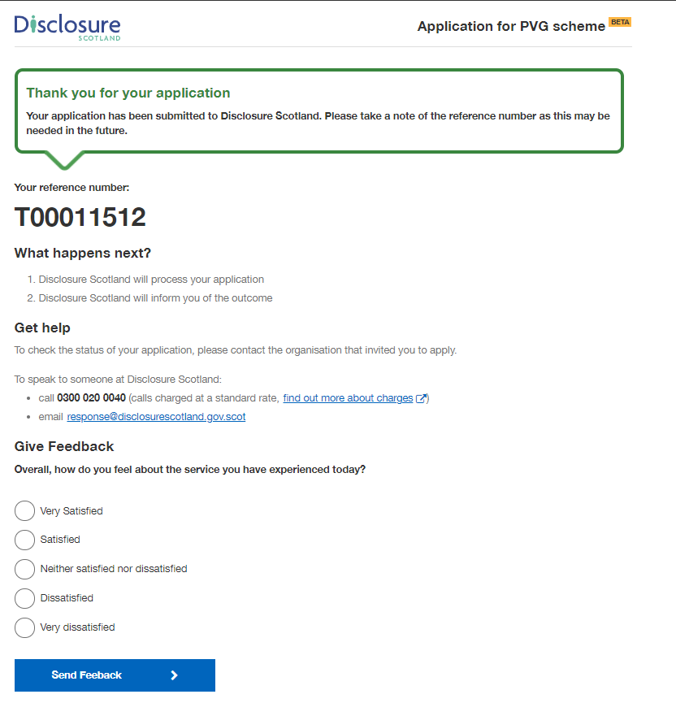

Apply for an Existing Scheme Record

These screenshots show the online application process for applying for a Scheme Record for existing members.

Apply for a Scheme Record

This screen shows the product you are applying for and explains that you will need your PVG scheme number before you start the application.

If you are responsible for paying for the application, there will be additional payment details displayed under the heading ‘paying for this application’.

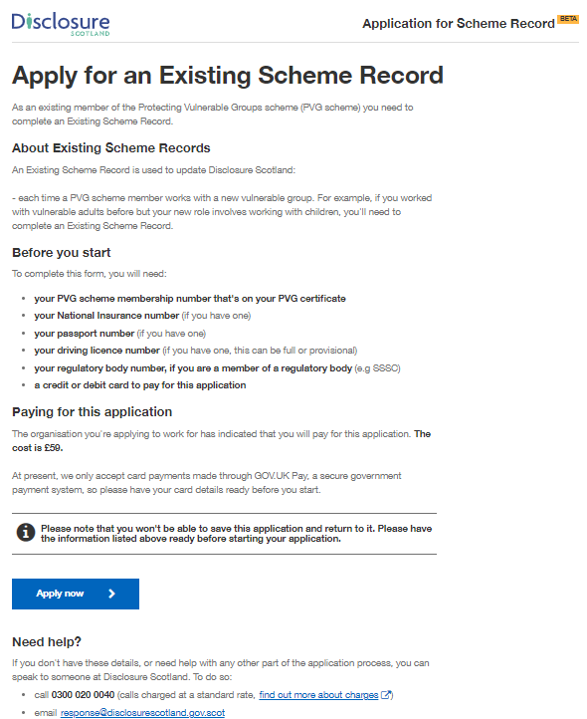

Your personal information

This screen details how Disclosure Scotland will use your personal information. To progress with the application, select the checkbox to give your permission to Disclosure Scotland to keep and share your personal information for the purposes described.

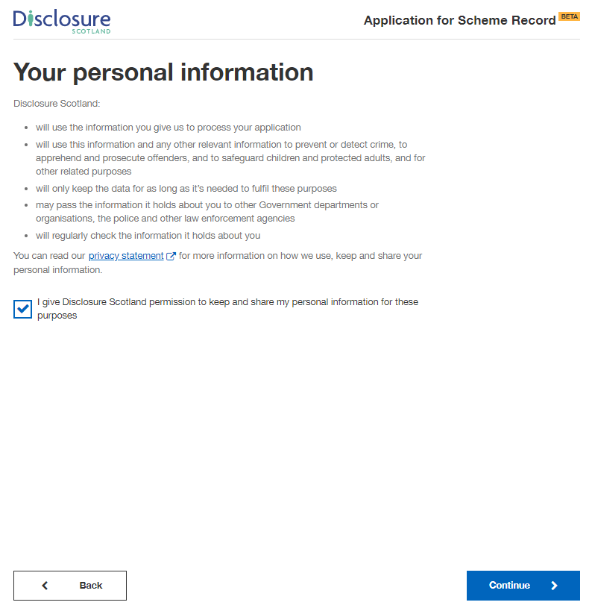

Check application details

This screen will show details of the position that the countersignatory has completed on your behalf.

These details cannot be edited. If these details are incorrect, please contact your countersignatory.
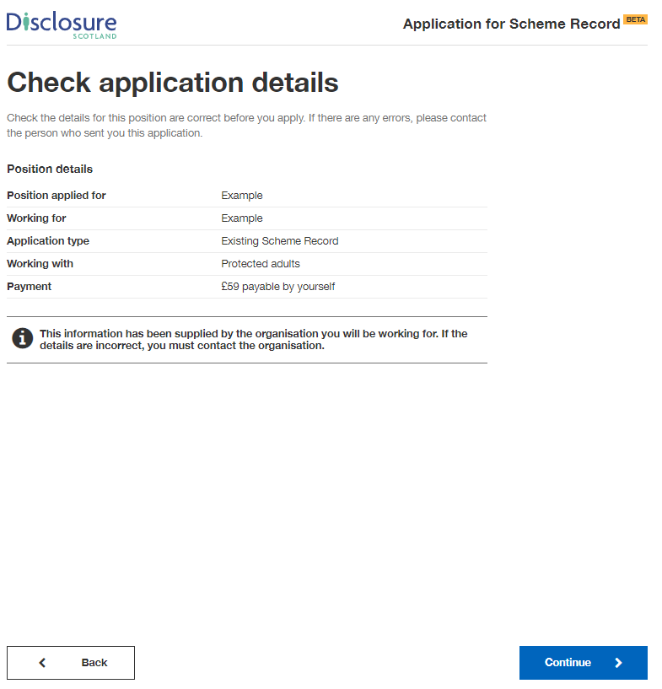

Your PVG scheme number

This screen asks you to enter your PVG scheme number. This can be found on your PVG certificate. It is a 16 digit reference, for example: 1234 5678 1234 5678

If you do not know your number, please contact Disclosure Scotland.

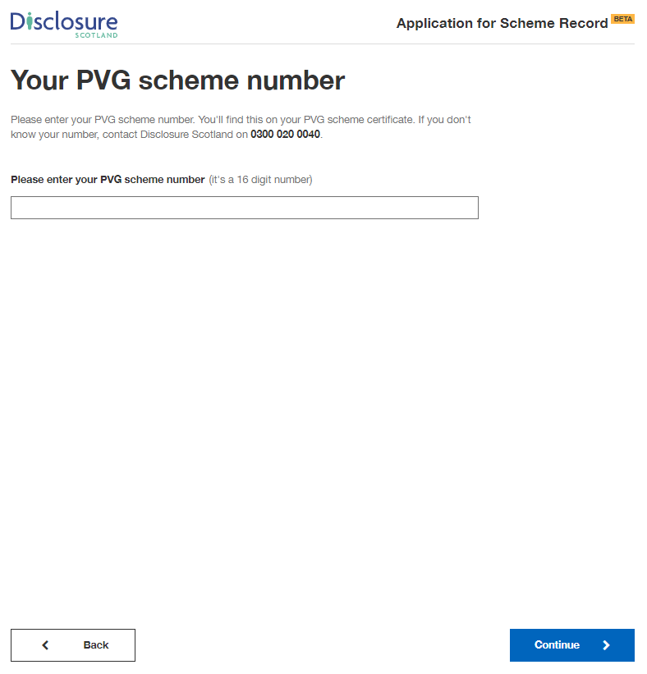

Your full name and previous names

On this screen, please enter your full name including any middle names. Please do not use initials.

If you’re transgender or non-binary and concerned about completing the form, please read the advice on the linked page.
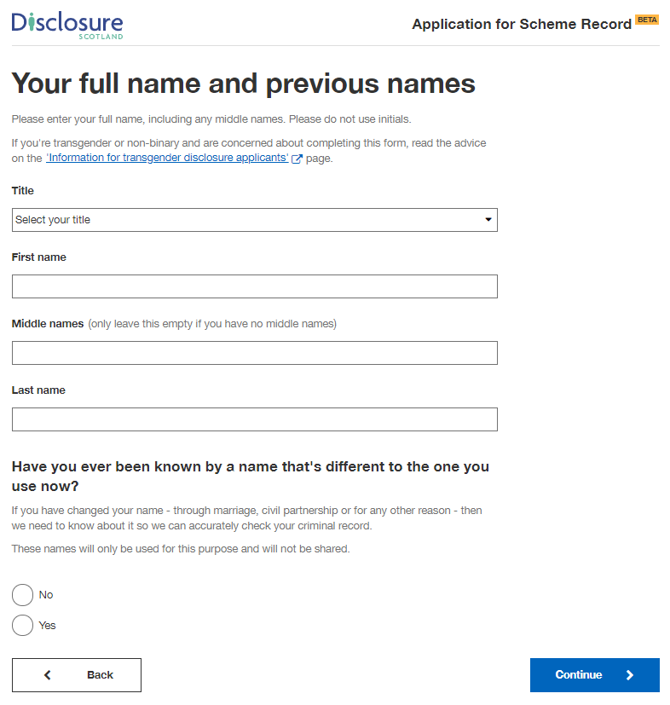

If you were previously known by another name, selecting ‘Yes’ will present additional fields for you to enter these other names.

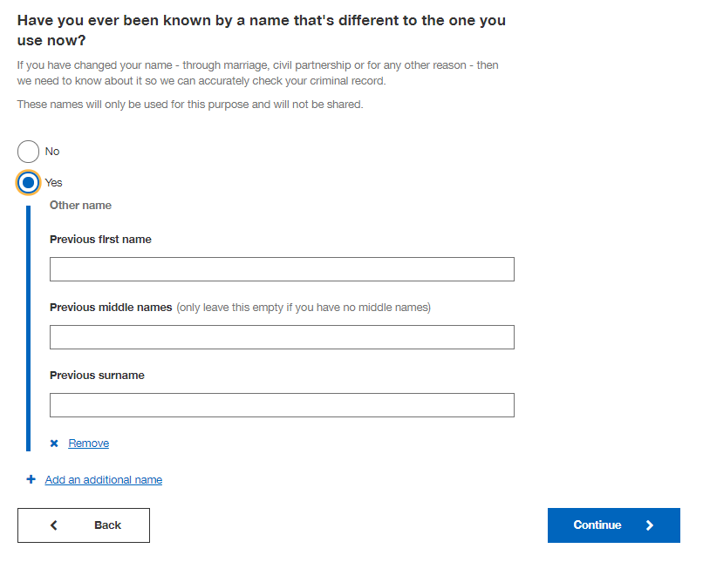

Your date of birth

Enter your date of birth on this screen. If you don’t know your date of birth, use the one on offical documents, such as your passport or driving licence.
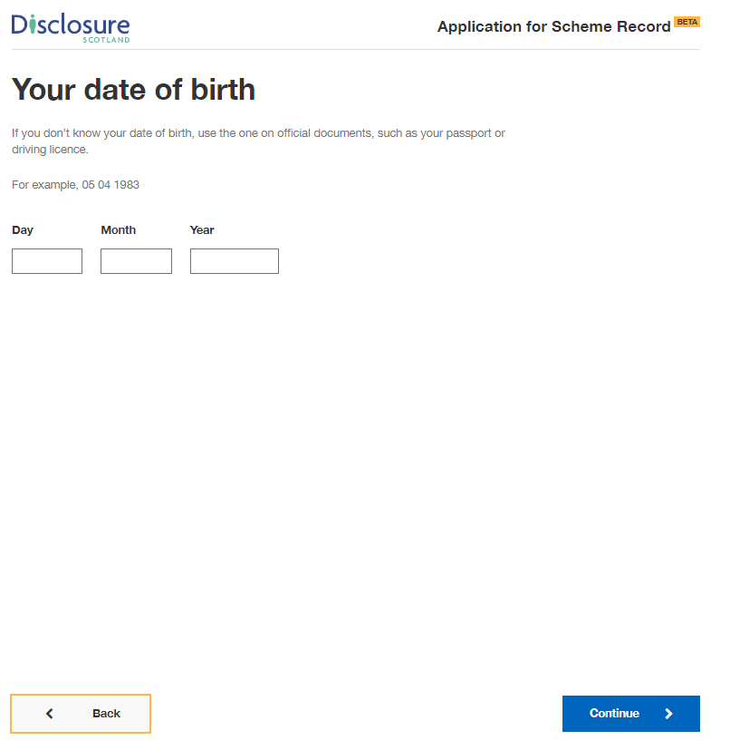

Your contact details

On this screen enter a valid email address and contact telephone numbers.

We may need to contact you to help process your application so please provide as many contact details as you can.

It may slow down your application if you do not provide both an email address and telephone number.

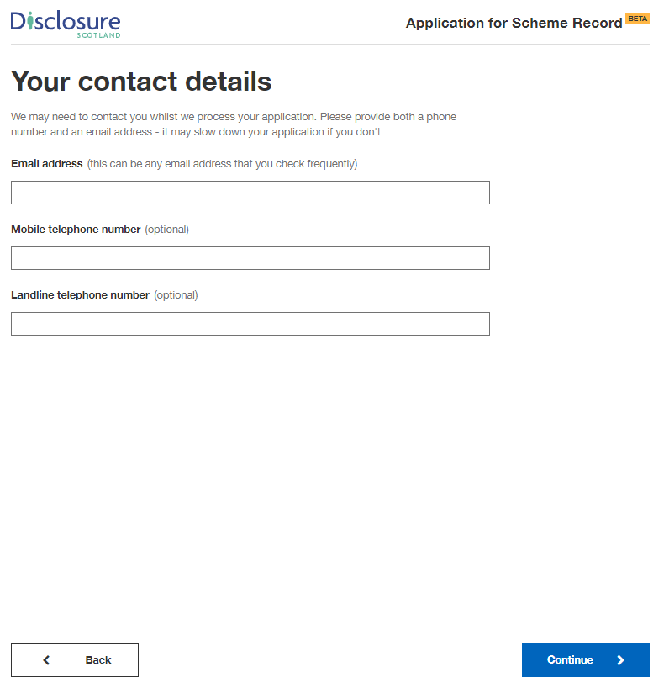

Your current address

Please provide your current address and the month and year you moved there.

You can enter your postcode and select ‘Find UK address’ - this will display a list of addresses in your postcode, select the correct address from the list.

Alternatively, you can select the blue link below and enter your address manually.

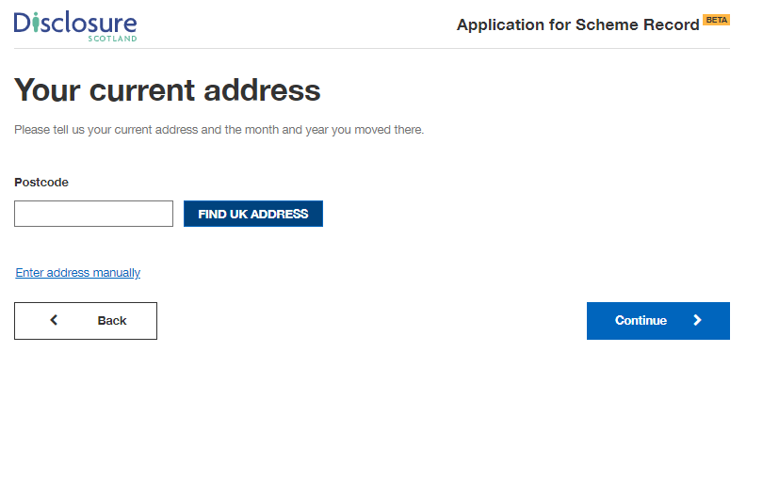

Once you have selected your address or entered it manually, you will be asked
‘When did you move here?’. Enter the month and year your moved to that address.

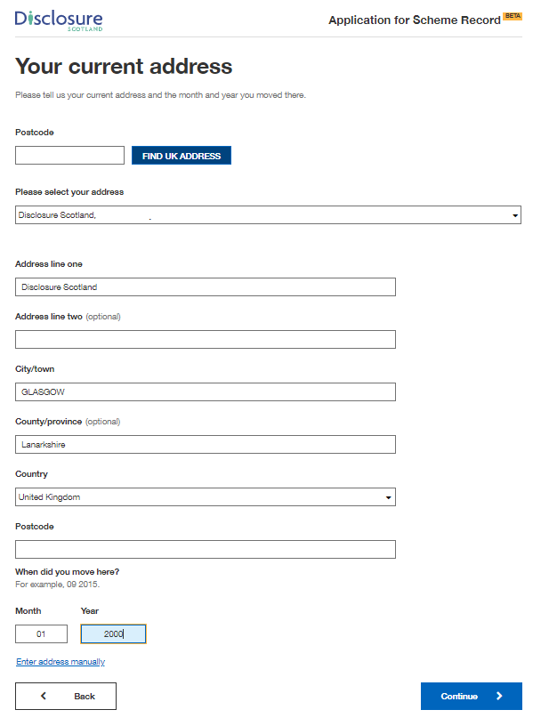

.

National Insurance Number

This screen asks if you have a National Insurance number. Please provide this information if you have it. It will help us progress your application.

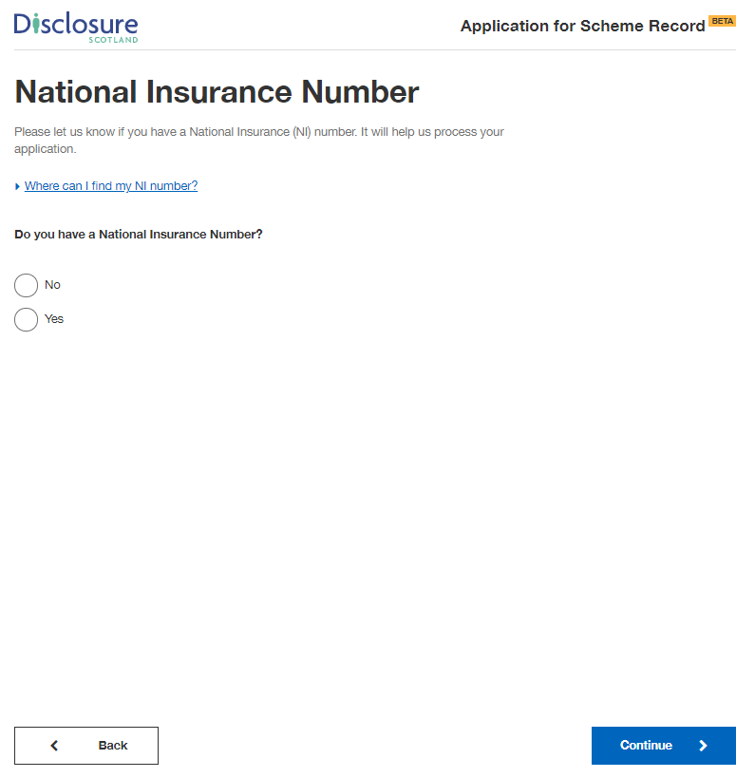
Selecting ‘Yes’ will present a field for you to enter your National Insurance number.

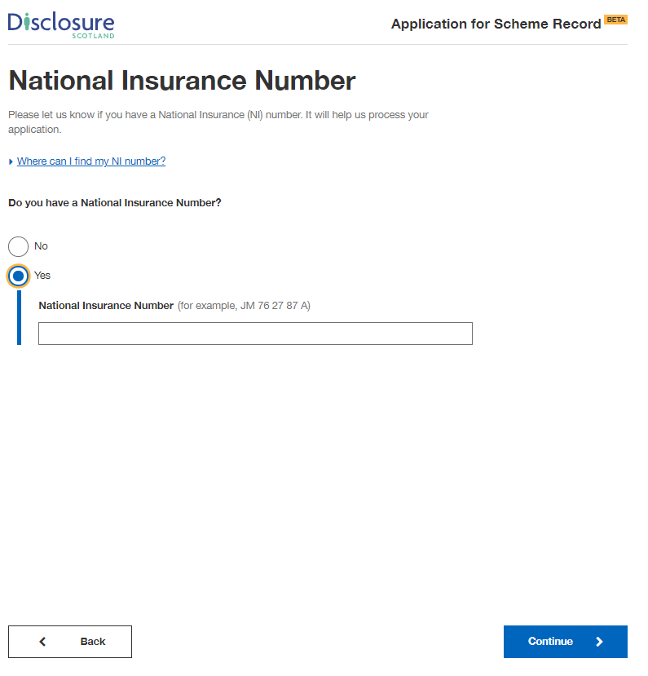

Passport

This screen asks if you have a passport.

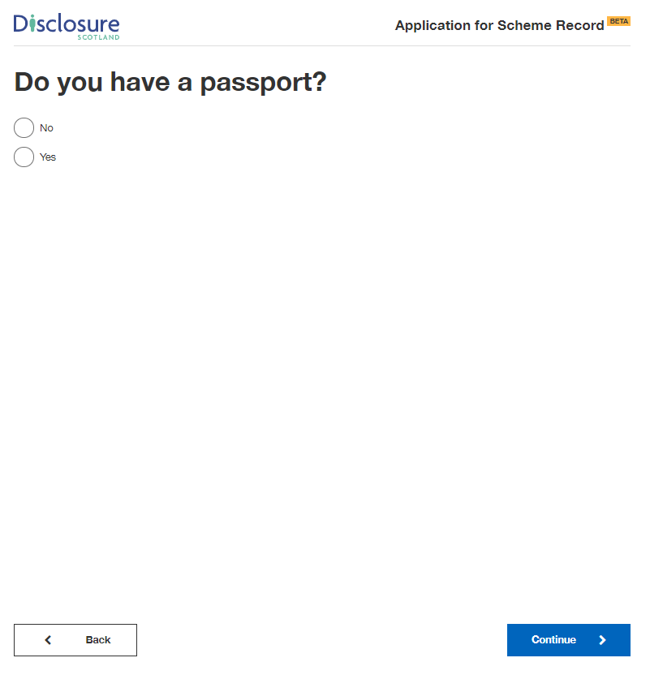

Selecting ‘Yes’ will present a field for you to enter your passport number.

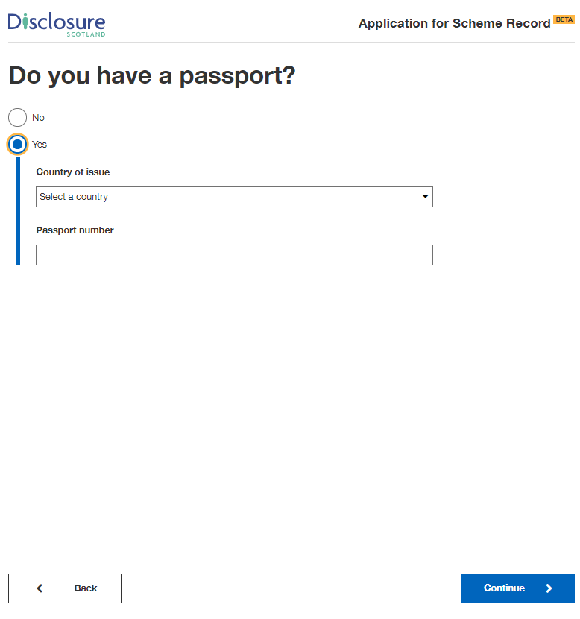

Driving Licence

This screen asks if you have a driving licence.

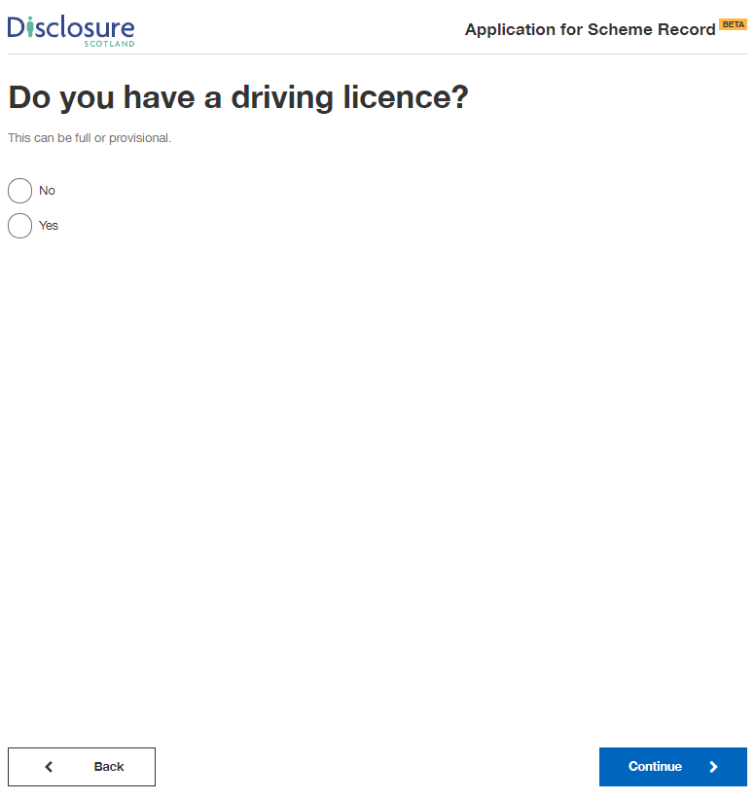

Selecting ‘Yes’ will present a field for you to enter your driving licence number.

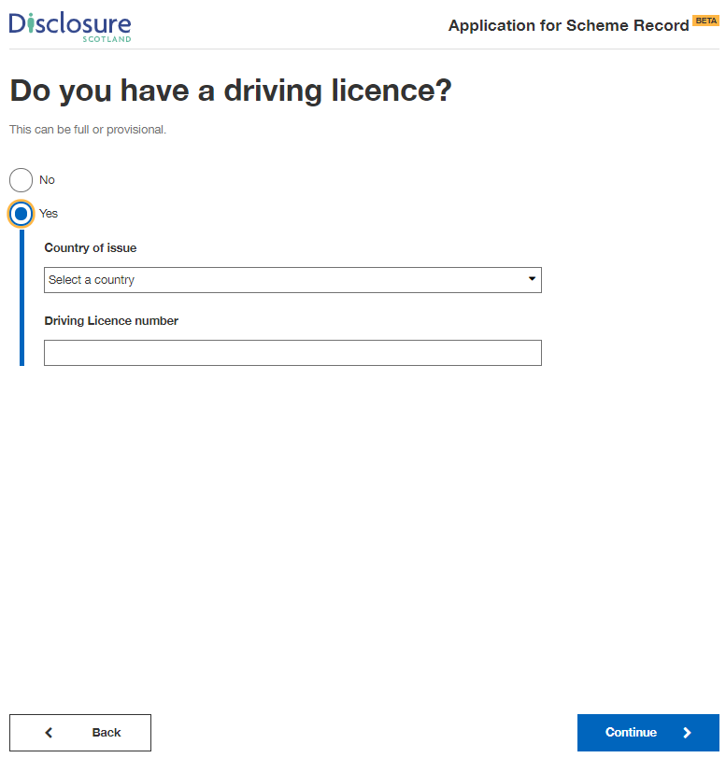

Regulatory body details

This screen asks if you’re a member of any of the regulatory bodies listed.
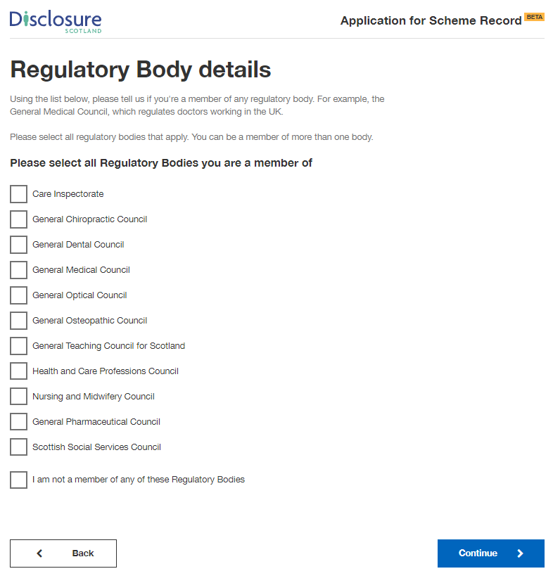

Selecting one of the regulatory bodies will present a field for you to enter your regulatory body registration number.

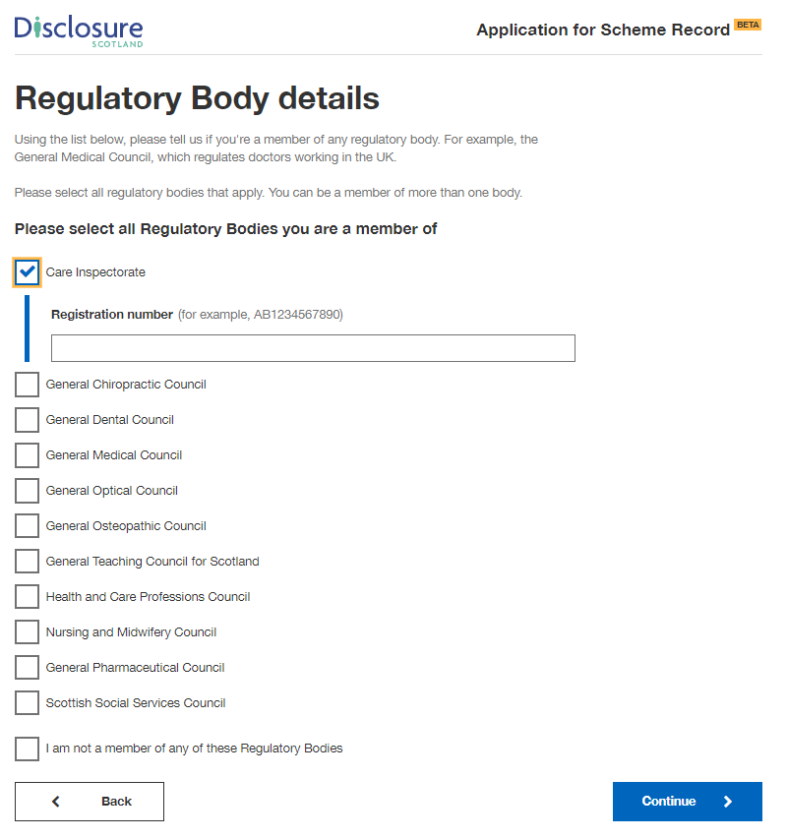

Review your application

This screen gives you the opportunity to check your answers and make sure they are correct. If you need to change any of your details, change them at this stage by selecting the blue ‘change’ link at the right of the screen.
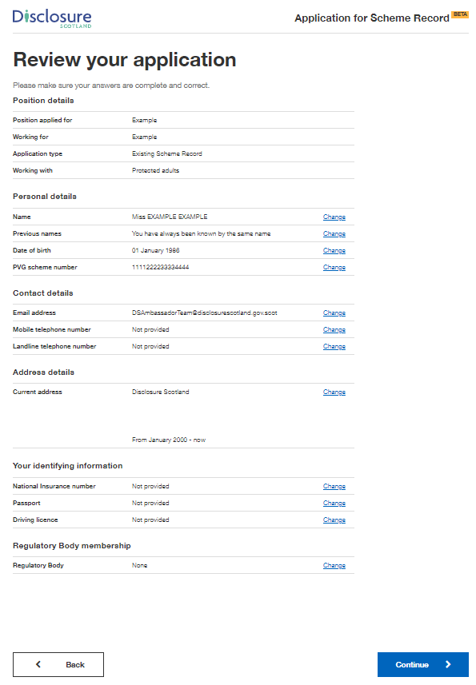

Declaration

This screen is the declaration. By selecting the checkbox, you are declaring that the information you have given is complete and correct, and you understand that to knowingly make a false statement in this application is a criminal offence. You declare that you will give any additional information that may be required to verify the information given and will immediately notify any changes to this information.

You need to select the checkbox before you can continue with the application.

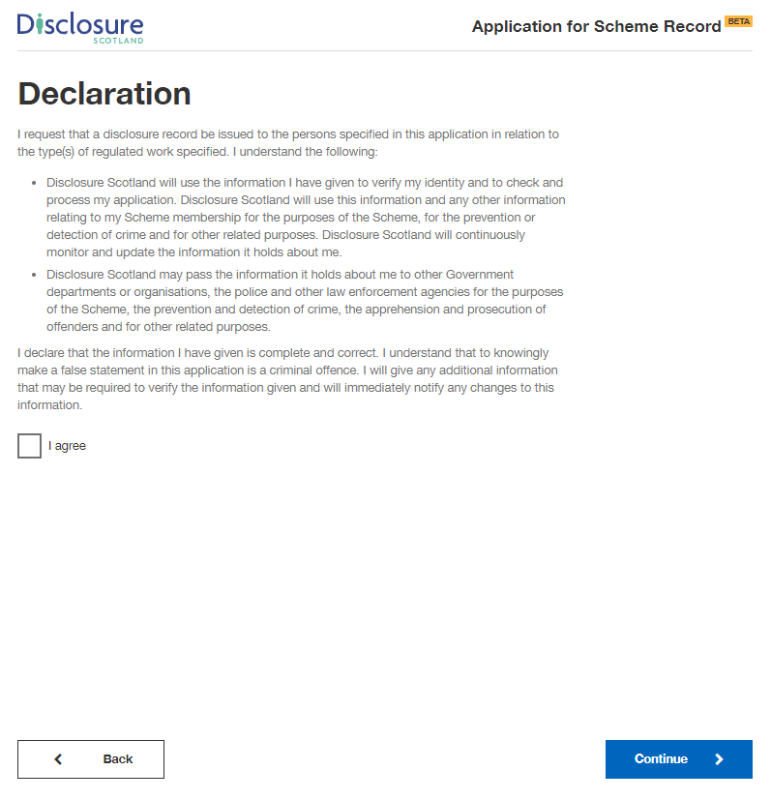

Paying for this application

You will be taken to this screen if your organisation selected the option where you are responsible for paying for the application by card. If not, you will be directed to the page - Thank you for starting this application

This screen explains that payment will be taken through GOV.UK Pay and also has a link to more information on refunds. Selecting ‘continue’ will take you to the GOV.UK pay screen.

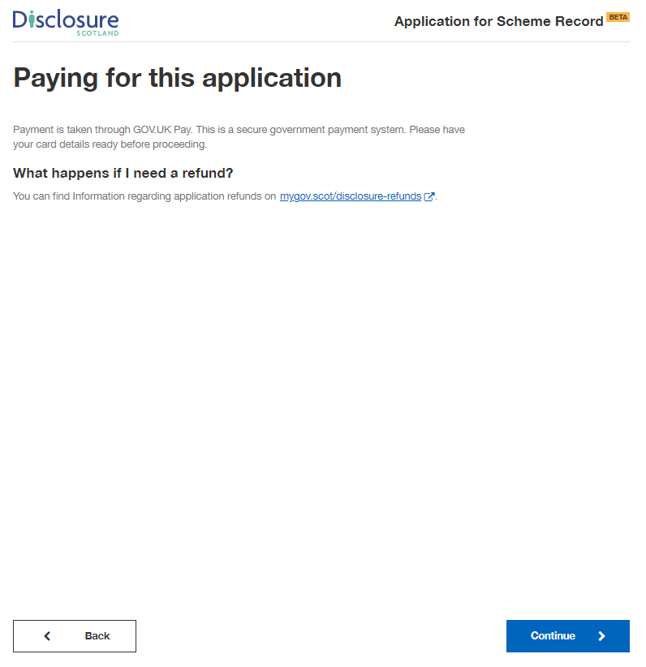

This screen is where you will enter you card details.

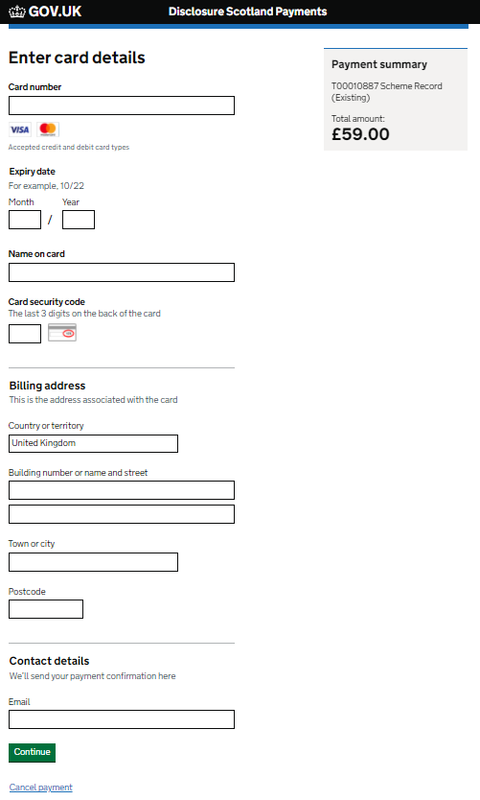

This screen asks you to confirm your payment. Select ‘Confirm payment’ to complete application and payment.

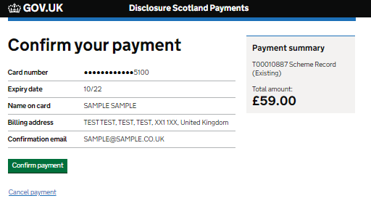

Upon successful payment you will receive a notification to the email address supplied on the Disclosure Scotland payment screen.

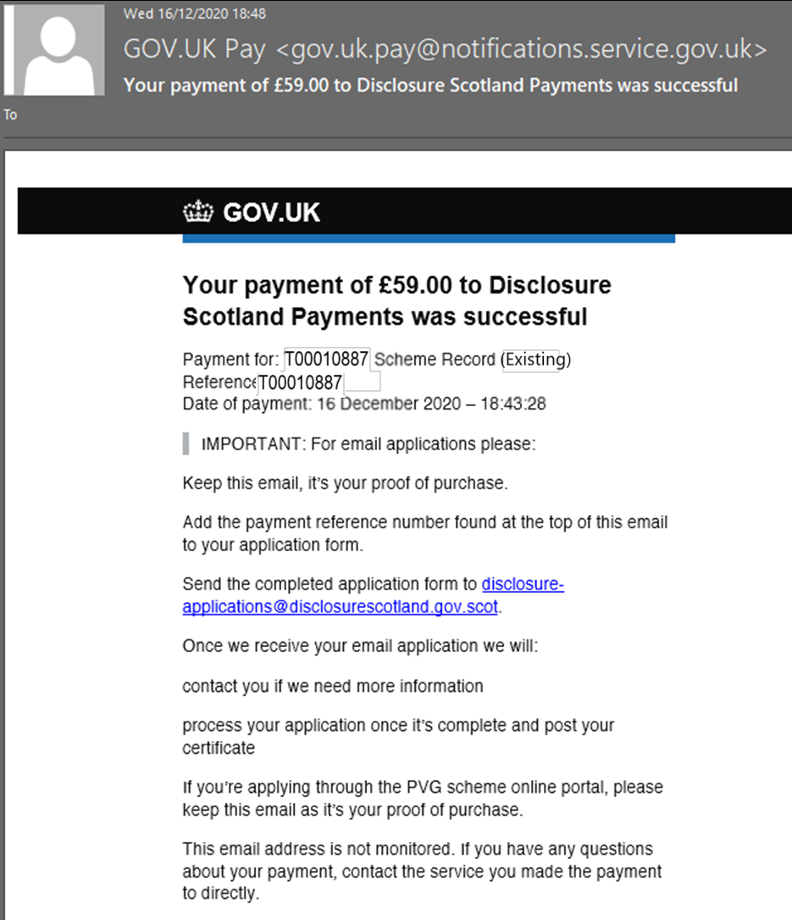

Thank you for your application

This is your confirmation screen. It lets you know that you have successfully submitted your application to Disclosure Scotland.

It will show your unique reference number relating to your application. Please take a note of the reference number as this may be needed in the future.

It also explains what happens next and provides contact details for Disclosure Scotland.

There is an opportunity for you to provide feedback on the service.
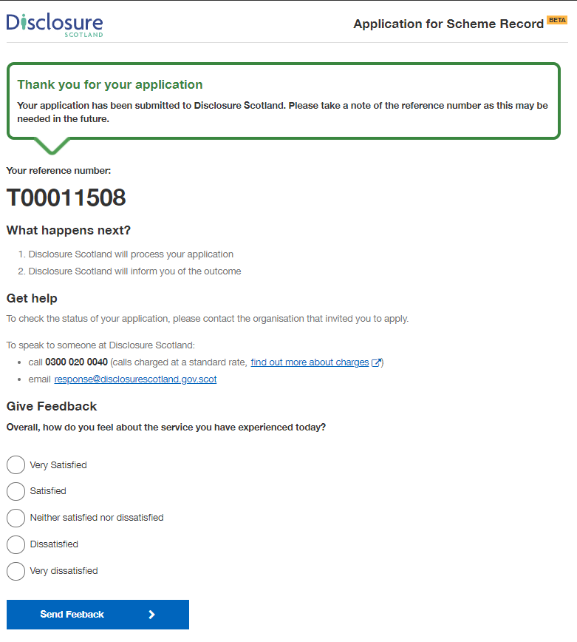

Apply for an Existing Scheme Record Update

These screenshots show the online application process for applying for a Scheme Record Update.

Apply for a Scheme Record update

This screen shows what product you are applying for and explains that you will need your PVG scheme number before you start the application.

If you are responsible for paying for the application, there will be additional payment details displayed under the heading ‘paying for this application’.

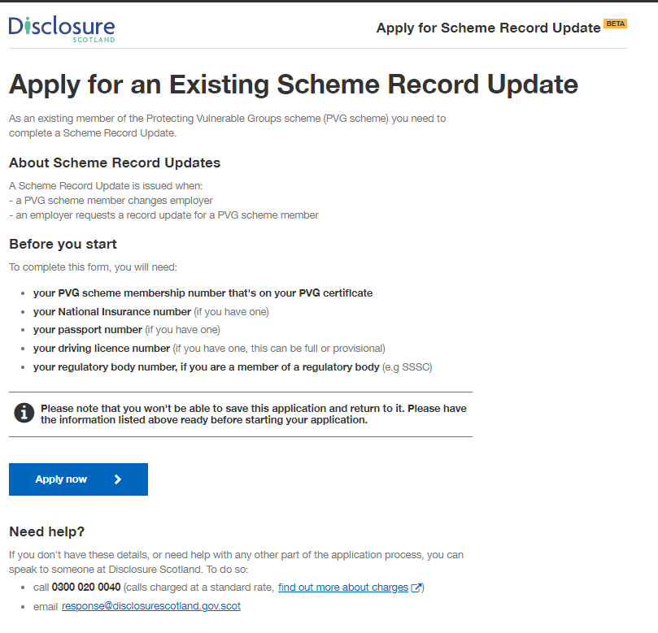

Your personal information

This screen details how Disclosure Scotland will use your personal information. To progress with the application, you need to select the checkbox to give your permission to Disclosure Scotland to keep and share your personal information for the purposes described.

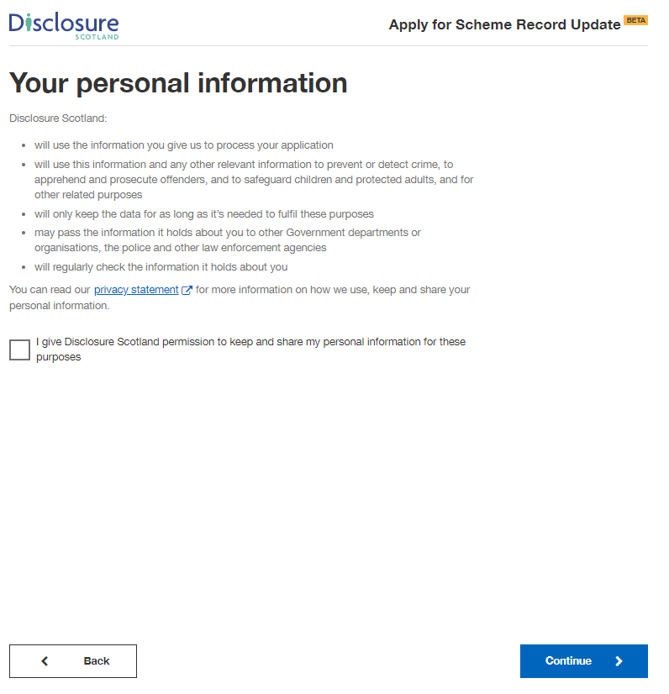

Check application details

This screen will show you the details of the position that the countersignatory has completed on your behalf.

These details cannot be edited. If these details are incorrect, please contact your countersignatory.

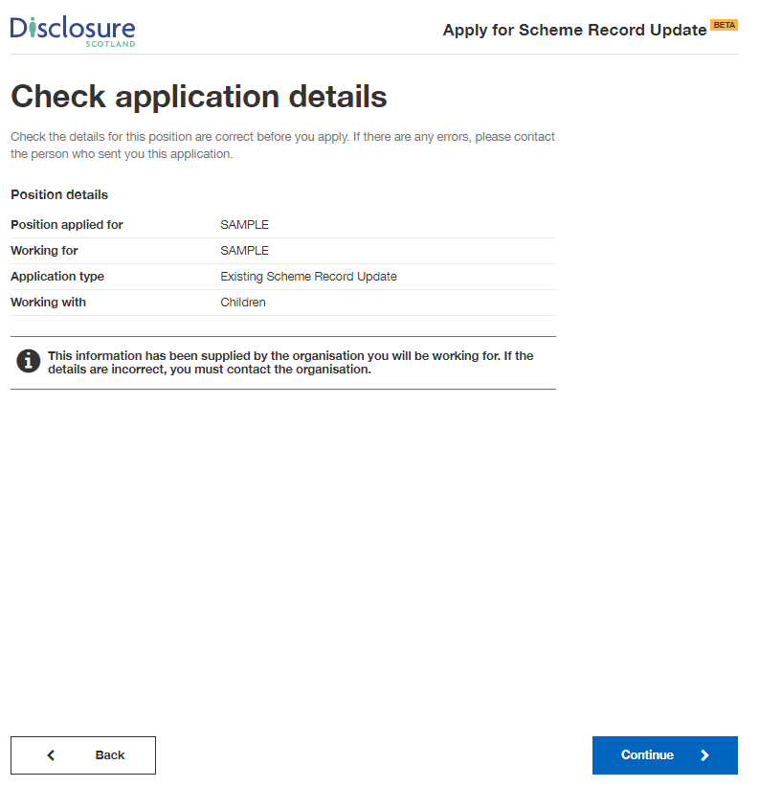

Your PVG scheme number

On this screen it asks you to enter your PVG scheme number. This can be found on your PVG certificate. It is a 16 digit reference, for example: 1234 5678 1234 5678

If you do not know your number, please contact Disclosure Scotland.

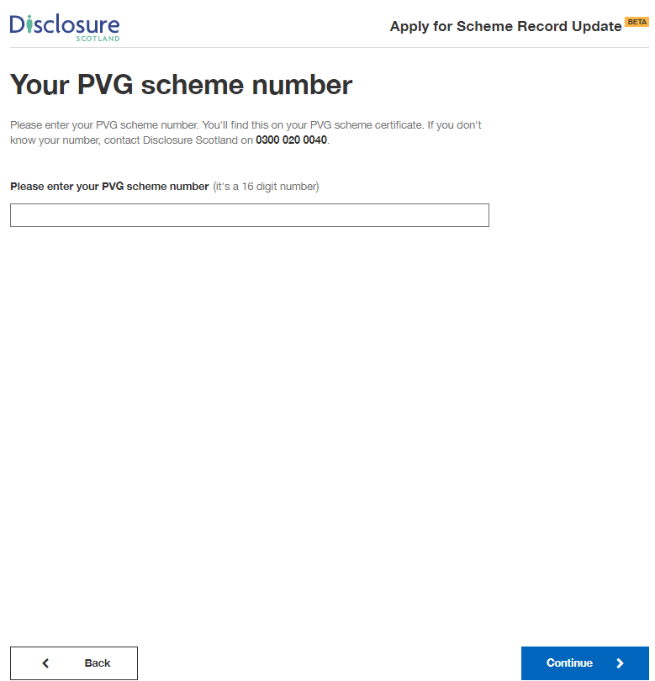

Your full name and previous names

On this screen, please enter your full name including any middle names. Please do not use initials.

If you’re transgender or non-binary, and concerned about completing the form, please read the advice on the linked page.

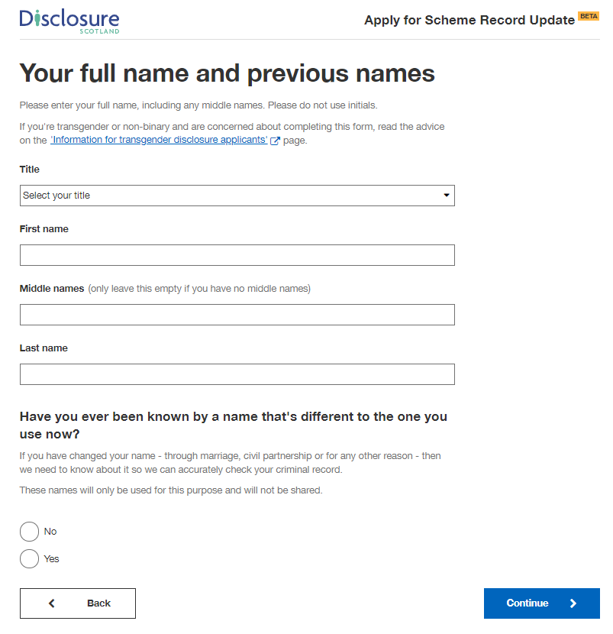

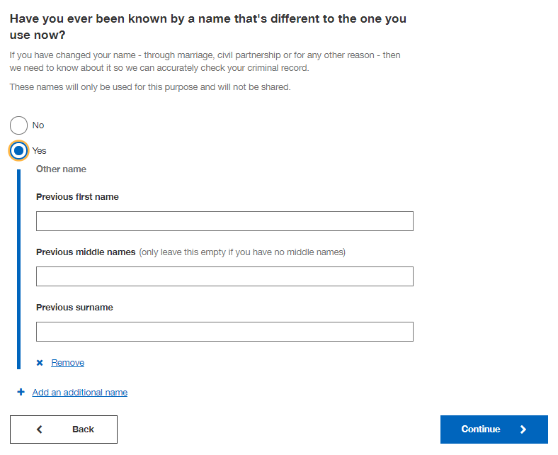

Your date of birth

Enter your date of birth on this screen. If you don’t know your date of birth, use the one on offical documents, such as your passport or driving licence.

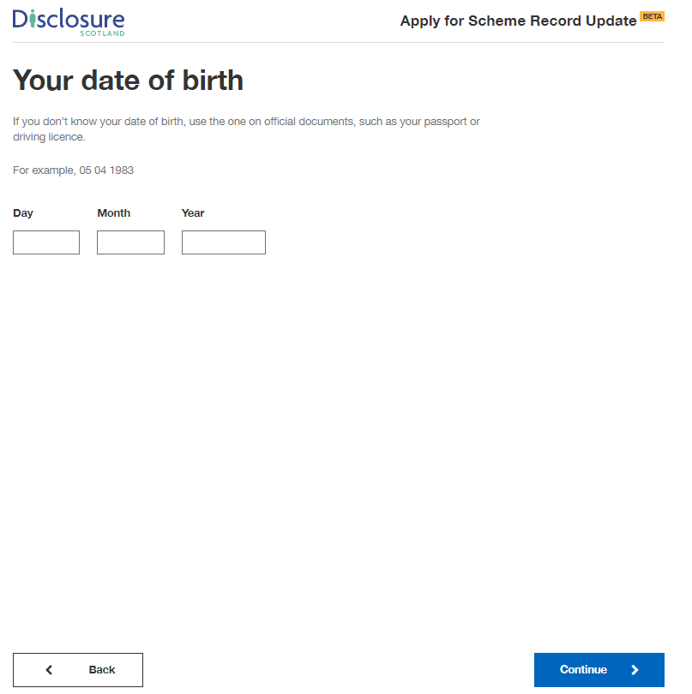

Your contact details

On this screen enter a valid email address and contact telephone numbers.

We may need to contact you to help process your application so please provide as many contact details as you can.

It may slow down your application if you do not provide both an email address and telephone number.

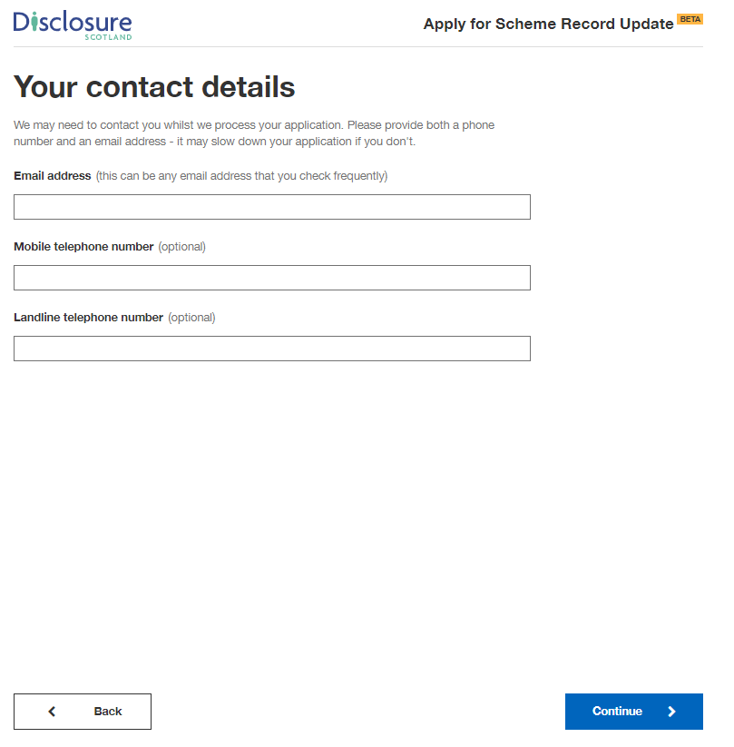
Your current address

Please provide your current address and the month and year you moved there.

You can enter your postcode and select ‘Find UK address’ - this will display a list of addresses in your postcode, select the correct address from the list.

Alternatively, you can select the blue link below and enter your address manually.

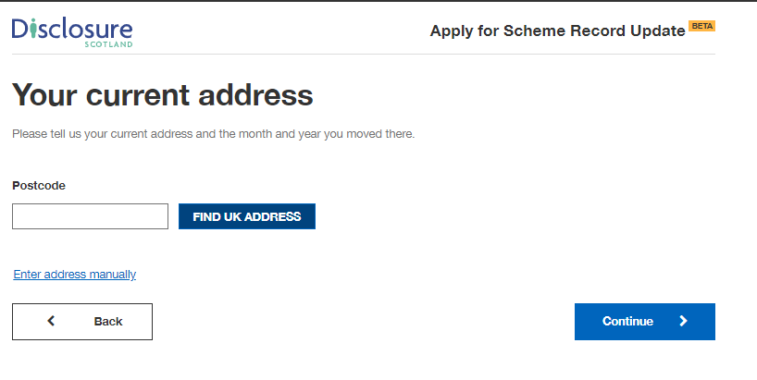
Once you have selected your address or entered it manually, you will be asked
‘When did you move here?’. Enter the month and year your moved to that address.

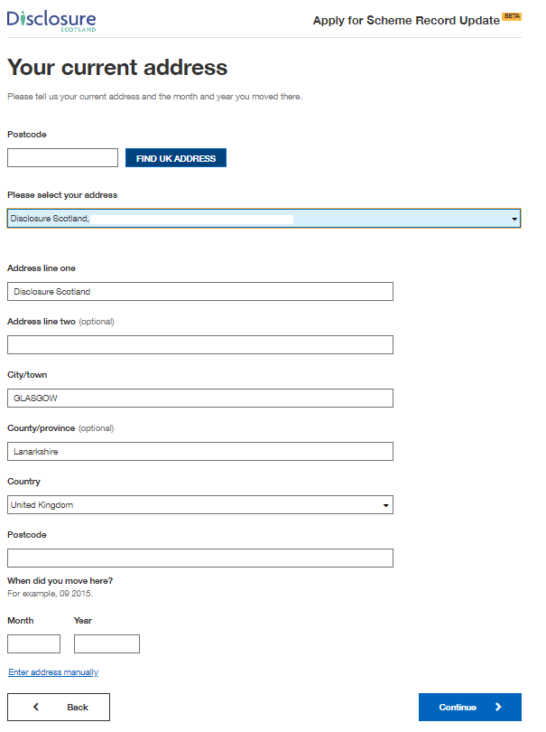

National Insurance Number

This screen asks if you have a National Insurance number. Please provide this information if you have it. It will help us progress your application.

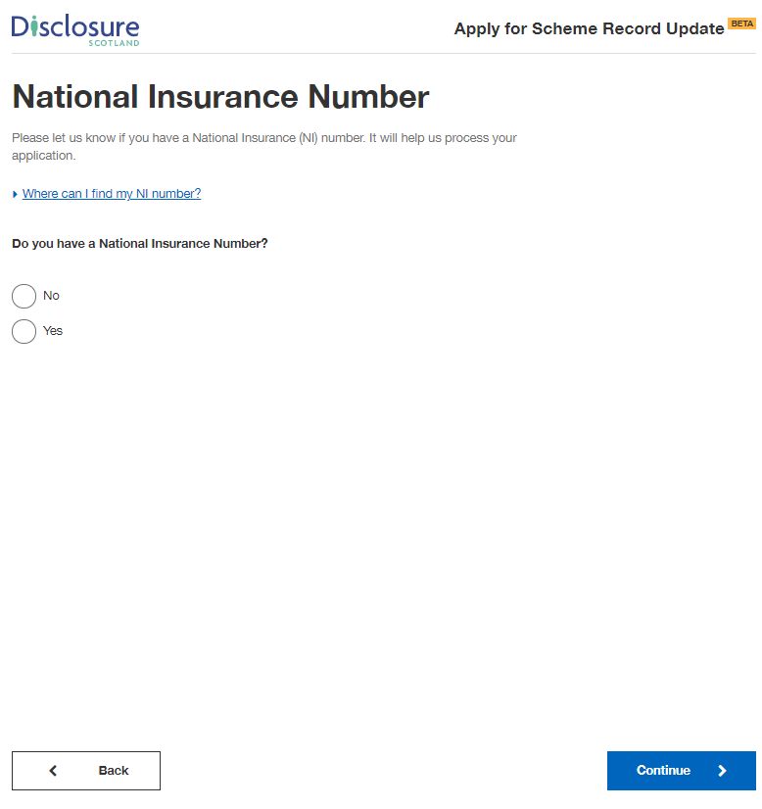

Selecting ‘Yes’ will present a field for you to enter your National Insurance number.

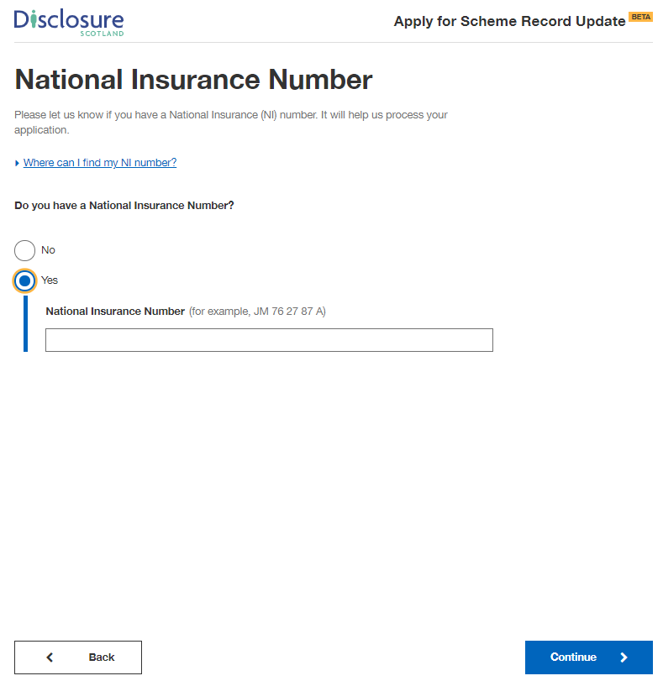

Passport

This screen asks if you have a passport.

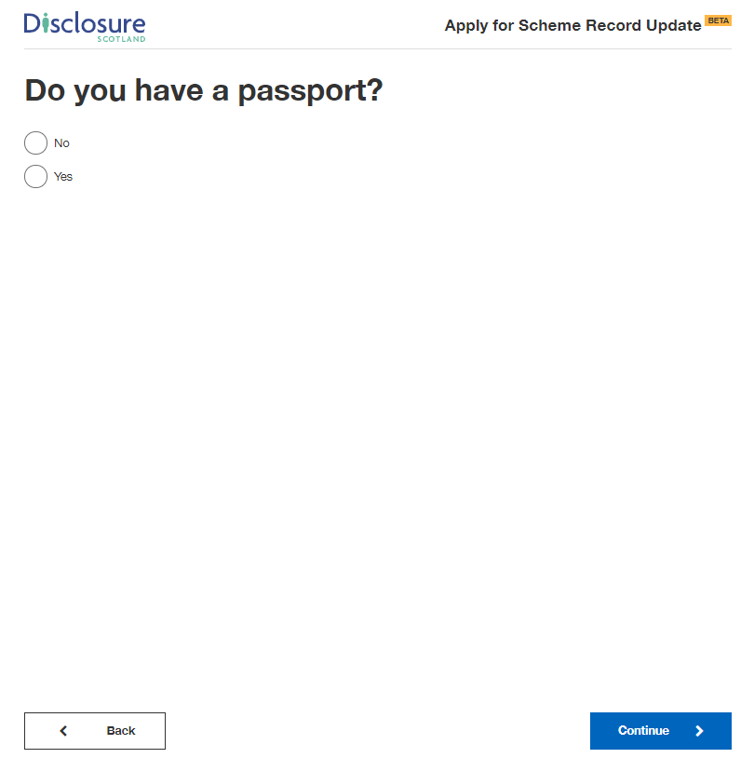

Selecting ‘Yes’ will present a field for you to enter your passport number.

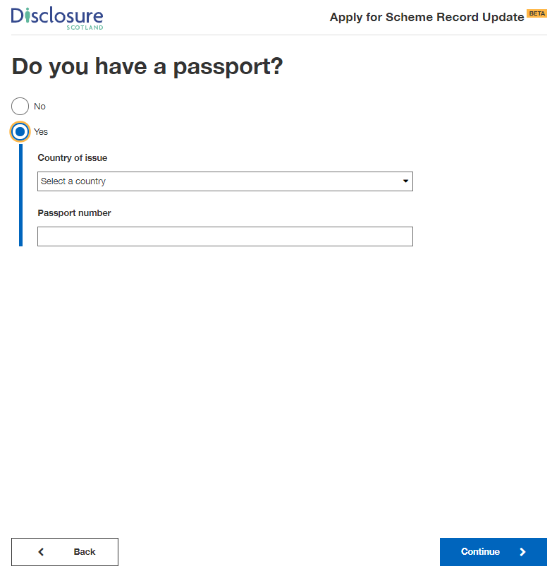

Driving Licence

This screen asks if you have a driving licence.

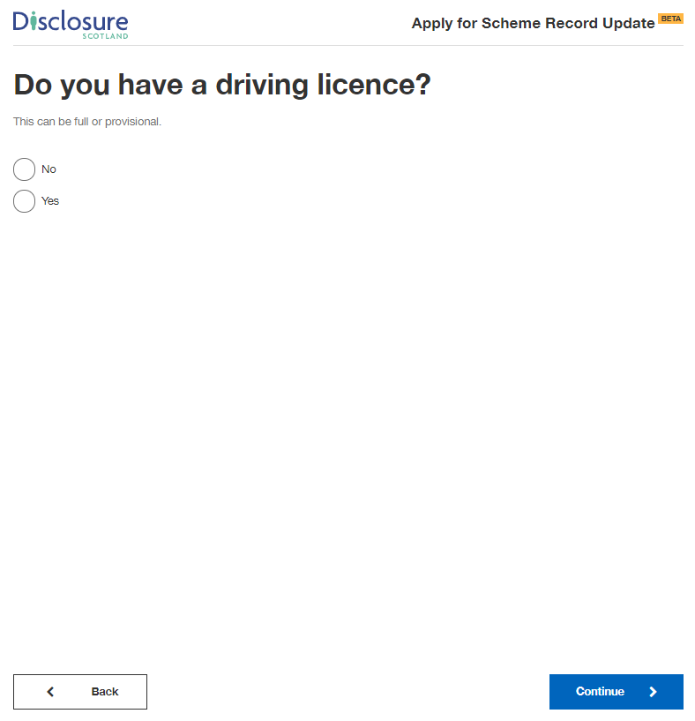

Selecting ‘Yes’ will present a field for you to enter your driving licence number.

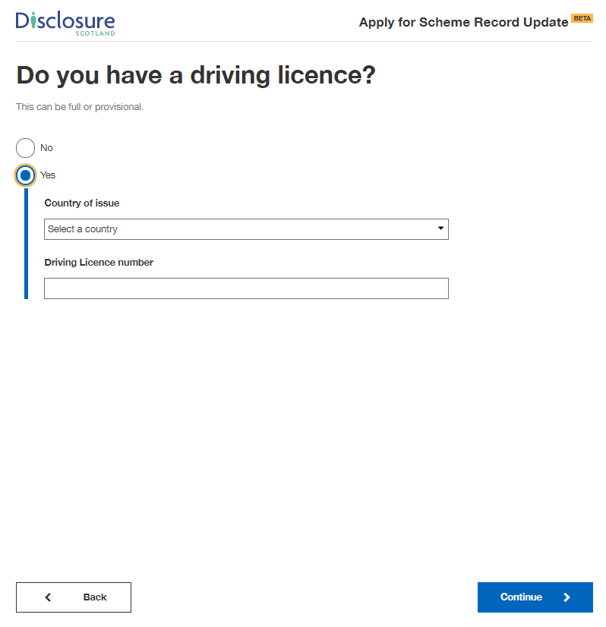

Regulatory body details

This screen asks if you’re a member of any of the regulatory bodies listed.
.

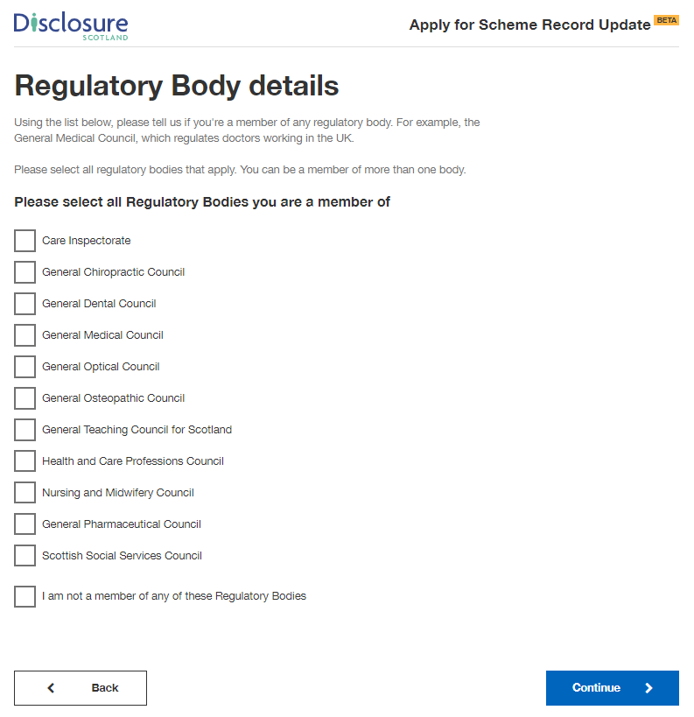

Selecting one of the regulatory bodies will present a field for you to enter your regulatory body registration number.

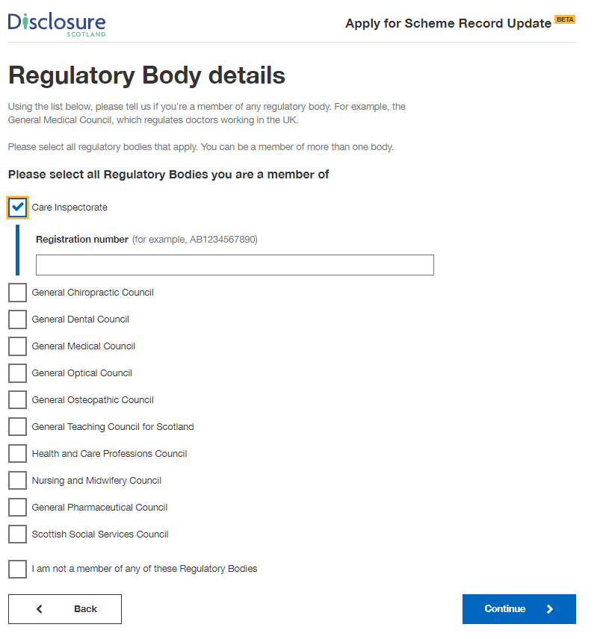

Review your application

This screen gives you the opportunity to check your answers and make sure they are correct. If you need to change any of your details, change them at this stage by selecting the blue ‘change’ link at the right of the screen.

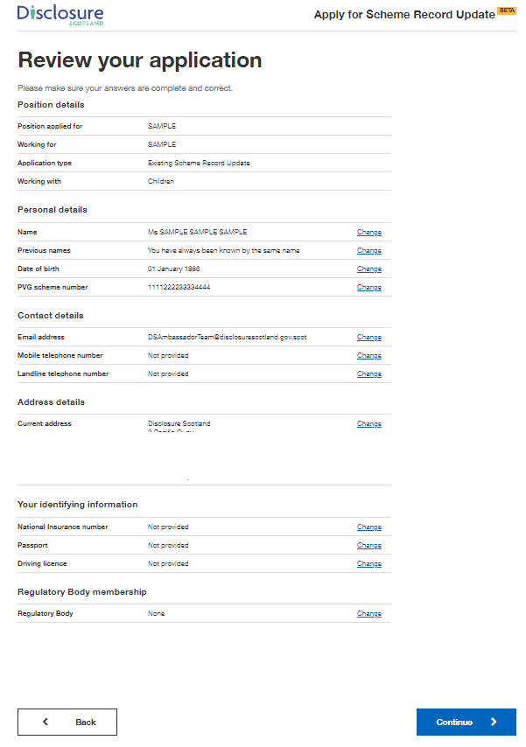

Declaration

This screen is the declaration. By selecting the checkbox you are declaring that the information you have given is complete and correct, and you understand that to knowingly make a false statement in this application is a criminal offence. You are declaring that you will give any additional information that may be required to verify the information given and will immediately notify any changes to this information.

You need to select the checkbox before you can continue with the application.

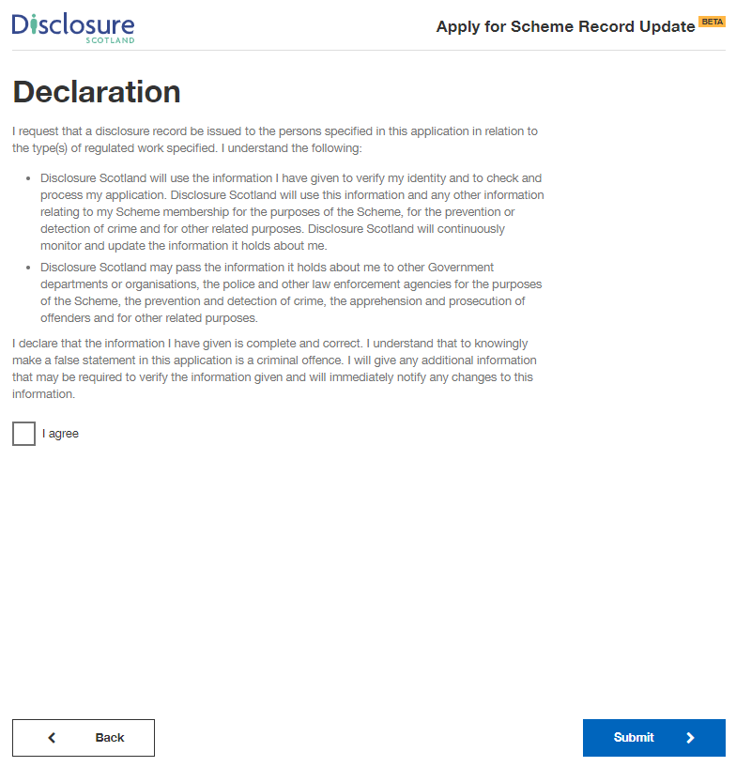

Paying for this application

You will be taken to this screen if your organisation selected the option where you are responsible for paying for the application by card. If not, you will be directed to the page - Thank you for starting this application

This screen explains that payment will be taken through GOV.UK Pay and also has a link to further information on refunds. Selecting ‘continue’ will take you to the GOV.UK pay screen.

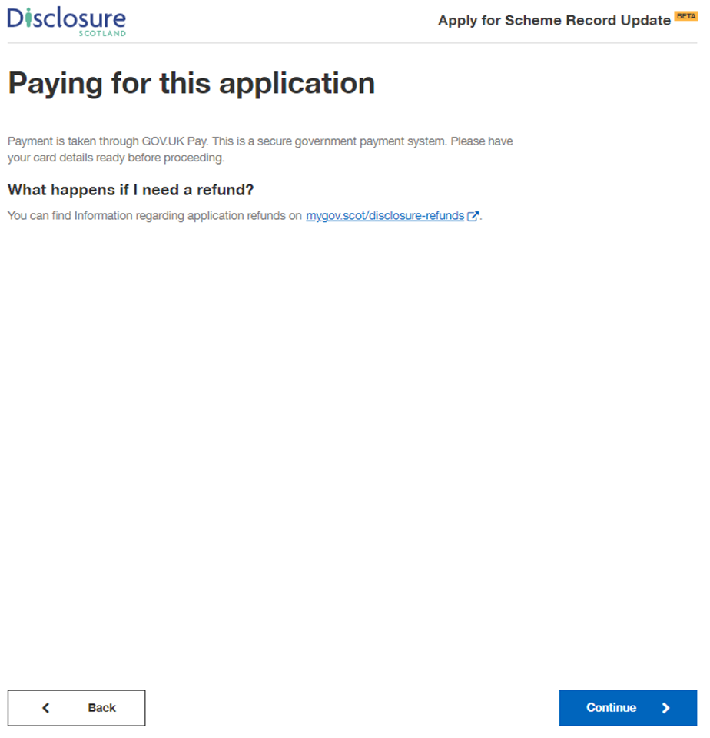

This screen is where you will enter you card details.

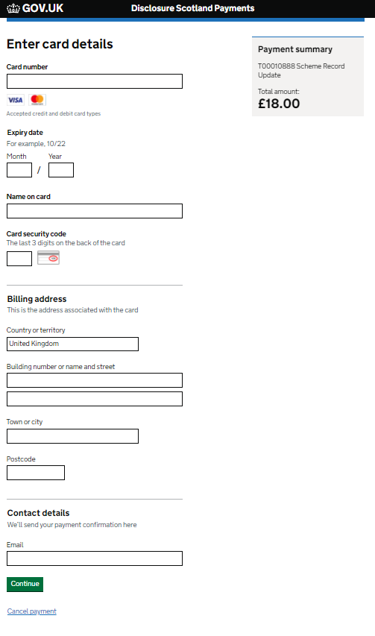

This screen asks you to confirm your payment. Select ‘Confirm payment’ to complete application and payment.

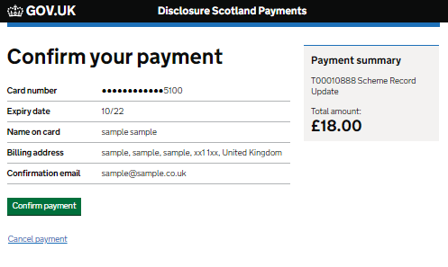

Upon successful payment you will receive a notification to the email address entered on the Disclosure Scotland payment screen.

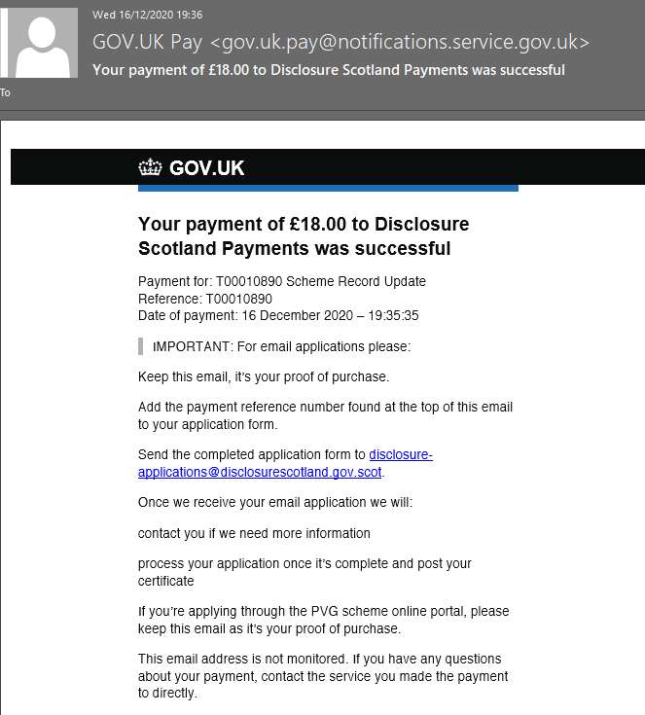

Thank you for your application

This is your confirmation screen. It lets you know you have successfully submitted your application to Disclosure Scotland.

It will show your unique reference number relating to your application. Please take a note of the reference number as this may be needed in the future.

It also explains what happens next and provides you with contact details for Disclosure Scotland.
There is an opportunity for you to provide feedback on the service.

