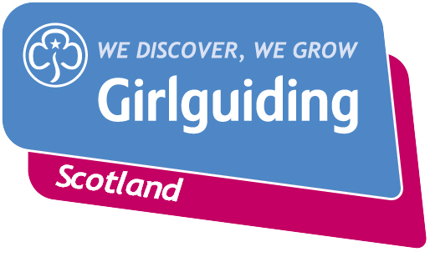
Press Release
FOR IMMEDIATE RELEASE / EMBARGOED (insert date article can be published)
<Insert date you send the release out: for example – 12 May 2021>

<Insert Girlguiding County/District/Division> CELEBRATES VOLUNTEERS’ WEEK: A TIME TO SAY THANK YOU
<Insert Girlguiding County/District/Division> celebrates Volunteers’ Week and all the amazing things local Girlguiding members have done for their community.
2021 marks the 37th year of Volunteers’ Week (1-7 June), when <insert Girlguiding County/District/Division> will join thousands of charities and voluntary organisations recognising the contribution volunteers make across Scotland and thanking them for all they do.
The contribution of volunteers is often unseen and unrecognised by many, visible only through the incredible impact of their volunteering. However, the coronavirus pandemic has rightly raised the profile of volunteering and more people than ever are aware of the immense contribution being made every single day by volunteers across Scotland.
This Volunteers’ Week <insert Girlguiding County/District/Division> will be thanking and celebrating their <insert number> volunteers, by <include a short description of your event/plans>
<Insert a quote from a relevant person – this could be a CC, DC, young member> e.g. County Commissioner, Jane Smith said: “Volunteers' Week is a chance to celebrate and recognise the fantastic contribution our volunteers make. Thanks to them Girlguiding xxx has benefited from….”
Volunteers’ Week is a time to thank volunteers for the support they provide each year. As guiding groups adapt to the new Coronavirus restrictions, the charity’s volunteers are committed to deliver guiding in new and innovative ways so that they can continue to keep connected and empower girls and young women. The pandemic has changed volunteering and the charity is also proud to recognise those who have been unable to volunteer, or volunteer as regularly, and looks forward to welcoming them back.
<Insert Girlguiding County/District/Division> is currently looking for support from local heroes to make a meaningful impact in the lives of girls and young women to help them to grow their confidence, develop their voice and have fun and adventure. Anyone can get involved in guiding, whether or not they’ve previously been a member, and with a variety of volunteer roles to choose from people can give the time that suits them.
If you’re interested in becoming a volunteer or know a girl who would like to join guiding, please visit www.girlguidingscotland.org.uk/get-involved/ to find out how to get involved.
- ENDS –

Attached is an image of <description of photo e.g. girl with a badge, a screen shot of your video call, a photo of the activity>

For further information, please contact <Name, role, on 077 123 4567 or by email at xxxxxx>

Notes to editors:

About <insert name of County/District/Division>
<insert about>
About Girlguiding Scotland:
Girlguiding Scotland is the leading charity for girls and young women in Scotland, with 45,000 young members. We build girls’ confidence and raise their aspirations. We give them the chance to discover their full potential and encourage them to be a powerful force for good. We give them a space to have fun. Find out more at www.girlguidingscotland.org.uk

Reaction to COVID-19:

The delivery of face to face and virtual youth work by Girlguiding is determined by and in compliance with Scottish Government guidelines. More information can be found here: https://www.girlguiding.org.uk/making-guiding-happen/coronavirus-keeping-safe/

About Volunteers’ Week:
Volunteers’ Week is an annual campaign, which takes place every year 1-7 June. Charities across the UK will hold events to thank their volunteers. To find out more about volunteering in Scotland visit www.volunteerscotland.net

