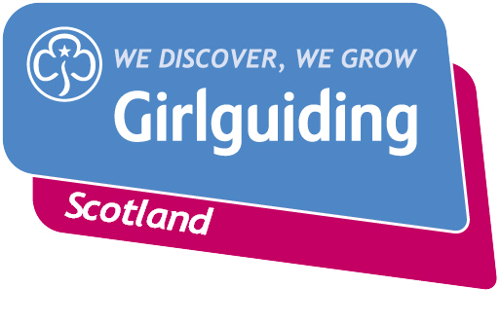
Press Release
FOR IMMEDIATE RELEASE / EMBARGOED (insert date article can be published)
<Insert date you send the release out: for example – 23 March 2020>

<Insert hometown / area eg.> SEEKS NEW VOLUNTEERS TO DELIVER VIRTUAL GUIDING

Girlguiding <insert county>, the leading charity for girls and young women, is actively seeking volunteers who can support online guiding and a return to face to face guiding in the longer term.
As guiding groups adapt to the new Coronavirus restrictions, the charity’s volunteers are committed to deliver guiding in new and innovative ways so that they can continue to keep connected and empower girls and young women. Many groups continue to meet online, following a move to virtual guiding after face to face meetings were suspended during lockdown.
Determined to carry on guiding during this challenging time, guiding groups such as the <insert unit name>, continue to stay connected over summer through a <weekly/fortnightly/monthly video call/virtual camp/first face to face outdoor meeting> with <insert number> of girls/young women taking part.
The group <insert details of what they do/did>.
<Insert name>, <Insert age>, from <Insert area>, said: QUOTE FROM GIRL e.g. “I’m really happy that I can keep doing Brownies during the summer holidays. It’s really fun doing our activities online and I like being able to stay in touch with my friends.”

<Insert name>, <insert role>, from <Insert area>, said: QUOTE FROM LEADER OR VOLUNTEER e.g. “As a Brownie leader I know how much our weekly meetings mean to our girls and the fun they have. By keeping the online sessions going over the summer months we can continue our amazing programme and the girls can stay connected. I’m so impressed with how everyone has adapted and we’re always looking for more volunteers to empower girls to be their best.”

Girlguiding Scotland, which provides opportunities for girls to develop life skills and have adventure, is the leading charity for girls and young women in Scotland with 45,000 members. For over 100 years guiding has made many positive differences in communities right across Scotland.
The charity is currently looking for support from local heroes to make a meaningful impact in the lives of girls and young women to help them to grow their confidence, develop their voice and have fun and adventure. Anyone can get involved in guiding, whether or not they’ve previously been a member, and with a variety of volunteer roles to choose from people can give the time that suits them.
Bringing the benefits of guiding to more girls and adults across Scotland is central to Girlguiding Scotland’s strategy for 2019-2021. Goals in this area include ensuring every girl and young woman who wants to join guiding in Scotland, whatever their background, will have the opportunity to do so.
If you’re interested in becoming a volunteer or know a girl who would like to join guiding, please visit www.girlguidingscotland.org.uk/get-involved/ to find out how to get involved.
- ENDS –

Attached is an image of <description of photo e.g. girl with a badge, a screen shot of your video call, a photo of the activity>

For further information, please contact <Name, role, on 077 123 4567 or by email at xxxxxx>

Notes to editors:

About Girlguiding Scotland:
Girlguiding Scotland is the leading charity for girls and young women in Scotland, with 45,000 young members. We build girls’ confidence and raise their aspirations. We give them the chance to discover their full potential and encourage them to be a powerful force for good. We give them a space to have fun. Find out more at www.girlguidingscotland.org.uk

Reaction to COVID-19:

The delivery of face to face and virtual youth work by Girlguiding is determined by and in compliance with Scottish Government guidelines. More information can be found here: https://www.girlguiding.org.uk/making-guiding-happen/coronavirus-keeping-safe/

