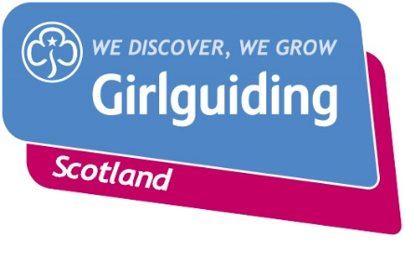
Press Release
FOR IMMEDIATE RELEASE / EMBARGOED (insert date article can be published)
<Insert date you send the release out: for example – 23 March 2020>

INSPIRATIONAL <INSERT HOMETOWN> WOMAN HONOURED FOR HER <INSERT YEARS> YEARS VOLUNTEERING WITH GIRLGUIDING SCOTLAND
A <insert town/area> Girlguiding Scotland volunteer has been honoured for her work supporting girls and young women over the last <insert number> years with the prestigious <insert award name>.
<Insert full name and current guiding role(s)> was presented with a specially-designed brooch in honour of her inspirational efforts by <insert presentation dignitary> at a recent ceremony at <insert presentation venue>.
<Insert first name>, <insert age> first became involved in guiding when she joined <insert first group> in <insert first group's area if applicable> in <insert first year of guiding> and has volunteered ever since – providing amazing opportunities for girls and young women
<insert name>’s highlights during her time with Girlguiding Scotland include <insert details of key experiences that standout e.g. attending an international event, watching girls grow in confidence, making life-long friends.>

<Insert first name>, <insert age>, said: <insert quote from volunteer playing on key messages, benefits of volunteering, e.g. “I’m extremely proud to receive this award.
Volunteering for Girlguiding Scotland is such a rewarding experience and it’s been wonderful to work with so many young women and girls over the years and see them gain new skills, grow in confidence and have fun.

“Volunteering has opened up so many fantastic opportunities for girls to enjoy new experiences, use their voice and be a powerful force for good in their communities. I would like to dedicate this award to all of the girls I have had the pleasure of knowing over the last <insert number> years.”

<Insert first name>, <insert age>, who attends < insert name of volunteer(’s)> unit said: <insert quote from girl in volunteer’s unit> said: e.g. “I love being a [insert name of section: Rainbow/Brownie/Guide/Ranger] because we get to do so many fun and exciting activities and adventures like XXX.

None of what we do would be possible without [INSERT VOLUNTEER NAME]. She’s a great [INSERT VOLUNTEER ROLE] and she organises lots of fun and exciting activities and trips for us.”

<Insert name> <Insert District/ Division/ County commissioner>, said: “<insert quote thanking them for their hard work eg. I want to say a huge thank you to <name> today. She has helped hundreds of girls to enjoy new experiences, make great friends and discover their potential. She has endless energy and enthusiasm and is committed to helping each girl to find her voice.”

For over 100 years guiding has made many positive differences in communities right across Scotland. As guiding groups adapt to the new Coronavirus restrictions, the charity’s volunteers are committed to deliver guiding in new and innovative ways so that they can continue to keep connected and empower girls and young women.
By giving just a couple of hours a week, volunteers can help to empower local girls and young women enjoy a wide range of exciting activities, gain new skills, make new friends and have fun. As a volunteer with Girlguiding Scotland you’ll be part of the leading charity for girls and young women in Scotland offering around 45,000 young members age 5-25 the chance to try new experiences, grow in confidence realise their potential and have fun.
If you’re interested in becoming a volunteer or know a girl who would like to join guiding, please visit www.girlguidingscotland.org.uk/get-involved/ to find out how to get involved.

-ENDS-
Attached is an image of <description of photo e.g. girl with a badge, a screen shot of your video call, a photo of the activity>

For further information, please contact <Name, role, on 077 123 4567 or by email at xxxxxx>

Notes to editors:

About Girlguiding Scotland:
Girlguiding Scotland is the leading charity for girls and young women in Scotland, with 45,000 young members. We build girls’ confidence and raise their aspirations. We give them the chance to discover their full potential and encourage them to be a powerful force for good. We give them a space to have fun. Find out more at www.girlguidingscotland.org.uk

Reaction to COVID-19:

The delivery of face to face and virtual youth work by Girlguiding is determined by and in compliance with Scottish Government guidelines. More information can be found here: https://www.girlguiding.org.uk/making-guiding-happen/coronavirus-keeping-safe/

