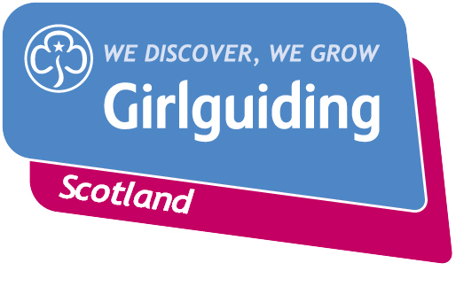
Press Release
FOR IMMEDIATE RELEASE / EMBARGOED (insert date article can be published)
<Insert date you send the release out: for example – 23 March 2020>

<INSERT CITY/TOWN> <INSERT GROUP TYPE EG: GUIDE/RANGER> RETURN FROM <INSERT COUNTRY ADJECTIVE> E.G. ‘FRENCH’> ADVENTURE
Girls from the <insert unit/ district / county name> have just returned from an unforgettable girl-only trip to <insert country> filled with fun, friendship and adventure.
The group of <insert number> girls/young women, aged <insert age range>, to <insert specific destination> where they visited <insert excursion details etc>.
<Insert further details about the trip e.g. any unusual or exciting activities, social action work undertaken, skills developed>
<Insert name>, <insert age>, said: “<insert quote e.g.> “I really enjoyed the trip to the South of France because it gave me a chance to see what life is like in a different country, as well as use some of the French I learned while doing my Interpreter badge.

“I made lots of new friends and learnt about a different culture while having a lot of fun!”

The girls/young women worked extremely hard to drum up <insert amount> towards to the cost of the trip, raising the cash by <insert two or three fundraising activities where possible>.
The group’s leader, <insert leader name>, said: <insert quote, e.g.>: “Giving girls a space to develop new skills, grow in confidence and enjoy new experiences is what Girlguiding Scotland is all about, so I was really excited to take our girls on a once-in-a-lifetime trip to XXX.

“Having the opportunity to travel abroad is so important as it offers girls the chance to learn about new cultures and gain new skills and independence while planning and fundraising for their trip.

“The girls had a blast and I’m sure it’s an experience they’ll remember for years to come.”

International travel is just one of many opportunities Girlguiding Scotland offers girls and young women ages 5 to 25. As the leading charity for girls and young women in Scotland with around 45,000 members, their unique programme includes badges in everything from mindfulness to bushcraft, women’s rights to vlogging, plus opportunities to enjoy outdoor adventure, gain awards, develop leadership skills, use their voice and take action.

Bringing the benefits of guiding to more girls and adults across Scotland is central to Girlguiding Scotland’s strategy for 2019-2021. Goals in this area include ensuring every girl and young woman who wants to join guiding in Scotland, whatever their background, will have the opportunity to do so.
If you’re interested in becoming a volunteer or know a girl who would like to join guiding, please visit www.girlguidingscotland.org.uk/get-involved/ to find out how to get involved.
- ENDS –

Attached is an image of <description of photo e.g. girl with a badge, a screen shot of your video call, a photo of the activity>

For further information, please contact <Name, role, on 077 123 4567 or by email at xxxxxx>

Notes to editors:

About Girlguiding Scotland:
Girlguiding Scotland is the leading charity for girls and young women in Scotland, with 45,000 young members. We build girls’ confidence and raise their aspirations. We give them the chance to discover their full potential and encourage them to be a powerful force for good. We give them a space to have fun. Find out more at www.girlguidingscotland.org.uk

Reaction to COVID-19:

The delivery of face to face and virtual youth work by Girlguiding is determined by and in compliance with Scottish Government guidelines. More information can be found here: https://www.girlguiding.org.uk/making-guiding-happen/coronavirus-keeping-safe/

