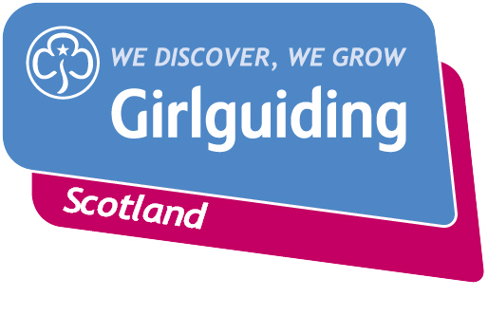
Press Release
FOR IMMEDIATE RELEASE / EMBARGOED (insert date article can be published)
<Insert date you send the release out: for example – 23 March 2020>

<Insert hometown / area eg.> GIRLGUIDING SCOTLAND SUPERSTAR RECEIVES NEW VOLUNTEERING AWARD

A Girlguiding Scotland volunteer celebrated achieving Girlguiding Scotland’s Growing Guiding Award which recognises volunteers who have helped the charity achieve their access goals by making a difference in their local community.

<Insert name>, <Insert age>, from <Insert area>, was presented with her Growing Guiding award <insert details of presentation eg. alongside other dedicated Girlguiding members from the local area at an event in <XXX>.

<Insert name> was nominated by <Insert name> after <insert reasons for nomination and action taken>

The next nomination round deadline will be later on this year/month/next year on <insert date>.

<Insert name> said: <insert quote speaking about some of the action she took, any challenges she faced and the result of her action>

Girlguiding Scotland, which promotes community service and provides opportunities for girls to develop life skills, is the leading charity for girls and young women in Scotland with around 45,000 members.
Empowering girls to take action and make a difference is just one of many opportunities Girlguiding Scotland can offer girls and young women aged 5 to 25. Their unique programme includes learning about world issues and science to social action, adventure sports and international travel.
Bringing the benefits of guiding to more girls and adults across Scotland is central to Girlguiding Scotland’s strategy for 2019-2021. Goals in this area include ensuring every girl and young woman who wants to join guiding in Scotland, whatever their background, will have the opportunity to do so.
If you’re interested in becoming a volunteer or know a girl who would like to join guiding, please visit www.girlguidingscotland.org.uk/get-involved/ to find out how to get involved.
- ENDS –

Attached is an image of <insert name, unit name with their award>.

For further information, please contact <Name, role, on 077 123 4567 or by email at xxxxxx>

Notes to editors:

About the Growing Guiding award:

This new award is for Girlguiding Scotland volunteers who have helped us achieve our access goals by making a difference in their local community. Helping more girls and adults from across Scotland to access the benefits of guiding is key to Girlguiding Scotland’s strategy for 2019-2021.

Our ACCESS goals are:

- Every girls and young woman who wants to join guiding in Scotland will have the opportunity to do so
- Girls and adults from diverse backgrounds and communities across Scotland will want to join guiding
- Every adult volunteer will receive a warm welcome and an induction specific to their role

The next nomination round deadline is <insert date>. Download the nomination form at <insert link>.

About Girlguiding Scotland:
Girlguiding Scotland is the leading charity for girls and young women in Scotland, with 45,000 young members. We build girls’ confidence and raise their aspirations. We give them the chance to discover their full potential and encourage them to be a powerful force for good. We give them a space to have fun. Find out more at www.girlguidingscotland.org.uk

Reaction to COVID-19:

The delivery of face to face and virtual youth work by Girlguiding is determined by and in compliance with Scottish Government guidelines. More information can be found here: https://www.girlguiding.org.uk/making-guiding-happen/coronavirus-keeping-safe/

