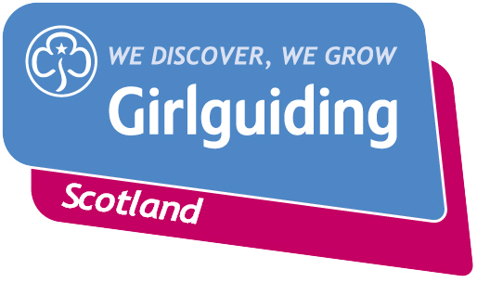
Press Release
FOR IMMEDIATE RELEASE / EMBARGOED (insert date article can be published)
<Insert date you send the release out: for example – 23 March 2020>

<INSERT LOCATION> <RAINBOWS/BROWNIES/GUIDES/SENIOR SECTION MEMBERS> TAKE ACTION & RAISE FUNDS FOR <INSERT CHARITY NAME OR CAUSE>
Girlguiding members from <insert location> have decided to take action for a cause they care about by hosting a fundraising event on <insert date>.
<Insert unit name> are aiming to raise <insert fundraising target> for <insert details of what money is for> through <insert details of fundraising event>.
The event will be held at <insert time> at <insert address>.
The girls decided to support <name of charity> because <they had a talk by a charity rep, they discussed it in a meeting, they know someone who has been helped by the charity, etc.>.
<Insert girl’s name>, <insert age>, said: <Insert girl quote, e.g:> “I’m really looking forward to doing our sponsored swim for Oxfam.
“It’s great being in Guides, because we get to choose what we do, so we can take action for things we really care about.”
The group’s leader, <insert leader’s full name>, said: <Insert leader quote, e.g:> “The girls feel really passionately about raising money for developing communities and it’s brilliant to be able to support them to do this through guiding.
“Girlguiding Scotland has always encouraged and empowered to speak out on the issues they care about and be a powerful force for good in their communities and beyond. The girls have been hard at work preparing for their XXX and I can’t wait to see just how much they achieve.”
Girlguiding Scotland, which promotes community service and provides opportunities for girls to develop life skills, is the leading charity for girls and young women in Scotland with around 45,000 members.

They offer girls and young women aged 5 to 25 a wide range of opportunities to try new experiences, learn new skills and grow in confidence. Their unique programme includes learning about world issues and science to social action, adventure sports and international travel.

For over 100 years guiding has made many positive differences in communities right across Scotland. As guiding groups adapt to the new Coronavirus restrictions, the charity’s volunteers are committed to deliver guiding in new and innovative ways so that they can continue to keep connected and empower girls and young women.
Bringing the benefits of guiding to more girls and adults across Scotland is central to Girlguiding Scotland’s strategy for 2019-2021. Goals in this area include ensuring every girl and young woman who wants to join guiding in Scotland, whatever their background, will have the opportunity to do so.
If you’re interested in becoming a volunteer or know a girl who would like to join guiding, please visit www.girlguidingscotland.org.uk/get-involved/ to find out how to get involved.
-ENDS-

Attached is an image of <description of photo e.g. girl with a badge, a screen shot of your video call, a photo of the activity>

For further information, please contact <Name, role, on 077 123 4567 or by email at xxxxxx>

Notes to editors:

About Girlguiding Scotland:
Girlguiding Scotland is the leading charity for girls and young women in Scotland, with 45,000 young members. We build girls’ confidence and raise their aspirations. We give them the chance to discover their full potential and encourage them to be a powerful force for good. We give them a space to have fun. Find out more at www.girlguidingscotland.org.uk

Reaction to COVID-19:
The delivery of face to face and virtual youth work by Girlguiding is determined by and in compliance with Scottish Government guidelines. More information can be found here: https://www.girlguiding.org.uk/making-guiding-happen/coronavirus-keeping-safe/

