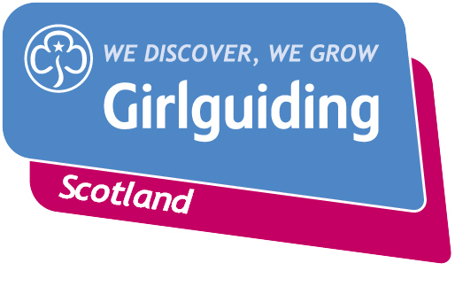
Press Release
FOR IMMEDIATE RELEASE / EMBARGOED (insert date article can be published)
<Insert date you send the release out: for example – 23 March 2020>

GIRLGUIDING MEMBERS FROM ACROSS <INSERT AREA> <INSERT CHALLENGE/EVENT/ACTIVITY> TO RAISE FUNDS FOR <INSERT NAME OF CHARITY/CAUSE>
Girlguiding members from across <insert area> have <insert description of activity>, raising a fantastic <insert amount> for <insert cause>.
Across the area <insert number Rainbow/Brownie/Guide/Ranger> units plus <e.g. adult volunteers and members of the Trefoil Guild> joined in the fundraising challenge to <insert activity details>.
<Insert area> members were inspired to do their part to support after <insert details>.
<Insert further details of the activity ie where it took place>.
<insert area> members smashed their initial fundraising target of <£XXXX> going onto raise more <insert amount>.
<Insert name>, <Insert age>, from <Insert area>, said: QUOTE FROM GIRL e.g. “We had so much fun doing our mile – we decided to XXXX for our mile which was hard work but we really enjoyed crossing the finish line. At Guides we’ve been learning all about how we can take action and help causes we care about – it feels good to know that the money we’ve raised is going to make a real difference to other people’s lives.”
<Insert name>, <insert role>, from <Insert area>, said: QUOTE FROM LEADER OR VOLUNTEER e.g: “It was brilliant to see girls from all over Tweed Valley getting involved and doing their part. We were particularly impressed with all the creative way units found to do their mile – from dancing to hiking and even one group who went round an assault course as many times as it took to make a mile!
“Seeing the effort the girls were putting in inspired me and a few other leaders to push ourselves that bit further too and hike up Ben Nevis to help raise even more funds.
“Social action projects like this are a really important part of Girlguiding. This challenge has shown the girls that when they take action they can make a real difference to people in their communities and beyond I hope all our members feel really proud of just how much they’ve achieved.”
Girlguiding Scotland, which promotes community service and provides opportunities for girls to develop life skills, is the leading charity for girls and young women in Scotland with around 45,000 members.
Empowering girls to take action and make a difference is just one of many opportunities Girlguiding Scotland can offer girls and young women aged 5 to 25. Their unique programme includes learning about world issues and science to social action, adventure sports and international travel.
For over 100 years guiding has made many positive differences in communities right across Scotland. As guiding groups adapt to the new Coronavirus restrictions, the charity’s volunteers are committed to deliver guiding in new and innovative ways so that they can continue to keep connected and empower girls and young women.
Bringing the benefits of guiding to more girls and adults across Scotland is central to Girlguiding Scotland’s strategy for 2019-2021. Goals in this area include ensuring every girl and young woman who wants to join guiding in Scotland, whatever their background, will have the opportunity to do so.
If you’re interested in becoming a volunteer or know a girl who would like to join guiding, please visit www.girlguidingscotland.org.uk/get-involved/ to find out how to get involved.
- ENDS –

Attached is an image of <description of photo e.g. girl with a badge, a screen shot of your video call, a photo of the activity>

For further information, please contact <Name, role, on 077 123 4567 or by email at xxxxxx>

Notes to editors:

About Girlguiding Scotland:
Girlguiding Scotland is the leading charity for girls and young women in Scotland, with 45,000 young members. We build girls’ confidence and raise their aspirations. We give them the chance to discover their full potential and encourage them to be a powerful force for good. We give them a space to have fun. Find out more at www.girlguidingscotland.org.uk

Reaction to COVID-19:
The delivery of face to face and virtual youth work by Girlguiding is determined by and in compliance with Scottish Government guidelines. More information can be found here: https://www.girlguiding.org.uk/making-guiding-happen/coronavirus-keeping-safe/

