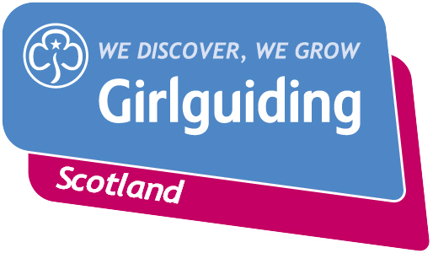
Press Release
FOR IMMEDIATE RELEASE / EMBARGOED (insert date article can be published)
<Insert date you send the release out: for example – 23 March 2020>

<Insert hometown / area eg.> GIRLGUIDING SCOTLAND SUPERSTAR RECEIVES TOP AWARD

A Girlguiding Scotland star is celebrating after completing a number of challenges to has achieve her <select appropriate level: Bronze/ Silver /Gold> Duke of Edinburgh’s Award.

<Insert name>, <Insert age>, from <Insert area>, was presented with her Duke of Edinburgh’s Award (DofE) <insert details of presentation eg. alongside other dedicated Girlguiding members from the local area at an event in <XXX>.

<Insert name> took <insert number> took on a number of personal challenges including <insert some examples of activities / challenges undertaken – for example volunteering with her local Brownie unit, training for and completing a sponsored fun-run, and taking part in a hiking expedition to the Ben Nevis.>

The DofE Award is a voluntary, non-competitive programme of activities and challenges for young people age 14-24, designed to help participants push themselves and develop new skills as they work towards their Bronze, Silver or Gold Award.

<Insert name> said: <insert quote speaking about some of the challenges she completed and what she gained from them eg. “I feel so proud to have achieved my DofE Bronze Award. It was a big challenge but I had loads of fun trying new things and learning new skills.

I really enjoyed volunteering with my local Brownie unit and getting to lead the girls in games and activities. I also loved going on our expedition to Ben Nevis – it was hard work, and I came back with a few blisters but the view from the top was amazing.

Completing my DofE Award has shown me just how much I can achieve. It’s been a big confidence boost and now I can’t wait to start working towards my Silver and maybe even my Gold award! >

Gaining their DofE Award is just one of a huge range of opportunities Girlguiding Scotland, the leading charity for girls and young women in Scotland, offers its around 45,000 young members.
From adventurous activity to international travel, social action to campaigning, Girlguiding Scotland offers girls and young women aged 5 to 25 a wide range of opportunities to try new experiences, learn new skills and grow in confidence.
Bringing the benefits of guiding to more girls and adults across Scotland is central to Girlguiding Scotland’s strategy for 2019-2021. Goals in this area include ensuring every girl and young woman who wants to join guiding in Scotland, whatever their background, will have the opportunity to do so.
If you’re interested in becoming a volunteer or know a girl who would like to join guiding, please visit www.girlguidingscotland.org.uk/get-involved/ to find out how to get involved.
- ENDS –

Attached is an image of <description of photo e.g. girl with a badge, a screen shot of your video call, a photo of the activity>

For further information, please contact <Name, role, on 077 123 4567 or by email at xxxxxx>

Notes to editors:

About Girlguiding Scotland:
Girlguiding Scotland is the leading charity for girls and young women in Scotland, with 45,000 young members. We build girls’ confidence and raise their aspirations. We give them the chance to discover their full potential and encourage them to be a powerful force for good. We give them a space to have fun. Find out more at www.girlguidingscotland.org.uk

Reaction to COVID-19:

The delivery of face to face and virtual youth work by Girlguiding is determined by and in compliance with Scottish Government guidelines. More information can be found here: https://www.girlguiding.org.uk/making-guiding-happen/coronavirus-keeping-safe/

