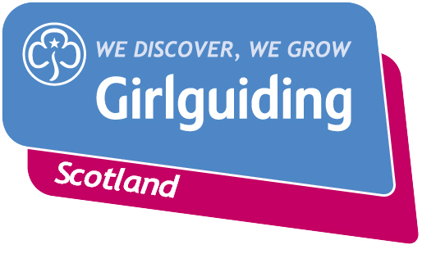
Press Release
FOR IMMEDIATE RELEASE / EMBARGOED (insert date article can be published)
<Insert date you send the release out: for example – 23 March 2020>

CALLING ON [insert hometown] GIRLS TO JOIN THE FUN & ADVENTURE OF GIRLGUIDING SCOLTAND
A local <insert section> unit is inviting more <delete as appropriate: girls/young women> to join them on a journey of fun, friendship and adventure.
New Girlguiding Scotland members can look forward to an exciting and hugely varied programme of activities, events and trips where they will make lifelong friends in a safe girl-only environment.
The group currently has <insert number> girls and offers an action-packed programme of activities planned including <insert details>.
The <insert name of unit> meet on <insert day of week> evenings after school at a venue in < insert area of venue for example hometown eg: Clydebank, but not exact location>. <Insert any other info which may be useful e.g. upcoming taster sessions>.
<insert name>, the group’s leader, said: <insert quote from leader welcoming new girls e.g. “This is a fantastic opportunity for even more local girls to meet new friends and have amazing experiences while growing in confidence and self-belief.>
“We’re a friendly bunch and we’re always really excited to meet new members. Girlguiding Scotland is open to all girls whatever their background or circumstances so please don’t hesitate to get in touch if you’re interested in joining.”
<Insert name of girl>, < insert age>, who is a member of <insert name of unit> said: <insert quote from girl who is a member of the unit e.g. “I love being a <insert section> and having fun every week. We get to pick what activities we want to do, go on trips and play lots of games. Plus I’ve made lots of new friends.”
Girlguiding Scotland, which promotes community service and provides opportunities for girls to develop life skills, is the leading charity for girls and young women in Scotland with around 45,000 members.

They offer girls and young women aged 5 to 25 a wide range of opportunities to try new experiences, learn new skills and grow in confidence. Their unique programme includes learning about world issues and science to social action, adventure sports and international travel.

Bringing the benefits of guiding to more girls and adults across Scotland is central to Girlguiding Scotland’s strategy for 2019-2021. Goals in this area include ensuring every girl and young woman who wants to join guiding in Scotland, whatever their background, will have the opportunity to do so.
If you’re interested in becoming a volunteer or know a girl who would like to join guiding, please visit www.girlguidingscotland.org.uk/get-involved/ to find out how to get involved.
- ENDS –

Attached is an image of <description of photo e.g. girl with a badge, a screen shot of your video call, a photo of the activity>

For further information, please contact <Name, role, on 077 123 4567 or by email at xxxxxx>

Notes to editors:

About Girlguiding Scotland:
Girlguiding Scotland is the leading charity for girls and young women in Scotland, with 45,000 young members. We build girls’ confidence and raise their aspirations. We give them the chance to discover their full potential and encourage them to be a powerful force for good. We give them a space to have fun. Find out more at www.girlguidingscotland.org.uk

Reaction to COVID-19:

The delivery of face to face and virtual youth work by Girlguiding is determined by and in compliance with Scottish Government guidelines. More information can be found here: https://www.girlguiding.org.uk/making-guiding-happen/coronavirus-keeping-safe/

