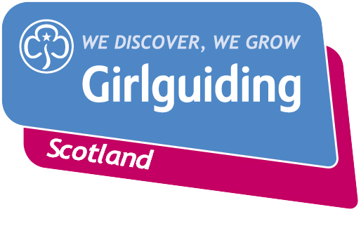
Press Release
FOR IMMEDIATE RELEASE / EMBARGOED (insert date article can be published)
<Insert date you send the release out: for example – 23 March 2020>

<INSERT GROUP NAME> RETURN FROM AMAZING ADVENTURE AT <INSERT DESTINATION>
Girls from the <insert unit name> have returned home from an exciting <insert length> trip to <insert destination>.
The girls, all aged between <insert ages>, took part in a host of exciting adventures during their trip including <insert details of activities e.g. abseiling, science investigation, zip-lining>.
<Insert girl’s name>, <insert age>, said: <Insert girl quote, e.g :> “This was the first time I’d ever been away without my family. It was so fun going away with my guiding friends!
“We did lots of fun things but what I most enjoyed was…”
The group’s leader, <insert leader’s full name>, said: “The trip to <insert destination> was a great chance for the girls to get away and enjoy each other’s company in a safe, girl-only space.
“It was fantastic to see the girls go beyond their comfort zone and try new things – from archery to zorbing. They really grew in confidence during the camp and learnt some brilliant new skills – from cooking on an open fire to pitching a tent.
“All the girls told me how much they enjoyed themselves and they can’t wait to decide where they want to go next and plan another adventure.”
Adventures like this are just one of the wide range of activities open to girls and young women through Girlguiding Scotland, the leading charity for girls and young women with around 45,000 members. They offer girls and young women aged 5 to 25 a wide range of opportunities to try new experiences, learn new skills and grow in confidence. Their unique programme includes learning about world issues and science to social action, sports and international travel.
If you’re interested in becoming a volunteer or know a girl who would like to join guiding, please visit www.girlguidingscotland.org.uk/get-involved/ to find out how to get involved.
- ENDS –

Attached is an image of <description of photo e.g. girl with a badge, a screen shot of your video call, a photo of the activity>

For further information, please contact <Name, role, on 077 123 4567 or by email at xxxxxx>

Notes to editors:

About Girlguiding Scotland:
Girlguiding Scotland is the leading charity for girls and young women in Scotland, with 45,000 young members. We build girls’ confidence and raise their aspirations. We give them the chance to discover their full potential and encourage them to be a powerful force for good. We give them a space to have fun. Find out more at www.girlguidingscotland.org.uk

Reaction to COVID-19:

The delivery of face to face and virtual youth work by Girlguiding is determined by and in compliance with Scottish Government guidelines. More information can be found here: https://www.girlguiding.org.uk/making-guiding-happen/coronavirus-keeping-safe/

