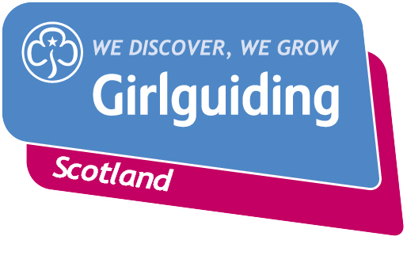
Press Release
FOR IMMEDIATE RELEASE / EMBARGOED (insert date article can be published)
<Insert date you send the release out: for example – 23 March 2020>

<Insert hometown / area eg.> GIRLGUIDING SCOTLAND SUPERSTAR RECEIVES TOP AWARD

A Girlguiding Scotland star celebrated achieving Girlguiding’s highest award on <insert date>.

<Insert name>, <Insert age>, from <Insert area>, was presented with her Queen’s Guide award <insert details of presentation eg. alongside other dedicated Girlguiding members from the local area at an event in <XXX>.

<Insert name> took <insert number> years to complete the tough Queen’s Guide award, a personal collection of challenges which must be completed before a young woman turns 26.

<Insert name>, who is <insert local detail here, eg studying engineering at the University of Glasgow >, selected personal challenges in fields including volunteering, social action, developing new skills and travelling to a new place.
<NAME’S> personal challenges included <Insert details here eg. travelling to Finland to take part in an arctic expedition, fundraising for a local children’s hospice and working with her Brownies to run a campaign against littering in their local area>.

The Queen’s Guide award is the highest award a young member, aged 16-25, can achieve in Girlguiding. Members choose their own challenges, at their own pace and work towards their award over a period of one to three years. It aims to help young women to gains skills and confidence for life and work.

<Insert name> said: <insert quote speaking about some of the challenges she completed and what she gained from them eg. “The Queen’s Guide challenge I am most proud that I set myself was running the Edinburgh half marathon. I raised £00 for WaterAid and part of it was running this amazing half marathon dressed as a tap!

“I also organised a sleepover for 100 Brownies so they could experience the independence of being away from home with their friends – no parents allowed!

“Working towards my Queen’s Guide Award was a big challenge but it’s been so rewarding. I’ve gained new skills and the confidence to take the lead, not just in Girlguiding but in other areas of my life too.”>

From adventurous activity to international travel, social action to campaigning, Girlguiding Scotland offers girls and young women aged 5 to 25 a wide range of opportunities to try new experiences, learn new skills and grow in confidence.
For over 100 years guiding has made many positive differences in communities right across Scotland. As guiding groups adapt to the new Coronavirus restrictions, the charity’s volunteers are committed to deliver guiding in new and innovative ways so that they can continue to keep connected and empower girls and young women.
If you’re interested in becoming a volunteer or know a girl who would like to join guiding, please visit www.girlguidingscotland.org.uk/get-involved/ to find out how to get involved.
- ENDS –

Attached is an image of <description of photo e.g. girl with a badge, a screen shot of your video call, a photo of the activity>

For further information, please contact <Name, role, on 077 123 4567 or by email at xxxxxx>

Notes to editors:

About Girlguiding Scotland:
Girlguiding Scotland is the leading charity for girls and young women in Scotland, with 45,000 young members. We build girls’ confidence and raise their aspirations. We give them the chance to discover their full potential and encourage them to be a powerful force for good. We give them a space to have fun. Find out more at www.girlguidingscotland.org.uk

Reaction to COVID-19:

The delivery of face to face and virtual youth work by Girlguiding is determined by and in compliance with Scottish Government guidelines. More information can be found here: https://www.girlguiding.org.uk/making-guiding-happen/coronavirus-keeping-safe/

