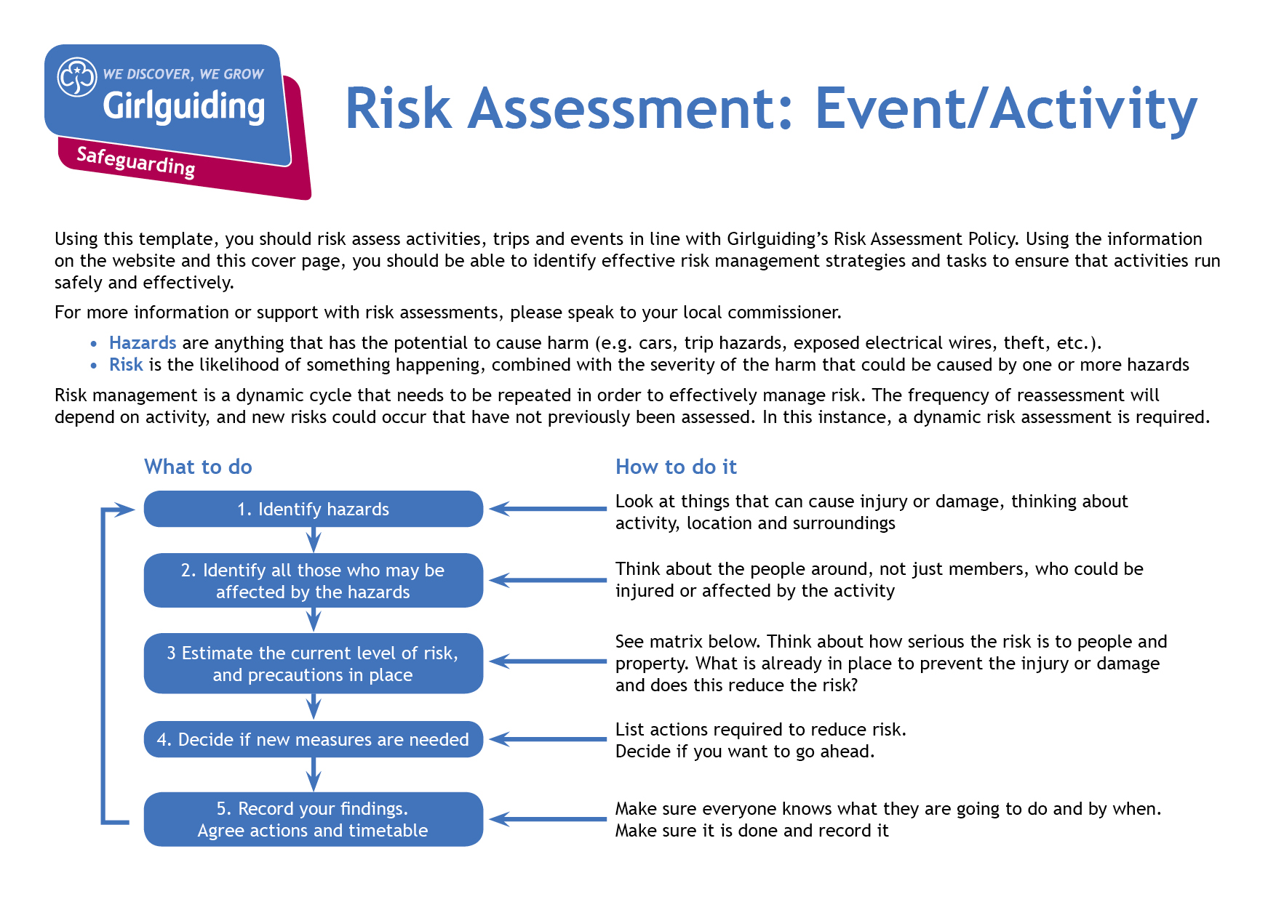
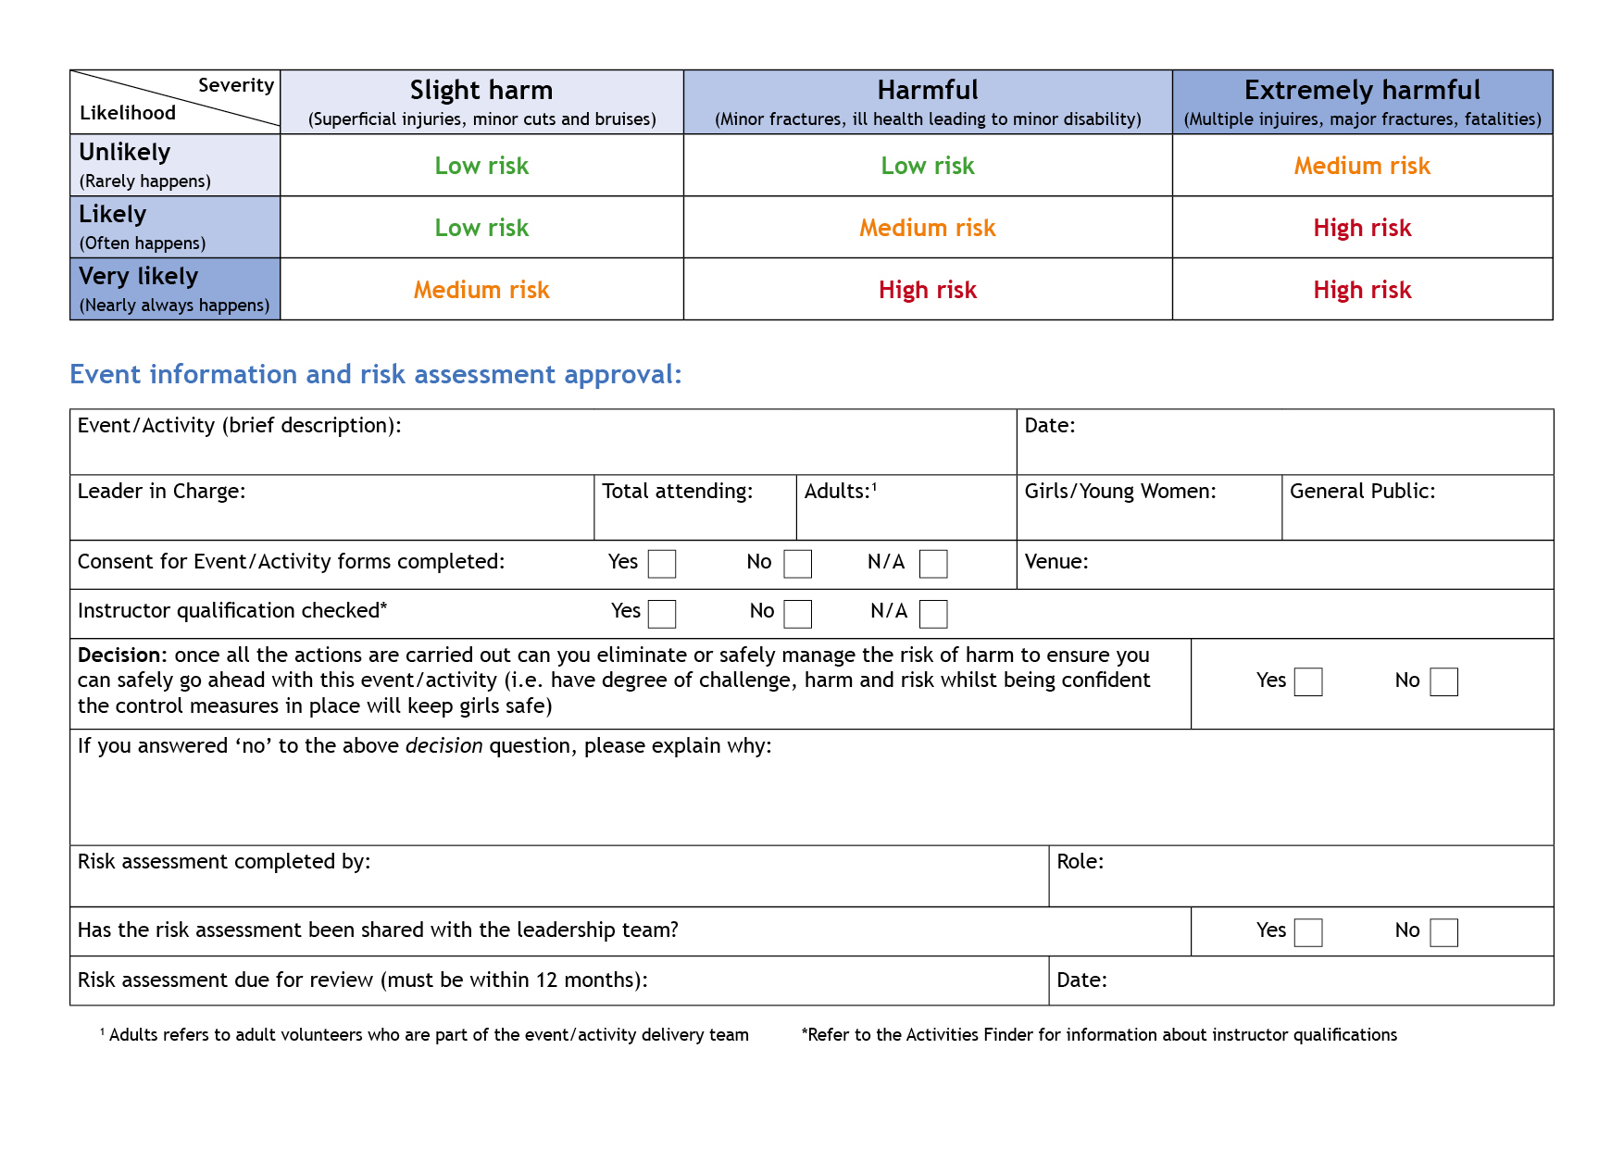

Virtual Girlguiding Meeting
April- June 2020

Anna Other
10 parents
10
2

12
Virtual meeting

Hazards  What could cause harm or damage? | Who or what is at risk of being affected and how? | What are you already doing?  How have you reduced the risk already? | Likelihood of risk occurring  (L/M/H) | Severity of risk  (L/M/H) | Are further controls necessary?  What else needs to happen to reduce the risk to an acceptable level? | Action by:  name/  date
Safeguarding during virtual meetings | All participants (young members, family members and volunteers)  Meeting in home venues – less control over environment, potential hazards and wellbeing of girls.  Safeguarding of leaders so they have correct procedures in place to minimise risk of allegations and concerns being raised | All participants must be named on the Girlguiding virtual meeting consent form and this form must be signed (electronically) by their parents/carers and returned to the leader before they can take part.  The girls must join the call in a suitable communal environment and be appropriately dressed.  There will be a minimum of two adults on the call who will stay on the call until all the girls have logged off.  One adult on the call will have their leadership qualification and a current PVG. One adult (this may be the same person) will hold a current Safe Space level 3.  Leaders will not contact the girls using online conferencing tools outside the pre-arranged meeting. If leaders need to make contact, they will do so using the usual channels of communication.  Leaders will use appropriate language/behaviour during the call. All leaders will be in a communal environment and be appropriately dressed during the call. Where possible they will blur the background during the meeting.  All members of their household will use appropriate language/behaviour throughout the call.  Messaging/chat between participants during the virtual meeting will be disabled by the Leader.  Leader will review and check any links or videos they direct the girls to and ensure they are age appropriate. | L | M | Parents must adhere to the guidance on the form and be in attendance at the virtual meeting. Rainbows and Brownies must have parents in the same room. Guides/ Rangers must have parents nearby.  Access to the meeting is made through the parent’s/carer’s account (unless young member meets minimum age required for that platform).  For younger members, parents will drop off the child at the meeting.  When the meeting ends parents will make sure the girl has logged off the call correctly and signed out of any accounts (where used).  Leaders will not accept virtual contact with girls (outwith the planned meeting time) but will continue to keep in contact through the usual communication channels.
Managing information | All participants (young members, family members and volunteers)  Prevention of accidental data sharing | Leaders will ensure that all participants have the appropriate photo/video permissions.  Leaders will check if chosen online platform automatically records calls or videos, and disable this.  Leaders will check if chosen online platform automatically stores to a 'cloud', and disable this. | L | L | Disable any automatic recording and storing of information on the online platform you use for virtual meetings.
Health and Hygiene- edible activity  Safety if using kitchen utensils | All participants (young members, family members and volunteers)  Health risks associated with poor hygiene/ safety | Ensure that girls wash hands if taking part in an edible activity and that any food is put out of reach of family pets. | L | M | Brief parents in advance that there is going to be a food-related activity and ask them to create a safe area for the food to be prepared.  Have parent/carer around to for supervision and assistance if girls are using sharp utensils.
Crafts | All participants (young members, family members and volunteers)  potential minor injuries  Damage to furnishings in room | Participants to be briefed on safe use of craft equipment and materials.  Plan individual crafts and try them out beforehand to ensure suitability.  Brief parents about the materials required and any potential hazards, such as suggesting tables are covered to avoid damage to home furnishings. | L | L | Leaders should discuss and ensure the suitability of any activities planned for virtual meetings.  Parents will know in advance of meeting what materials will be required and space needed to carry out crafts safely.  Brief girls about the activity and include suitable safety warnings/advice as appropriate. Supervise activity on the day.
Taking part in the meeting whilst concentrating on screen could result in girls not being aware of furniture/hazards in the room | All participants (young members, family members and volunteers)  Environmental hazards | Remind girls at the beginning of the call to be aware of their surroundings, including any pets or other people in the room. | L
Games | All participants including members of household and volunteers  - bumps, cuts, broken bones | Leaders will remind girls to be aware of:  - Trip hazards  - Other people in the room  - Space constraints  -Pets | M | L | When planning the meeting consider suitability of games for indoor space.  Whilst running the game have one leader keep an eye solely on girls to spot if there are any problems.
Leader becomes aware of safeguarding concern regarding a young member during online meeting | Participants and families  Safeguarding concerns- including -disclosure  -welfare | If a leader has a concern about a young member or their family, they should contact their commissioner as well as the national safeguarding team.  Report it within 24 hours, or sooner if it is an emergency or there’s an immediate risk of harm.  Refer to the Girlguiding Safeguarding policy for more information:  https://www.girlguiding.org.uk/making-guiding-happen/policies/girlguiding-policies/safety-and-safeguarding-policy/ |  |  | You can contact the national Safeguarding team on:  Tel: 020 7834 6242 (usual office hours)  Out of hours emergency phone: 07508 032997 (5pm-10pm Monday-Friday; 9am-10pm Saturday/Sunday).  Please do not text the out of hours number, as we are unable to access these messages.  Email: safeguarding@girlguiding.org.uk  In an emergency you can also contact the police, you must let the Safeguarding team know as soon as possible if you do this.

