Social media ads for girl recruitment
We have some graphics and sample social media posts aimed at recruiting more girls, that you can use to highlight Girlguiding in your local area.
Download the images here
Rainbows:
Things might have changed but Rainbows is still here for girls aged 5-7! Register your daughter today https://bit.ly/GGSJoin
Rainbows is a great place for girls aged 5-7 to have fun and make friends for life! Register your daughter today https://bit.ly/GGSJoin
Rainbows run, craft and whizz their way through fun activities while making friends for life! Is your daughter aged 5-7? Register today https://bit.ly/GGSJoin
Rainbows keeps girls aged 5-7 laughing and learning during these strange times! Register your daughter today https://bit.ly/GGSJoin

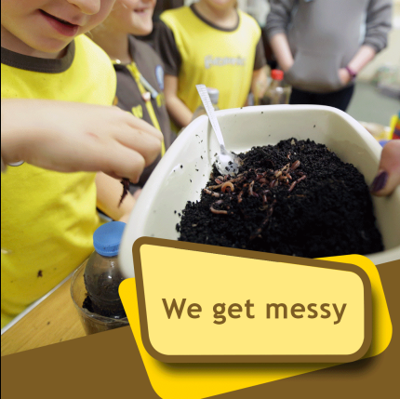
Brownies:
Brownies go exploring, have adventures and they make memories for life! Is your daughter aged 7-10? Register to join today https://bit.ly/GGSJoin
Things might have changed but Brownies is still here for girls aged 7-10! Register your daughter today https://bit.ly/GGSJoin
Life might be on hold in lots of ways but Brownies is still here for girls aged 7-10! Register your daughter today https://bit.ly/GGSJoin

Guides:
Guides climb, camp, craft, learn new skills and make friends for life! Girls aged 10-14 are welcome to join - register today https://bit.ly/GGSJoin
Things might have changed but Guides is still here for girls aged 10-14! Register your daughter today https://bit.ly/GGSJoin
Guides give girls aged 10-14 a safe place to grow in confidence, learn new skills and make friends for life! Register your daughter today https://bit.ly/GGSJoin

Rangers:
Rangers empowers girls aged 14-18 to change the world by offering amazing opportunities they wouldn’t get elsewhere! Register today https://bit.ly/GGSJoin

Things might have changed but Rangers is still here for girls aged 14-18! Register your daughter today https://bit.ly/GGSJoin

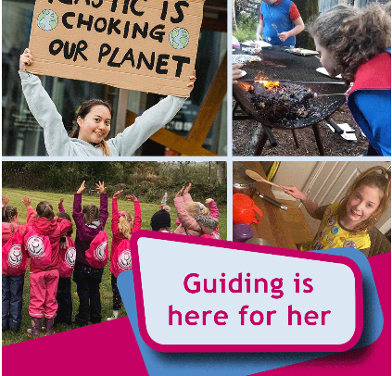
All sections:
From Rainbows to Rangers, Girlguiding is a great place for girls aged 5-18 to have fun, grow in confidence and make friends for life! Register your daughter today https://bit.ly/GGSJoin

Girlguiding encourages girls aged 5 to 18 to learn new skills, have fun and make friends. Register your daughter today https://bit.ly/GGSJoin

Girls run, laugh, climb, row and they change the world! Girlguiding is here for all girls - register your daughter today https://bit.ly/GGSJoin

