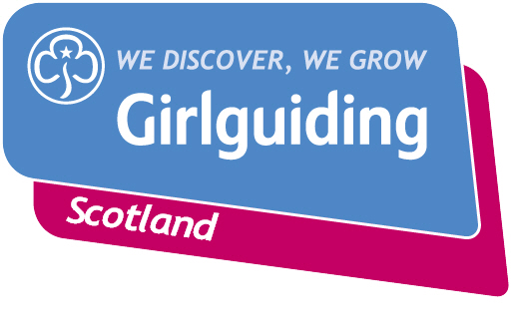
Hello,

My name is <XXX> and I am the County Public Relations Advisor (CPRA) for <INSERT COUNTY>. I am getting in touch to let volunteers in your <area /Division / District> know how I can help promote the fantastic work they do with their units every week.

In my role as a PRA I help to promote Girlguiding at a local, County and Scotland-wide level. Here are a few ways I can help you and volunteers in your local area to shout about Girlguiding:

- Writing press releases on all sorts of topics – whether it’s a Division camp, an overseas adventure or an appeal for more volunteers

- Girlguiding Scotland has a library of helpful templates for press releases on a wide range of activities and events. I can help you use these templates to write a brilliant story and get great coverage in your local paper

- Answering your questions from Districts, Divisions or units on branding and promotion materials including posters, flyers and badges

- Advising your District, Division or units on how best to use social media to promote your work and sharing their activities and achievements on County social media channels

- Sharing the amazing work you are doing at a local level with Girlguiding Scotland’s Marketing and Communications team so they can promote this on their website, social media channels and potentially in national press and in Guiding Magazine.

These are just the few of the ways I can help you to shout about the fantastic work you do, offering girls a safe space to enjoy new experiences, gain new skills, grow in confidence and have fun.

I would be very happy to come along to <local / District / Division> events or meetings to meet your volunteers and share how I can help.

If you have any questions just let me know.

Best wishes,
XXX

