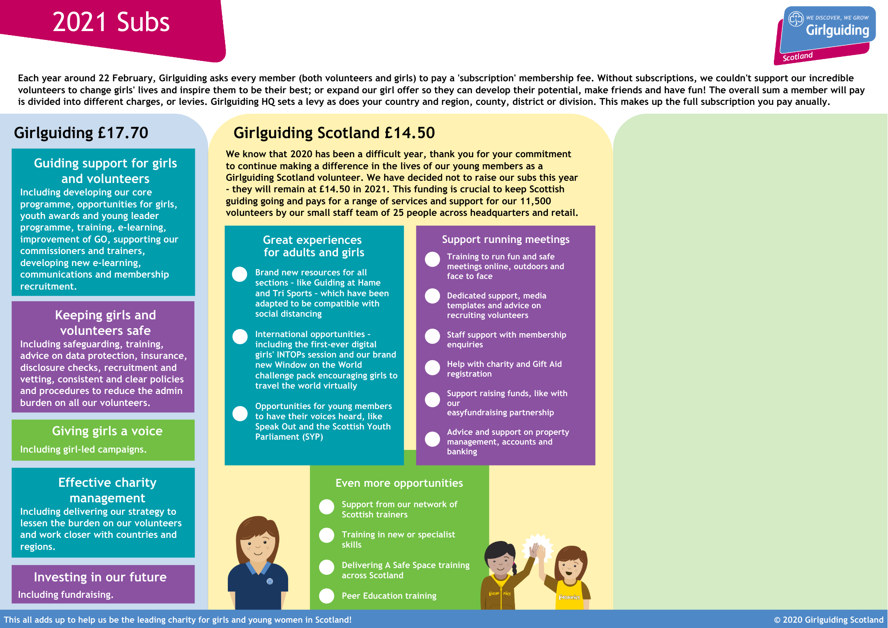

**Space for a heading**

* Highlight the key things your charge covers
* Add bullets as required

**Space for a second heading**

* Highlight the key things your charge covers
* Delete this box if it isn’t required

**You can add some context here.**

**Add your county and subs here**