Please visit https://status.oscr.org.uk/ to read the instructions in full before starting your application.
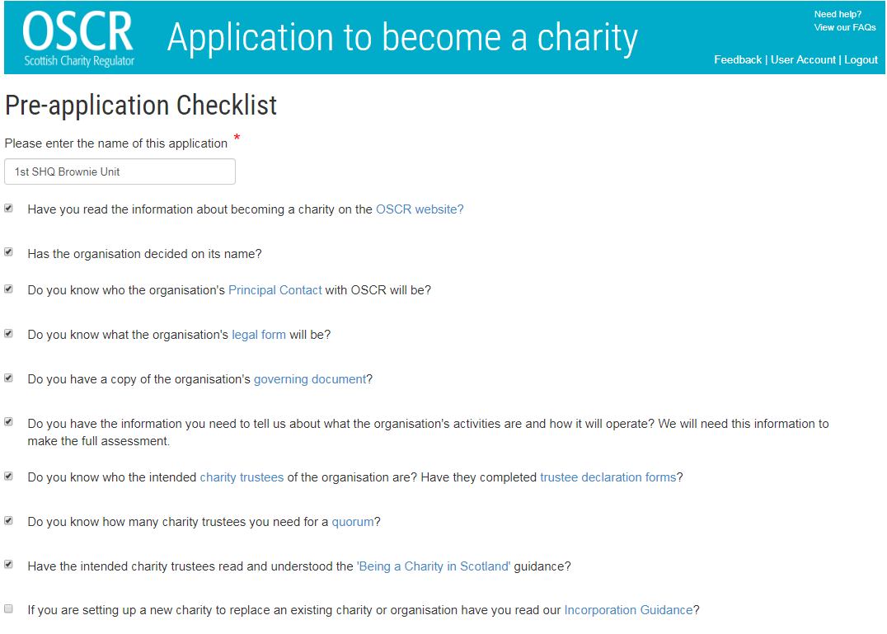 |  | You should read OSCR guidance, especially Being a Charity in Scotland  Based on the minute attached to this document and the text provided for you to copy and paste means you should tick all but last check box on this page  (leave unticked)
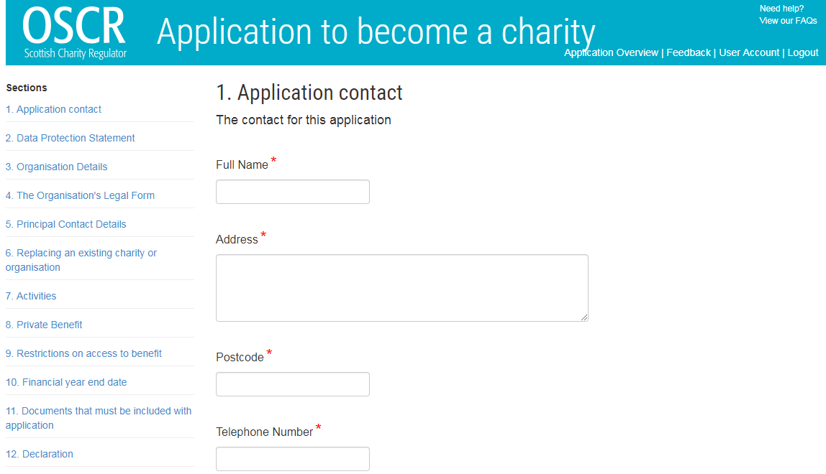 |  | Normally Unit Leader if one of the leaders is completing application
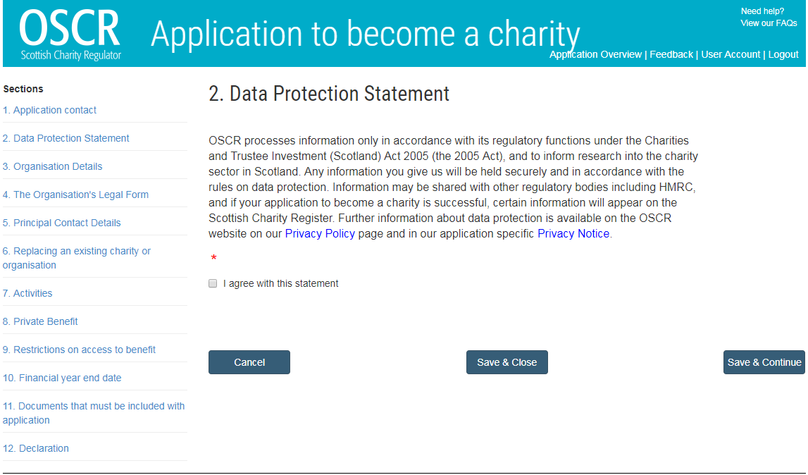 |  | Tick the box to agree
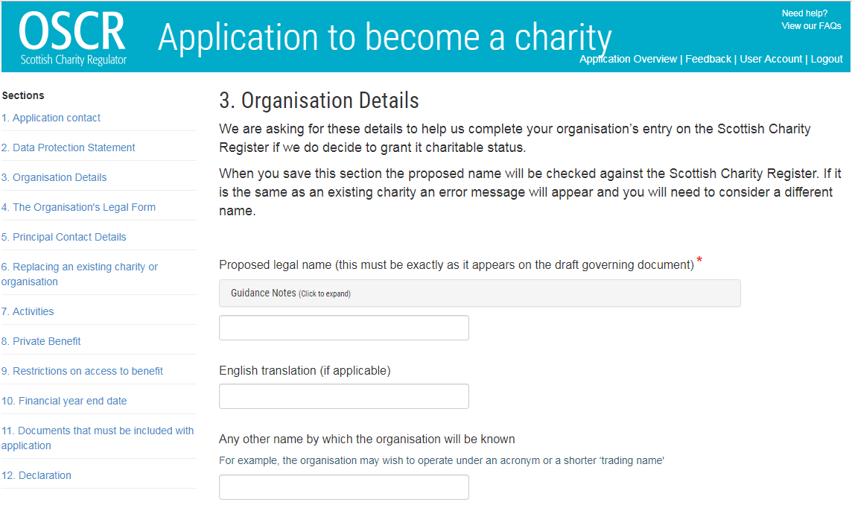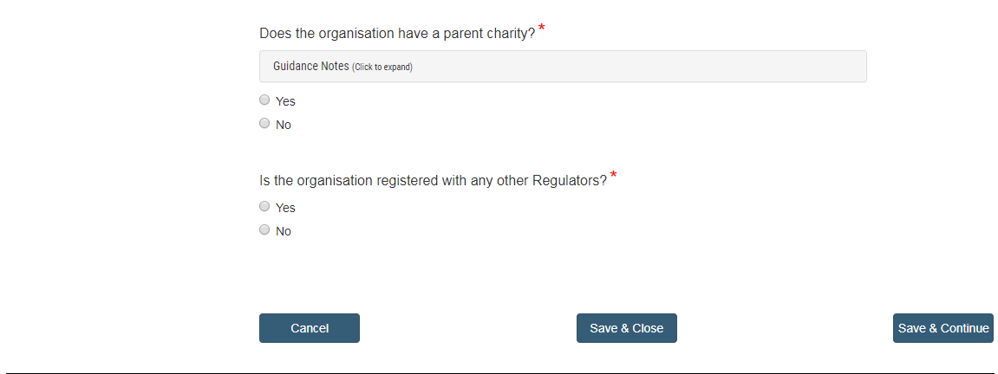 |  | Name of Unit as entered on GO. For example ; 150th City of Glasgow Rainbow Unit.  If your bank account detail is different to GO, enter the bank account name, e.g 150th Glasgow Rainbows.  Select No – as county, country or UK national Girlguiding bodies do not have power to govern the financial and operating policies of the unit to obtain a benefit.  Select No
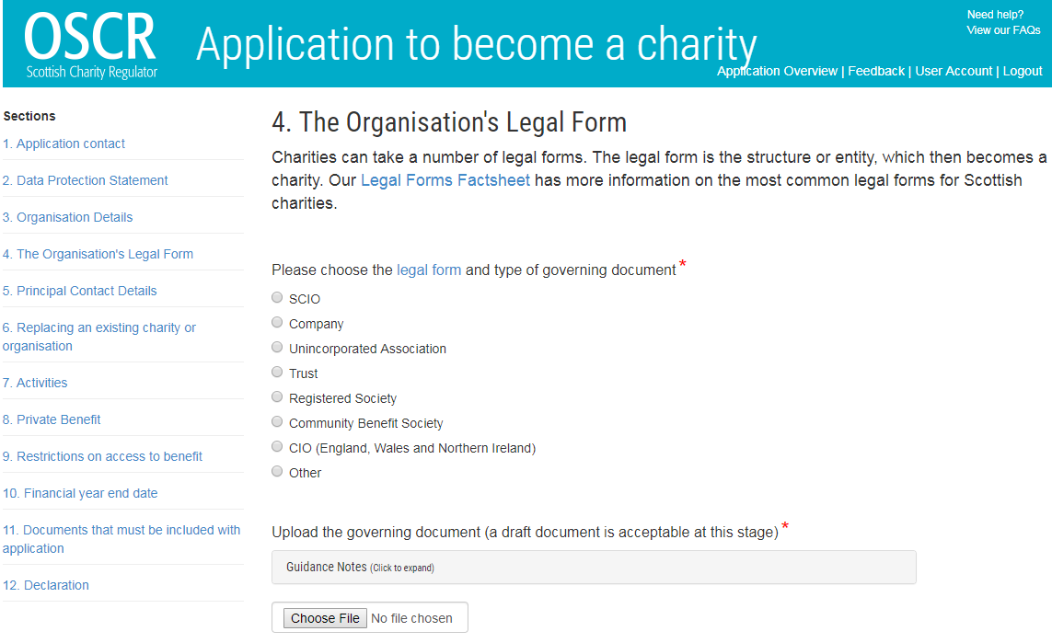 |  | Select Unincorporated Association  Attach a scanned signed minute. Template at end of this document.
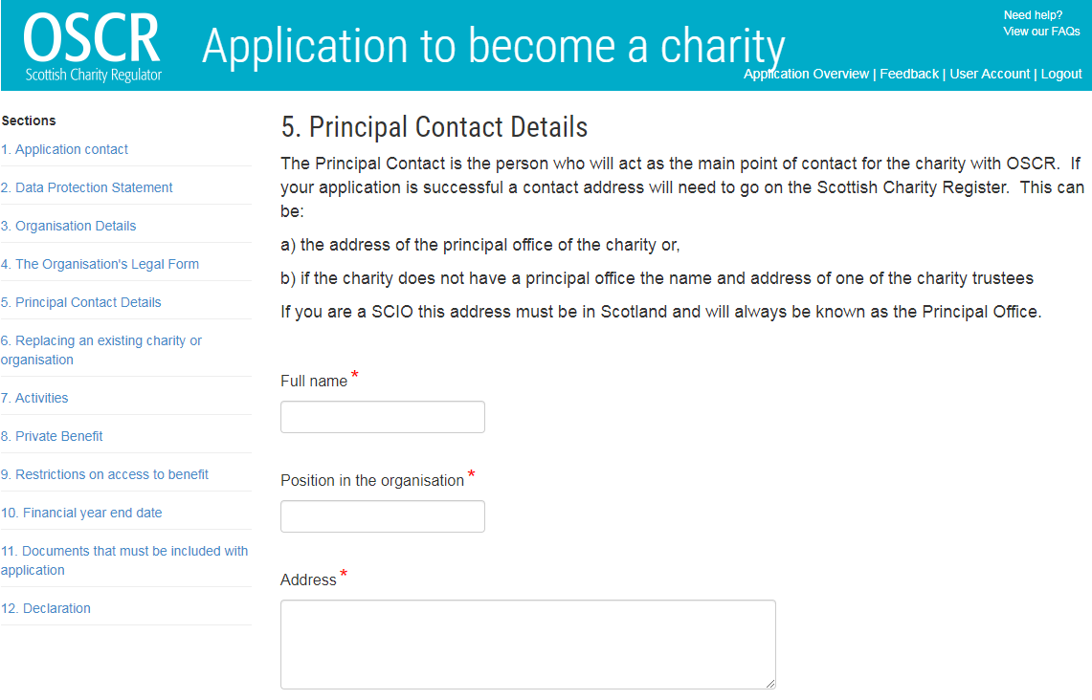 | This should be the unit leader
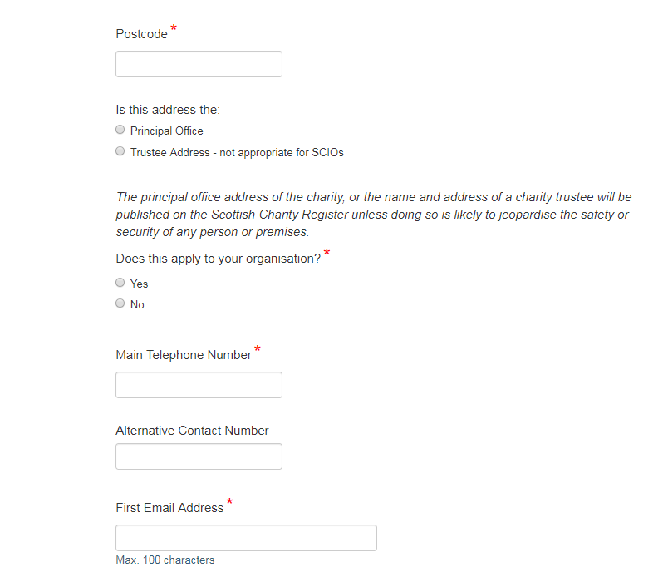 |  | Select Trustee Address  Select No. If “yes” does apply, contact Girlguiding Scotland headquarters to discuss before completing the application.
A second email address is useful to OSCR to contact the charity after the principal contact has moved on without informing them. We recommend another leader’s email address or unit email address (if exists) is entered here.

Leave blank or only add public facing unit social media accounts. Do not add closed Facebook groups and personal social media details.

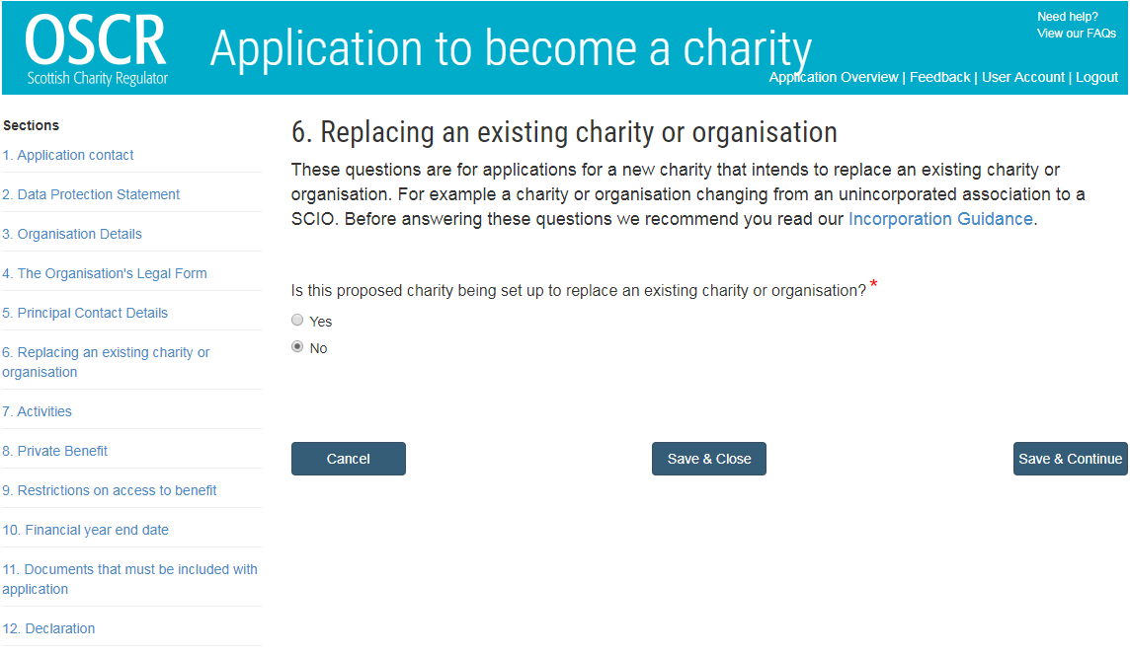 |  | Select No
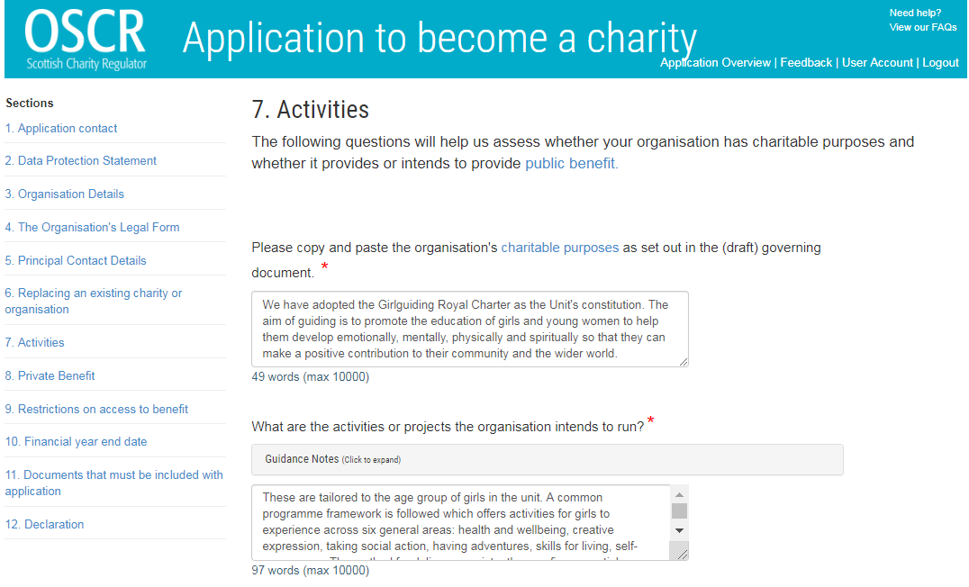 |  | Copy and paste the following:  We have adopted the Girlguiding Royal Charter as the Unit's constitution. The aim of guiding is to promote the education of girls and young women to help them develop emotionally, mentally, physically and spiritually so that they can make a positive contribution to their community and the wider world.  Copy and paste the following:  These are tailored to the age group of girls in the unit. A common programme framework is followed which offers activities for girls to experience across six general areas: health and wellbeing, creative expression, taking social action, having adventures, skills for living, self-awareness. The method for delivery consistently uses five essential ingredients: the programme is varied and balanced, girls work together in small groups, they are encouraged to be self-governing and to be involved in decision making, all must care for the individual and there is a shared commitment to a common standard which encourages proactive citizenship.
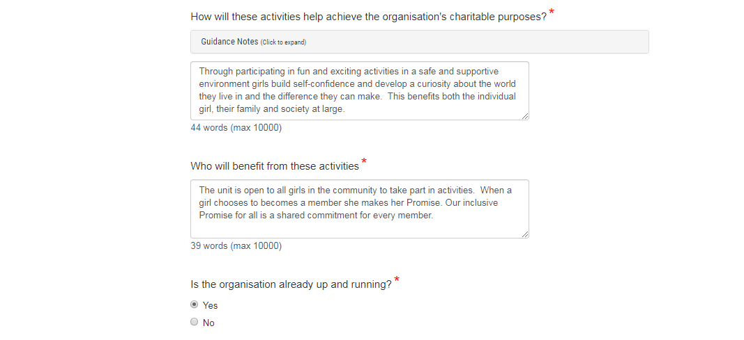 |  | Copy and paste the following:  Through participating in fun and exciting activities in a safe and supportive environment girls build self-confidence and develop a curiosity about the world they live in and the difference they can make. This benefits both the individual girl, their family and society at large.  Copy and paste the following:  The unit is open to all girls in the community to take part in activities. When a girl chooses to becomes a member she makes her Promise. Our inclusive Promise for all is a shared commitment for every member.  Select Yes
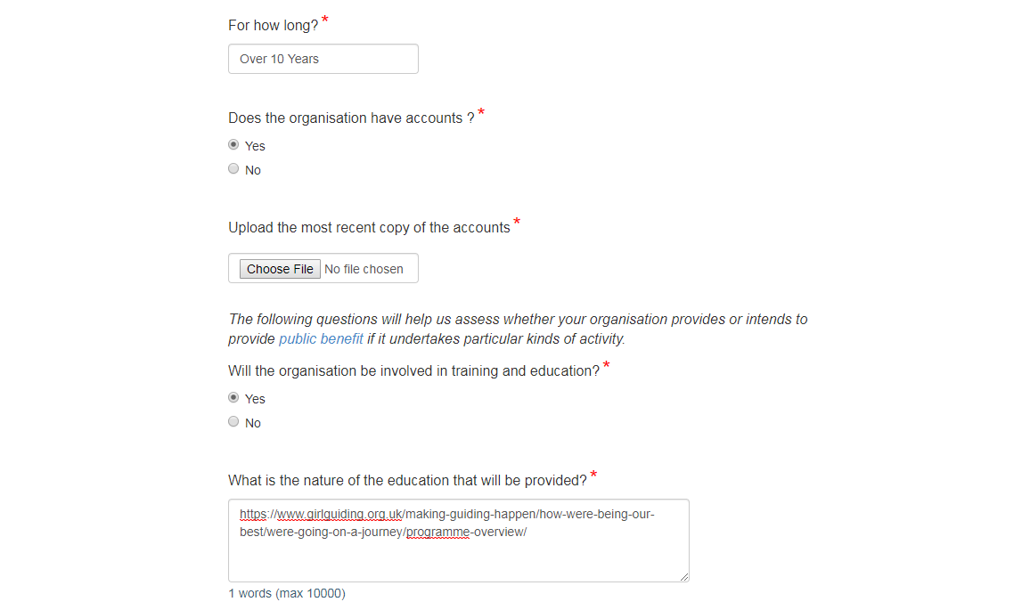  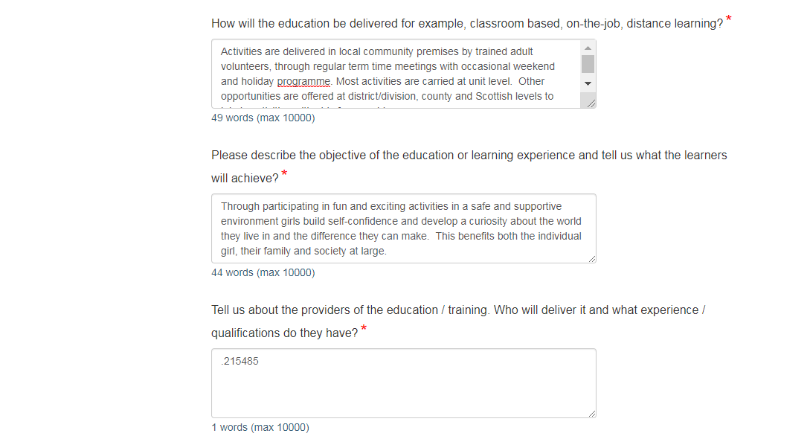 |  | Change to number of years/months if less than 10 years  Select Yes if existing unit. If new select No  Scan and attached the most recent copy of your unit’s accounts  Select Yes  Copy and paste the following:  https://www.girlguiding.org.uk/what-we-do/our-badges-and-activities/programme-for-every-girl/programme-overview/  Copy and paste the following:  Activities are delivered in local community premises by trained adult volunteers, through regular term time meetings with occasional weekend and holiday programme. Most activities are carried at unit level. Other opportunities are offered at district/division, county and Scottish levels to join in activities with girls from a wider area.  Copy and paste the following:  Through participating in fun and exciting activities in a safe and supportive environment girls build self-confidence and develop a curiosity about the world they live in and the difference they can make. This benefits both the individual girl, their family and society at large.  Copy and paste the following:  Our volunteers are subject to compulsory recruitment checks comprising criminal records checking (PVG registration), provision of two references and an interview with a senior volunteer. All volunteers are expected to follow the Girlguiding Code of Conduct. As part of the leadership qualification adult leaders are trained about safety and safeguarding and undertake regular training in in everything from first aid and child safety to running programme activities, planning trips away, communication and unit administration including finances.
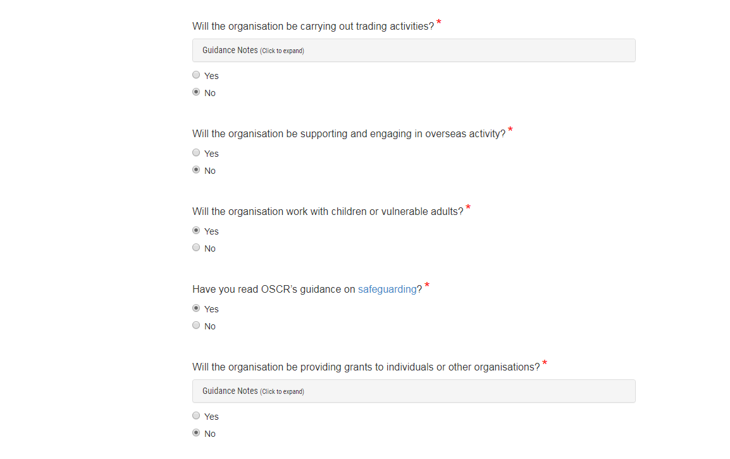 |  | Select No  Select No  Select Yes  Select Yes. You will be complying with Girlguiding safeguarding policy and guidance. OSCR guidance is written for the whole sector and complements it.  Select No
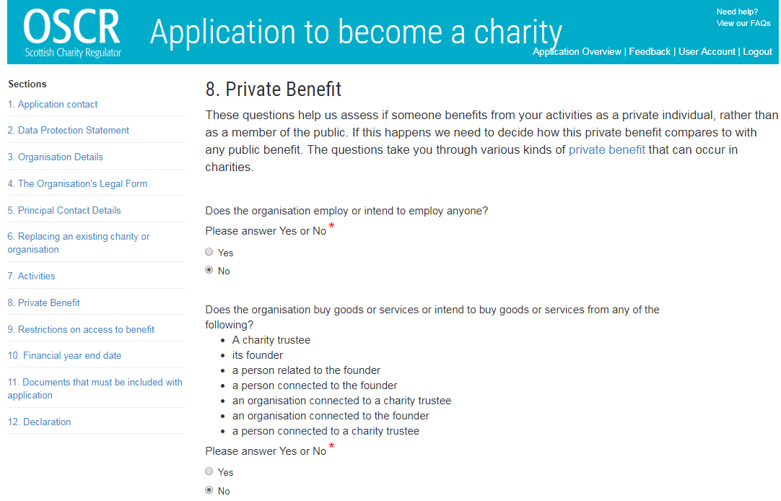 |  | Select No  Select No
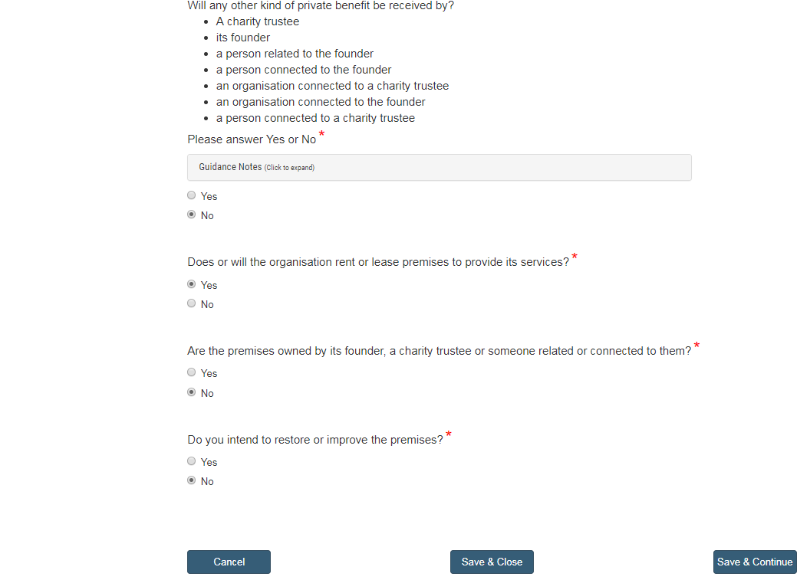 |  | Select No  Select Yes unless you operate out of an owned Girlguiding property without a lease  Select No  Select No
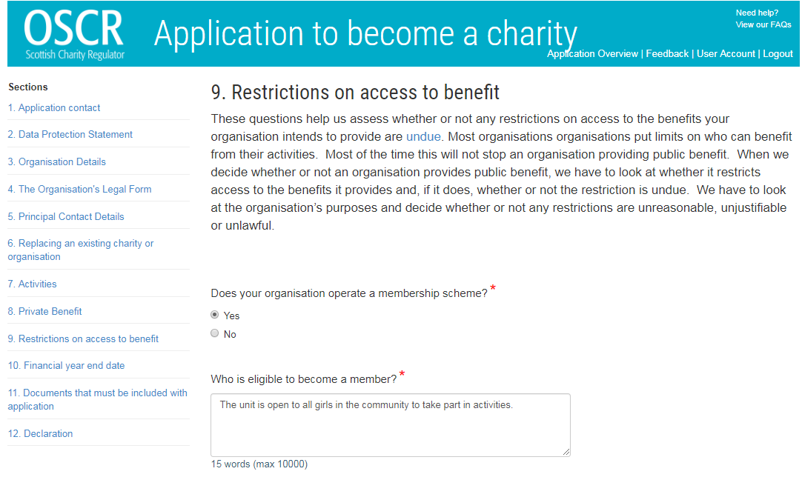 |  | Select Yes  Copy and paste the following:  The unit is open to all girls in the community to take part in activities.
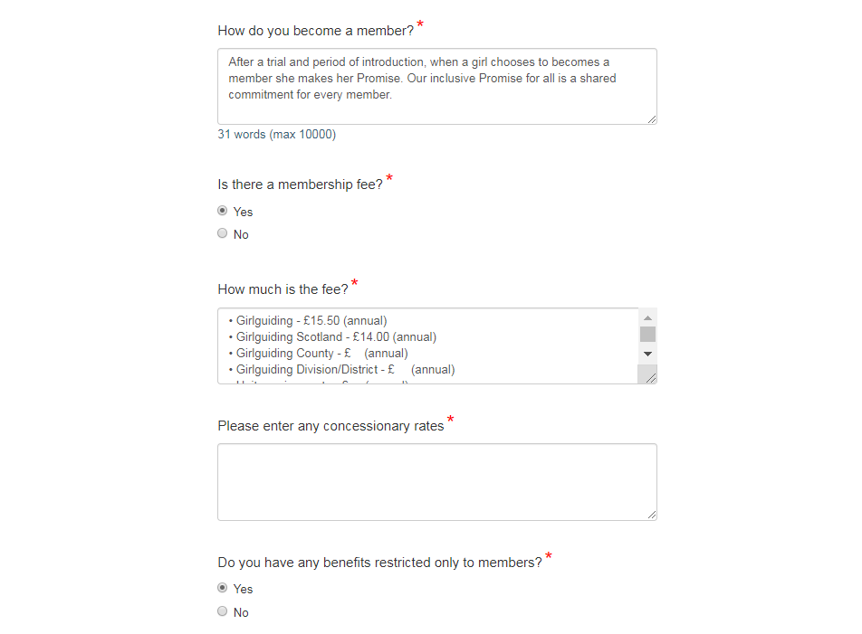 |  | Copy and paste the following:  After a trial and period of introduction, when a girl chooses to becomes a member she makes her Promise. Our inclusive Promise for all is a shared commitment for every member.  Select Yes  Copy and paste and COMPLETE the following:  • Girlguiding - £16.00 (annual) 2020 rate  • Girlguiding Scotland - £14.50 (annual) 2020 rate  • Girlguiding County - £ (annual)  • Girlguiding Division/District - £ (annual)  • Unit running costs - £ (annual)  Enter county/ division/district and unit as applicable.  If you offer sister rate reductions or any other concessions then list them  Select Yes
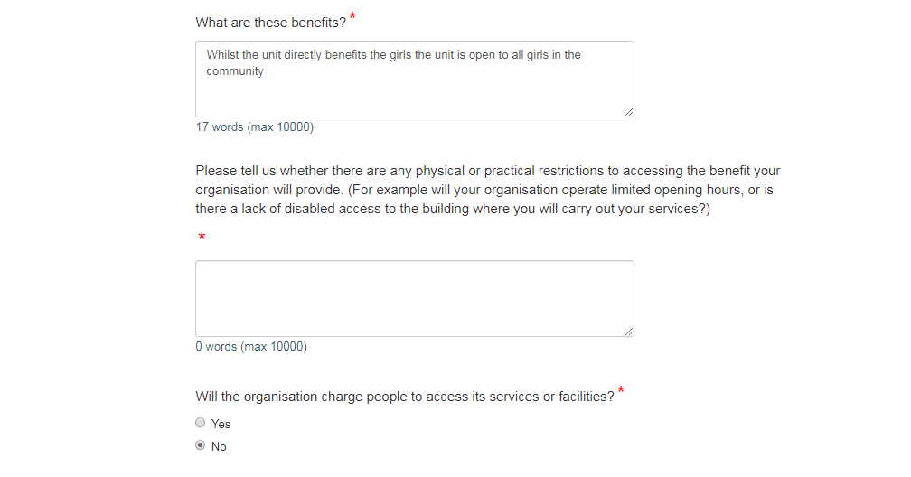 |  | Copy and paste the following:  Whilst the unit directly benefits the girls the unit is open to all girls in the community  As your meeting place should be accessible it is likely that this box will remain blank. But if you do have physical or practical restrictions please add them in.  Select No
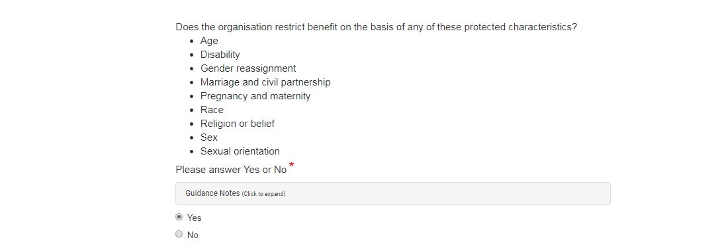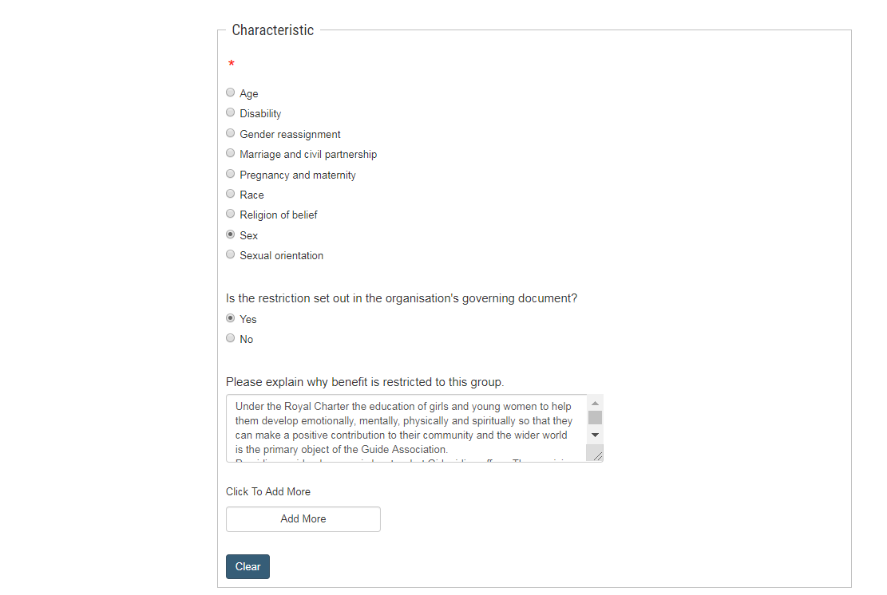 |  | Select Yes  Select “Sex”  Select Yes  Copy and paste the following:  Under the Royal Charter the education of girls and young women to help them develop emotionally, mentally, physically and spiritually so that they can make a positive contribution to their community and the wider world is the primary object of the Guide Association.  Providing a girl-only space is key to what Girlguiding offers. The provision of girl-only space is a way of achieving our aims of enabling girls and young women to develop their potential.
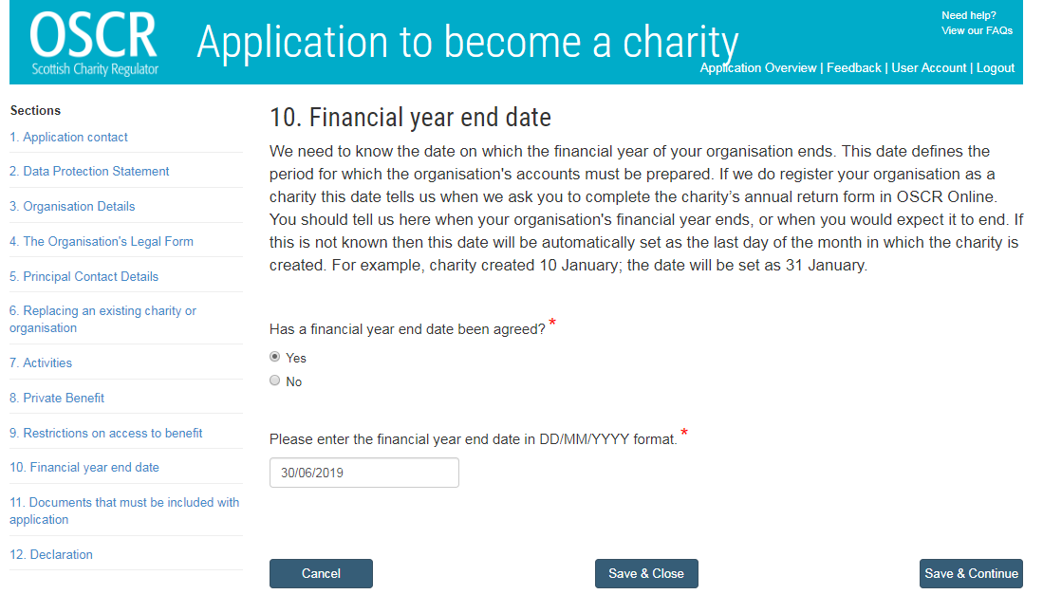 |  | Select Yes  Enter the unit’s accounting year end which will be the same as other units in your county. Check with your commissioner if you are unsure.
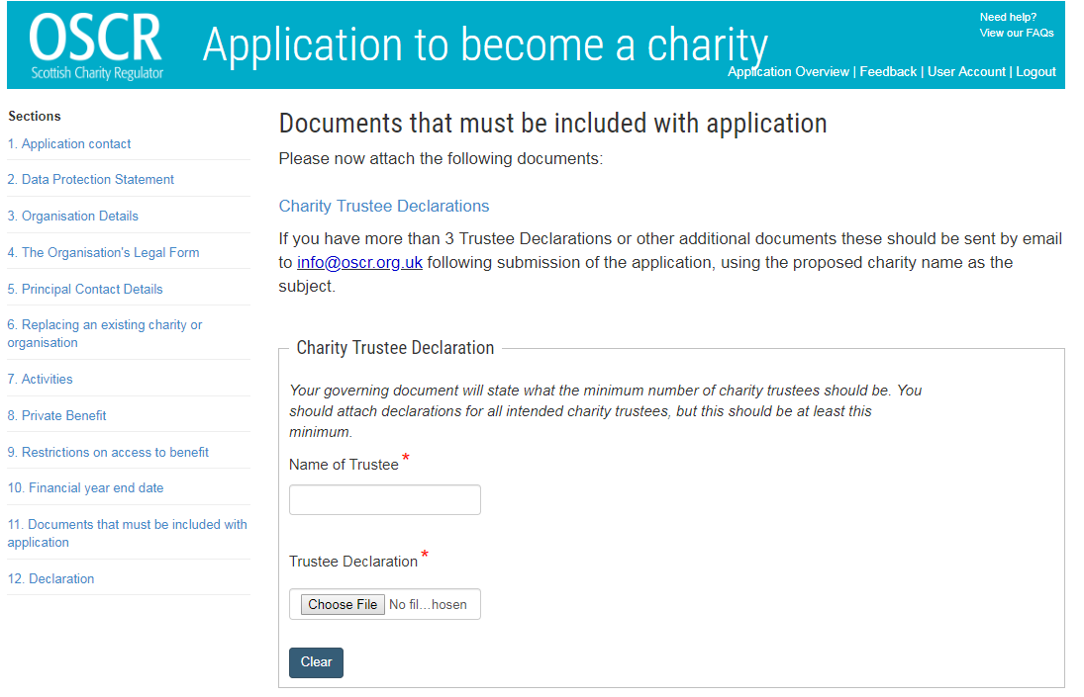 |  | Enter name  Signed and scanned Trustee Declaration forms should be attached here .  Blank forms can be found at https://www.oscr.org.uk/guidance-and-forms/forms-and-templates/trustee-declaration-form  NOTE: Up to 3 trustee declaration forms can be uploaded on this page. If you have more than 3 trustees please note the advice from OSCR at the top of this page
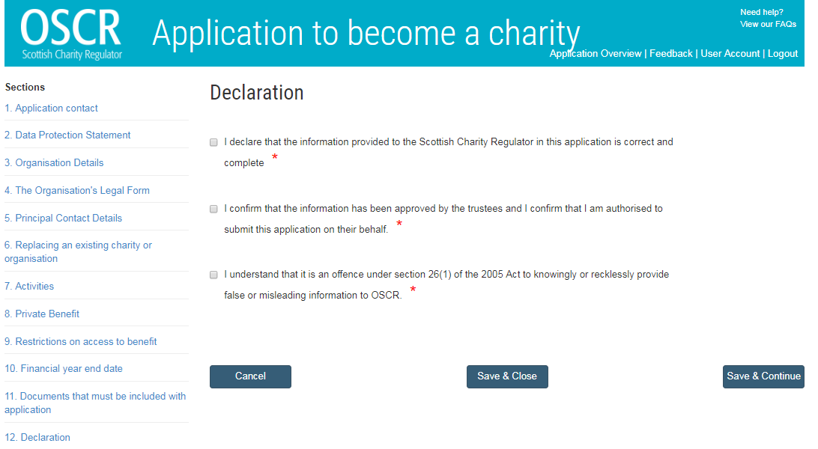 |  | Tick box  Tick box  Tick box
Minute of a meeting of xxxxx Unit, held on xxxx2020 at xxxxxx

Present:

Xxxxxx Unit Leader (Chair)
Xxxxxx Leader

It was unanimously agreed to adopt the Royal Charter dated the 14th December 1922 and supplemental Charters and Orders mutatis mutandis, of the Guide Association as the governing document of the unit. The unit is an unincorporated association formed in Scotland.
The unit will deliver a good guiding programme in accordance with the Guiding Manual, and any amendments thereto issued from time to time. The programme gives girls the space where they can be themselves, build friendships, gain valuable life skills and make a positive difference in their lives and their community.
The members of the unit are girls between the ages of 5 and 7
The adult volunteer leaders listed above are the charity trustees of the unit.

Signed: ______________________
Name:

Signed: ______________________
Name:

Signed: ______________________
Name:

