Social media ads for girl recruitment
We have some graphics and sample social media posts aimed at recruiting more girls, that you can use to highlight Girlguiding in your local area. Click the links below to download the animated graphics.
Sample posts:
There’s lots of fun to be had at with Girlguiding Scotland! Register your daughter today.

Guiding at Hame? No problem! We’re still trying new things and having new adventures right from home. Register your daughter today.

We’ve all had to make changes over the last few months. One thing that hasn’t changed? The awesome experiences Girlguiding Scotland can provide your daughter – right from home!

Girlguiding Scotland has gone digital! Your daughter can join Brownies straight from home – register her today.

Try new things and make new friends with Girlguiding Scotland! Register your daughter today.

Animated images for Instagram (download the images)
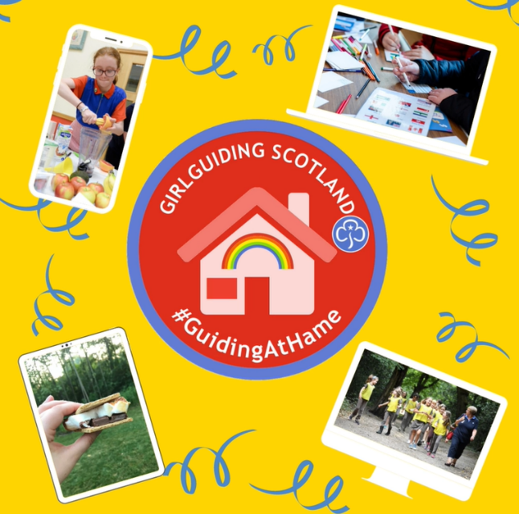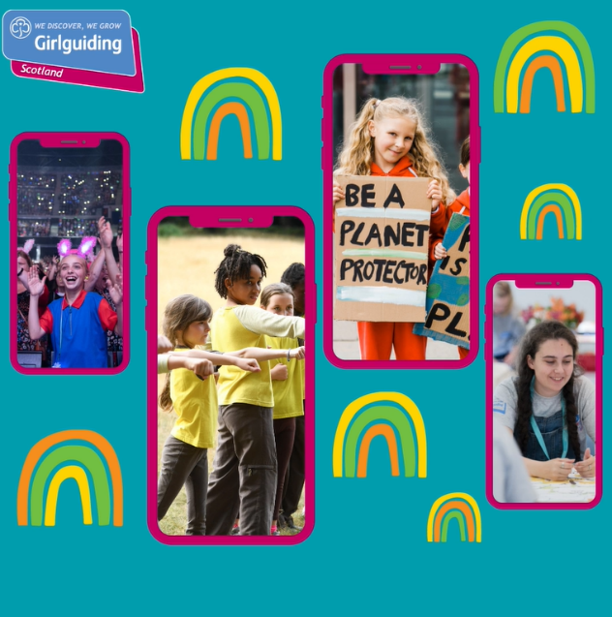

Animated graphics for Facebook and Twitter (download the images)

