Here are some ideas for social media posts to help recruit adult volunteers. Click the links below to download the images. Copy and paste the suggested text and tailor it to your local group, or come up with your own message.
Facebook advert (download the images)
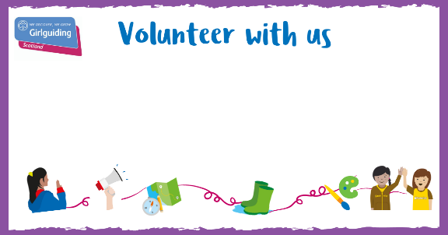 | - @[link to county FB page] are recruiting virtual Brownie leaders in [district/division/local area name]! Interested in joining the fun? Find out more at: link
 | - @[link to county FB page] are now virtually recruiting s’more volunteers! Find more information about how to join here:
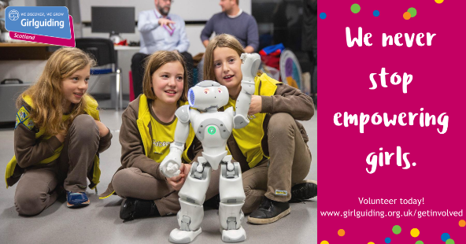 | - 2020 has brought a lot of changes. One thing that hasn’t changed? @[link to county FB page]’s commitment to empowering girls. We’re now recruiting for a variety of virtual volunteer roles to help us continue to empower the next generation of girls! Find out more here: link
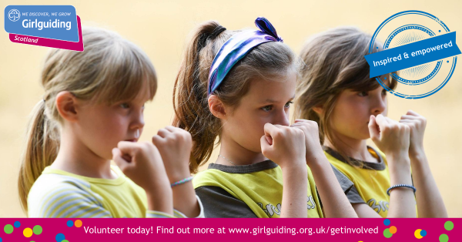 | - Help @[link to county FB page] continue to inspire and empower girls! We’re looking for volunteers to fill a variety of virtual roles across [city/local area]. Find out more here: link
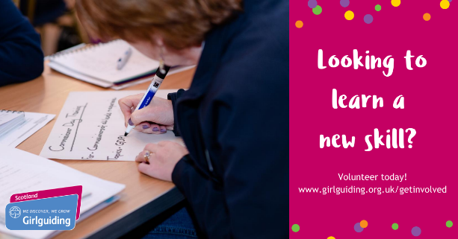 | - Looking to learn a new skill? From communication to time management and beyond, we’ve got you covered! Become a @[link to county FB page] volunteer today! Link

Twitter advert (download the images)
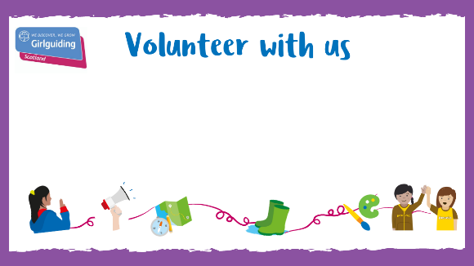 | - .@[link to county twitter] are recruiting virtual Brownie leaders in [district/division/local area name]! Interested in joining the fun? Find out more at: link
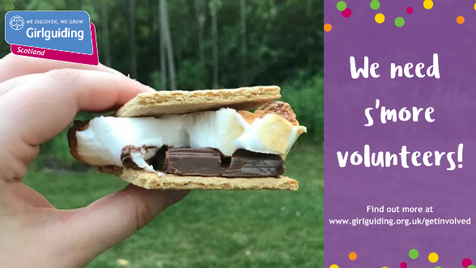 | - Looking for s’more fun? Join @[link to county twitter] as a volunteer today! Link
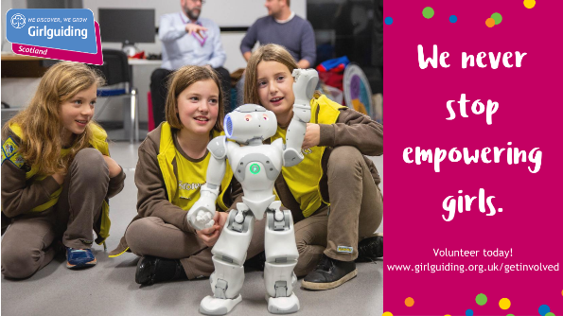 | - 2020 has brought a lot of changes. One thing that hasn’t changed? @[link to county twitter]’s commitment to empowering girls. We’re recruiting for a variety of virtual volunteer roles now! link
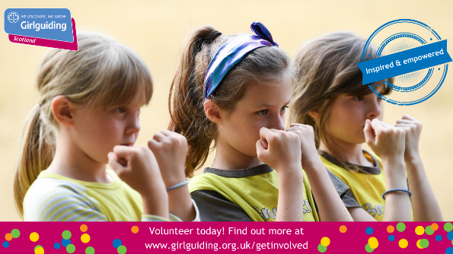 | - Help @[link to county twitter] continue to inspire and empower girls! We’re looking for volunteers to fill a variety of virtual roles across [city/local area]. Find out more here: link
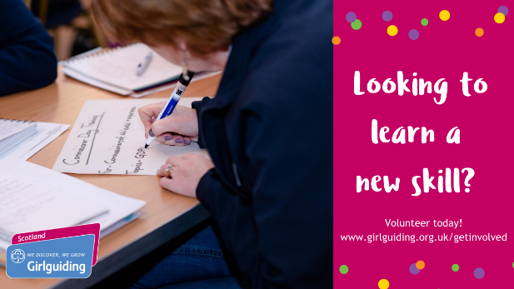 | - Looking to learn a new skill? From communication to time management and beyond, we’ve got you covered! Become a @[link to county twitter] volunteer today! Link

Instagram advert (download the images)
 | - [Link to county Instagram] are recruiting virtual Brownie leaders in [district/division/local area name]! Interested in joining the fun? Find out more at: link
- [Link to county Instagram] are now virtually recruiting s’more volunteers! Find more information about how to join here: link
- Looking for s’more fun? Join [Link to county Instagram] today! link
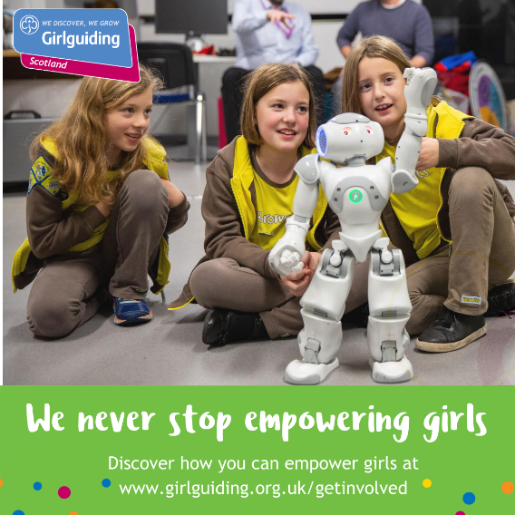 | - 2020 has brought a lot of changes. One thing that hasn’t changed [Link to county Instagram]’s commitment to empowering girls. We’re now recruiting for a variety of virtual volunteer roles to help us continue to empower the next generation of girls! Find out more here: link
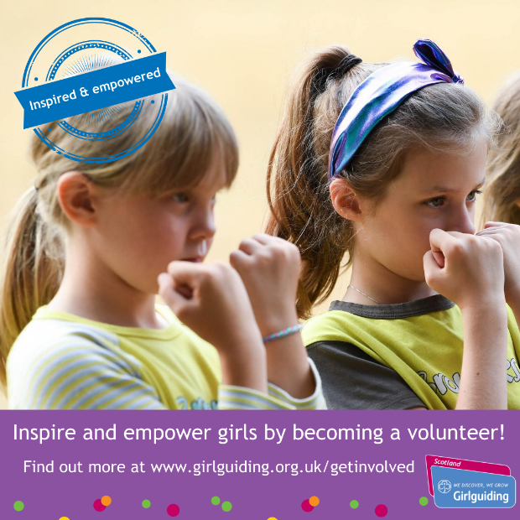 | - Help us continue to inspire and empower girls in [enter county/city/local area]! We’re looking for volunteers to fill a variety of virtual roles across [city/local area]. Find out more here: link
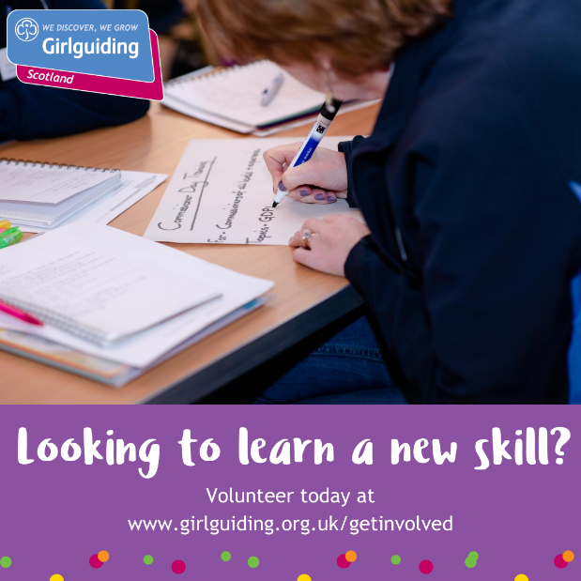 | - Looking to learn a new skill? From communication to time management and beyond, we’ve got you covered! Become a @[link to county Instagram] volunteer today! Link

Additional adverts (download the images)

