The Scottish Outdoor Team is part of the Guiding Development Team, our role is to support leaders and give them the assistance, support and opportunities necessary to help the girls enjoy all that Girlguiding Scotland offers.

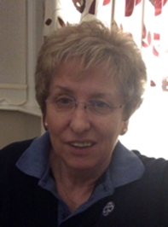 | Sheila Young  Scottish Outdoor Activities Adviser  When I started at a unit, I went along to help for a few weeks to allow the unit to stay open and my older daughter to get a place in Brownies. 30 years on and I'm still here! I have been very fortunate in the opportunities I have had and look forward to leading the Outdoor Team in planning Scottish adventures. Thank you for your support for Rise to the Challenge.
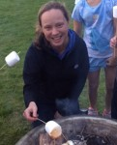 | Sam Robertson  Assistant Scottish Activities Adviser/ DofE Adviser  Having grown up in Helensburgh, I was encouraged through school and family to develop a love for the outdoors. I completed my Gold DofE in 1993 with an expedition through the Cairngorms and a very memorable residential with BSES expeditions in Svalbard. Fast forward 20 plus years and I am still doing Duke of Edinburgh.
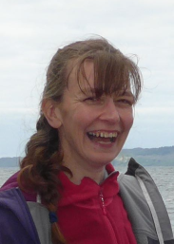 | Anna Hill  Scottish Walking Adviser  My love for walking and adventuring started in my teens when I was a Guide. As an adult Girlguiding has given me the confidence to become qualified to take the girls out on the mountains. As the Walking adviser I would like to help girls have adventures, and give adult leaders the confidence and opportunity to lead the girls to those adventurous places.
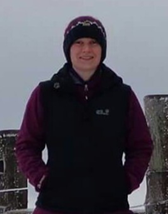 | Linsey Houghton  John Muir Adviser  I have been involved in Girlguiding for as long as I can remember. I'm happiest walking, camping and teaching others about the environment they live in. I am really keen to get as many units as possible interested in and taking part in the John Muir scheme, so if you love the environment and want to do something to help conserve it then get in touch.
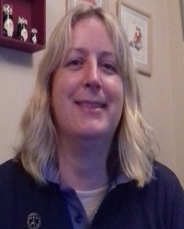 | Jane Ballany  Going Away Outdoor Adviser  I have been a member since becoming a Brownie at age 7. I've had loads of adventures between then and now as both a girl and leader. I love camping and would encourage everyone to give it a go. It gives the girls the chance to grow in confidence, develop their independence and team building skills whilst having fun in a safe environment. I hope to motivate you all to take your girls camping and to complete your Going Away With licence.
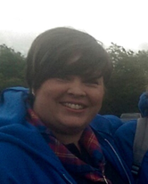 | Greer Litster  Going Away Indoor Adviser  I've been a leader for over 15 years and currently run a Brownie and Guide unit. I love taking the girls away on adventures and would love to help you do the same. The girls have a fantastic time and you can see the difference in their confidence when they come home. Let’s get planning together and make sure as many girls get away on an adventure this year as possible!

