The Marketing and Communication Committee supports and facilitates Girlguiding Scotland’s marketing and communications work across the media, marketing and digital channels.
Tina Alexander
Marketing & Communication Committee Chair

I am the Chair of Girlguiding Scotland’s Marketing and Communication Committee, supporting the staff and volunteer team to promote Girlguiding Scotland and all that we do for girls and young women across the country.

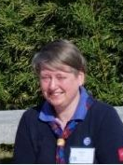 | Janice Blair  Marketing & Communication Committee Vice Chair  As the Vice Chair for Girlguiding Scotland’s Marketing and Communications Committee, I support the staff and volunteer team to promote Girlguiding Scotland. In particular I work with our network of county public relations advisers (CPRAs), supporting them to promote guiding in their local areas.
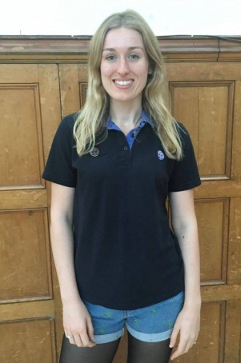 | Kimberley Chatt  Digital Champions Coordinator  I support our network of digital champions to help capture the fun and adventure of Girlguiding in their local areas - this includes arranging for digital champions to attend and document fun-days and events across Scotland and supporting volunteers to promote Girlguiding Scotland across digital channels.
Hannah Brisbane
Lead volunteer for Voice

I work with Girlguiding Scotland’s Marketing and Communication staff and volunteer team to promote girls’ voices, making sure young members’ views and experiences at the heart of our campaigning and promotional work and supporting girls to speak up on the issues that matter to them.
Lead volunteer for CPRAs
(role currently being covered by Vice Chair)

