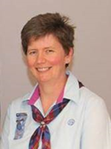 | Tricia Davenport  Chair of Membership Support  As chair of the Membership Support Team, I work with a great group of enthusiastic people, supporting members across Scotland, sharing good practice and promoting programme developments. I represent the team on the Guiding Development committee and I'm a Brownie leader in Clackmannanshire - I'm also outdoor adviser for the county.
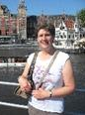 | Elizabeth Reid  Lones Adviser  As the Scottish Lones adviser/commissioner, I attend county commissioner events and I am also part of the Membership Support Team. I have been the unit leader of the Coldstream Guides for over 36 years. The role as Lones commissioner has been very challenging but satisfying.
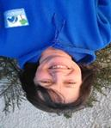 | Gillian Greenhow  Rainbow Adviser  I have been a Rainbow leader for almost 10 years in Tweed Valley in the Scottish Borders. I am also a job share district commissioner. I would love to hear what other Rainbow leaders are up to and to share ideas. I am really keen to promote sleepovers, they are great fun and a real opportunity to spend longer with your girls. Please get in touch if you need support with this or have any questions at all, if I don't know the answer I will do my best to find out for you.
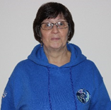 | Karen Mackie  Brownie Adviser  I have been a leader for 38 years. I enjoy my present role as adviser as it has allowed me to meet leaders from all over Scotland and be involved in the organisation of Brownie Events in Scotland. I also enjoy being part of the Membership Support Team and contributing towards Guiding Development. I hope to be able to support Brownie leaders and look forward to hearing from them.
Nicola Gray
Guide Adviser

I am a Guide leader and leader of The Senior Section from Inverurie in Gordon county. I have been a member of Girlguiding for almost 26 years now. My favourite part of being a leader is seeing the girls grow over their time in Guides, flourishing into confident young women. In my role as Guide adviser I can offer support with the transition between Brownies and Guides and Guides and The Senior Section.

Role vacant
Senior Section Adviser
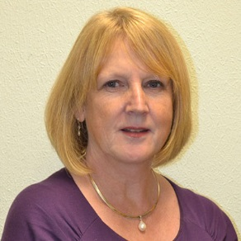 | Jan Thomson  Safe Space Adviser  I am the assistant county commissioner for Midlothian. Professionally I have experience of issues relating to safeguarding. I am pleased to be connected with the new Scottish county concerns team led by Elaine Kelly.
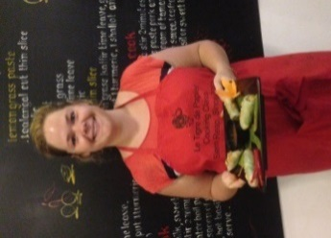 | Fiona Loudoun  Additional Needs Adviser  I am a unit leader at a local Brownie unit in Dundee. Outside of Girlguiding, I am an Occupational Therapist for children and young people and enjoy baking and spending time with friends and family. I can provide advice and guidance to allow adults or girls with any additional support needs to fully participate as much as they can within Girlguiding Scotland. I am now part of the county concerns team with Elaine Kelly.
Mikaela Shand
Join Us & GO Co-ordinator

I'm a Guide leader and leader of The Senior Section in Aberdeenshire. My role as Join Us and GO coordinator allows me to support adult members to give new girls and volunteers a warm welcome to our amazing charity. I also help our current members to use the membership systems efficiently and effectively to grow the membership.

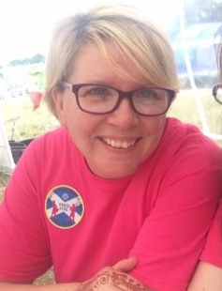  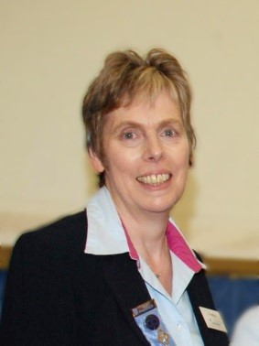 | Lorraine Dickson  BP Co-ordinator  I organise the BP Adventures for Girlguiding Scotland and provide support, advice and encouragement to Guide leaders, I am also a prospective trainer.  Elaine Kelly  County Concerns Team (Chair)  Hello everyone! I’ve just finished as deputy scottish chief commissioner and have agreed to coordinate processes relating to handling county concerns.

