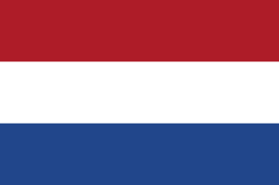

LET’S GO GLOBAL: THE NETHERLANDS
Explore the Netherland with these fun & easy activities
Guiding in The Netherlands

The Netherlands have one guiding and scouting organisation for boys and girls.

Guides in The Netherlands make this Promise: “I promise to do my best to be a good Guide (with the help of God*), to help everyone wherever I can, to go consciously in search of the spiritual value in my life, and to live up to the Guide law. You can count on me!”

*Members can choose whether or not to say this line at part of their Promise

And their Law says:
A Guide goes out with others to discover the world around her and to make it more worthwhile to live in.
She is honest, faithful and perseveres.
She is thrifty, and sober and takes good care of nature.
She respects herself and others.

Now that you know a bit more about guiding in The Netherlands learn about the country and its culture with these fun activities.

Put your best foot forward

Sections: Suitable for all
Time: 30 minutes
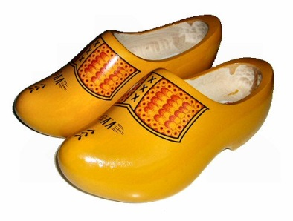
What you’ll need: Paper or card, selotape, marker and extras to decorate.

Wooden shoes or clogs are traditional footwear in the Netherlands. See if your unit can make their own clogs from paper or card and decorate them however you like. Try them on and see who can walk the furthest in their home-made shoes.

Stay High and Dry

Sections: Suitable for all
Time: 30 minutes
What You Will Need: Spaghetti, newspaper, marshmallows and any other crafting supplies you like

The Netherlands means "lower countries" and the country gets its name from the fact that just half of its land is more than a metre above sea level. In fact people of the Netherlands have engineered lots of ways to help them stay dry.

Can you make structure over one meter high using different materials? The design is up to you but your structure has to stand on its own! You could use spaghetti and marshmallows, paper, recycled materials etc!

If you’re feeling competitive give a prize to the tallest and most stable structure

Swap for King’s Day

Sections: Best for Brownies, Guides, Senior Section
Time: 30 mins
What You Will Need:

Koningsdag, meaning "King’s Day", is a national holiday in the Netherlands for the King's Birthday on 27th April. One of the ways people celebrate is with Flea Markets in the streets for one day only where they swap or sell their old clothes and possessions! This encourages people to re-use and recycle, not just throw old possession away.

Hold a swapping evening with your unit where everyone brings a piece of clothing, a book, a toy or an accessory they don’t want any more and trades it for something new to them. Alternatively hold a Bring and Buy sale to help your unit fundraise.

