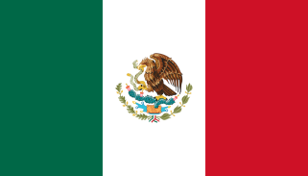

LET’S GO GLOBAL: MEXICO

Explore Mexico with our fun and easy activities for all ages!

Guiding in Mexico

Guiding began in Mexico in 1930.

In Mexico Rainbows are called Girasolas (meaning sunflowers), Brownies are called Haditas (meaning Fairies) Guides are called Guias and their Senior Section is called Guias Mayores.

Mexican Girl Guides say this Promise: “I promise on my honour that I will do my best, to do my duty to God and Mexico, my country, to help other people, and to live the Guide Law”

And they follow this Guide Law:

- A Guide’s honour is to be trusted
- A Guide is loyal
- A Guide is useful and helps others
- A Guide encourages peace and is a sister to every other Guide
- A Guide is courteous
- A Guide conserves and improves the environment and sees in nature the work of God
- A Guide obeys orders
- A Guide confronts difficulties wholeheartedly and with optimism
- A Guide is thrifty
- A Guide is pure in thought, in word and in deed

Now that you know more about guiding in Mexico try out these fun activities to help your unit explore the country and its culture.
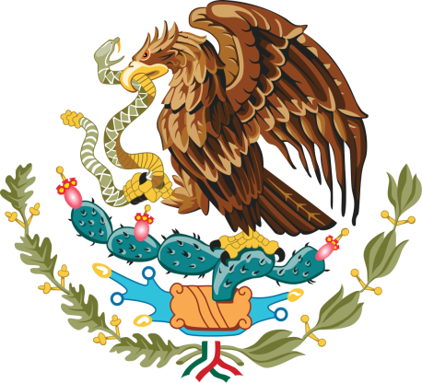
Choose your symbol

Who is for? Fun for all Sections
Time: 30 mins
What You Will Need: Pen and paper

The golden eagle is the national symbol of Mexico and it represents the legend of an eagle sitting on a cactus which signalled to the Aztec people where they should found the ancient city of Tenochtitlan.

If your unit had to choose something to represent it – what would it be? Choose a symbol to represent your unit – it can be an animal, plant or something totally different. Draw your symbol and explain to the group why you think it should represent the group.

If you want to go a step further why not take a vote once everyone has presented their idea and choose one symbol to represent your unit.

Shake some musical maracas

Who is it for: Best for Rainbows, Brownies, Guides
Time: 30 mins
What You Will Need: Egg cartons, sticky tape, tissue paper, dried beans or lentils, popsicle stick, tissue paper to decorate.

The maracas are a popular musical instrument in Mexico. Have a go at making your own from dried peas, beans or lentils. Follow the instructions below or look online for more inspiration.

- Cut out two egg cups from an egg carton.
- Fill one of these cartons with dried lentils or beans.
- Put your popsicle stick over the filled cup, then place the empty cup over this – to create a sphere.
- Tape your two egg cups together securely with the popsicle stick in between. Make sure there are a no gaps for your dried lentils to leak out of!
- Decorate your maracas with coloured tissue paper, glitter and more and shake away!

Celebrate with Cascaron Eggs

Who is for: Fun for all Sections

Time: 1 hour
What You Will Need: eggs, food colouring or markers, sticky or glue and tissue paper. Paper confetti (two cups per dozen eggs)

"Cascaron" is the Spanish word for eggshell. They eggshells are filled with confetti and are used for all sorts of celebrations including weddings, birthdays and Cinco De Mayo. To make your own:

- Make about a half inch hole in the bottom or top of an egg and drain the inside
- Rinse out the inside of the egg. When it is completely dry—decorate. You can use food colouring or markets.
- Fully fill the dry egg with paper confetti.
- Once finished, place a small piece of scotch tape over the opening of the egg...or glue on a small piece of tissue paper that matches the egg.
- Crack them to unleash a confetti shower – just remember to do this somewhere where it’s easy to clean up afterwards!

You can find photos and further instructions www.kidactivities.net/post/Cinco-de-Mayo-for-Kids.aspx

