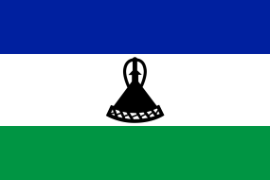
Let’s Go global: Lesotho
Explore Lesotho with our fun and easy activities for all ages!

Guiding in Lesotho

The Lesotho Girl Guide Association started in 1925.

In Lesotho, Guides make this Promise: “I promise that I will do my best to do my duty to God and my country, to help other people at all times, and to obey the Guide Law.”

And they keep this Guide Law:
- A Guide's Honour is to be trusted
- A Guide is loyal
- A Guide is helpful
- A Guide is friendly
- A Guide is polite and thoughtful of others
- A Guide is cares for the environment and all living things
- A Guide is obedient
- A Guide is smiles and sings under difficulties
- A Guide is thrifty
- A Guide is pure in thought, word and deed

Now that you know more about guiding in Lesotho try out these fun activities to help your unit explore the country and its culture.

Build your own Mokhoro

Sections: All
Time: 1 hour
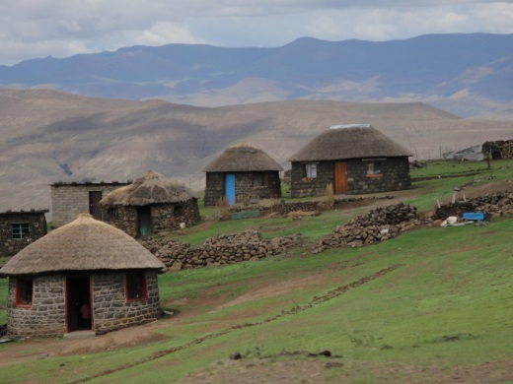
What You Will Need: sticks, stones, leaves. If you’re struggling to find these you can use materials crafting materials like card and popsicle sticks.

The traditional style of housing in Lesotho is called a Mokhoro and many older houses especially in smaller towns and villages are of this style. The Mokhoro is usually round or oval in shape and is traditionally made with natural materials, with walls made of large stones cemented together.

Split your unit into small group and have the girls use stones, sticks, grasses and other natural materials. If you’re struggling to find natural materials you can use crafting supplies like cardboard, straws or popsicles.

Then either outside or inside construct your Mokhoro. See if you can make one big enough for a small toy, or something similar, to fit inside and make sure it stays standing long enough for everyone to admire each other’s houses.

Design your own Basotho Blanket

Sections: All
Time: 30 mins
What You Will Need: Paper and pens
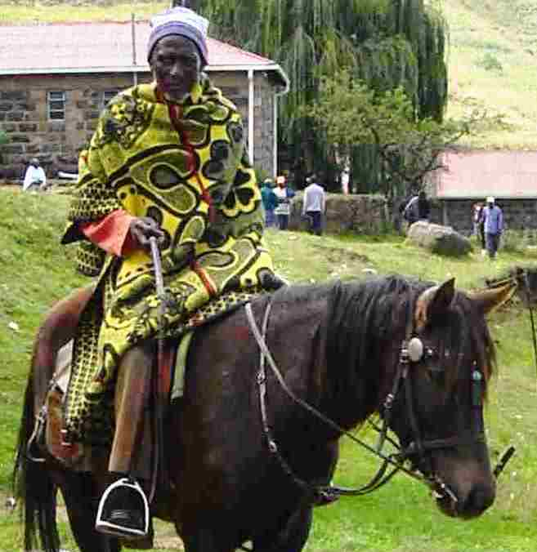
Traditional attire in Lesotho revolves around the Basotho blanket, a thick covering made primarily of wool. The blankets are popular throughout the country during all seasons and are worn differently for men and women.

The tradition dates back to 1860 when King Moshoeshoe I, founder of Lesotho, was given a wool blanket as a gift and made it a favourite part of this outfit. The King started quire a trend and it was soon adopted by many Bosotho people and became an important part of key life event like marriage and
birth.

Basotho blankets come in all different colours and designs but they have signature pin-stripes in common. This pin-stripe was originally a mistake by the weaver but it’s not become an iconic part of the Basotho blanket style. Can you spot the red pin-stripe on the one in this photo?

Design your own Basotho blankets using the pens and paper. Why have you chosen the colour you have? Have you remembered to include the signature pin-stripes on your blanket? Have you used any important symbols on your blanket?

