LET’S GO GLOBAL: IRELAND
Explore Ireland with these fun & easy activities
Guiding in Ireland

Guiding in Ireland began in 1911.

Irish Guides say this Promise: I promise on my honour to do my best, to do my duty to my God (or faith) and my country, to help other people at all times, and to obey the Guide Law".
Guiding in Ireland in split into the following age groups:
Ladybirds –ages 5 - 7 years
Brownies – ages 7 - 10
Guides - ages10 - 14
Senior Branch - ages 14 – 30

Now that you know a little more about guiding in Ireland, learn more about the country and its culture with these fun activities.
Tie your own Celtic Knot

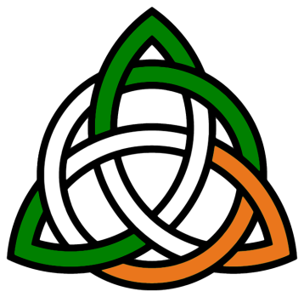
Sections: All
Time: 30 mins
What You Will Need: String / cord

Celtic knots are a traditional part of Irish art and crafts. The interlacing patterns represent eternity and continuity. You can make your own Celtic knot with just one piece of cord by following this step-by-step guide.
Hunt for gold

Sections: Rainbows, Brownies
Time: 15 mins
What You Will Need: Gold Coins / Treasure

Leprechauns are famous characters from Irish folklore – well known for their love of mischief and for supposedly hiding their gold at the end of rainbows.
Hold a gold hunt with your unit and see who can gather the most gold coins (unless you’re really a leprechaun you’ll want to use chocolate or paper coins for this one!)
Make it more of challenge by having the girls split into teams and see who can collect the most.

Kiss the Blarney Stone

Sections: Rainbows, Brownies, Guides
Time: 15 mins
What You Will Need: Poster, markers, post-it notes
The Blarney Stone is famous for its legendary powers – according to the well-known story those who kiss the ancient stone at Blarney Castle will become brilliant speakers – able to charm and persuade!
But you don’t have to go all the way to Ireland to give it a go – try out this quick and easy game.
- Draw a Blarney Stone on a poster and hang it on the wall.
- Have the players draw lips on post-it notes.
- Blindfold them one by one and spin them around 3 times (if you want to make it extra challenging).
- Then have the players attempt to stick their lips on the Blarney Stone. Players who come the closest win the gift of the gab!

