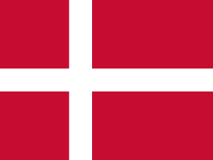
Let’s Go Global: Denmark
Explore Denmark with our fun and easy activities for all ages!

About Guiding in Denmark

Guiding in Denmark was founded in 1910 and the country became a foundation member of WAGGS in 1928.

In Denmark guiding is split into the following sections:
- Ranger Seniorspejder (ages 16-23)
- Guide Spejder (ages 12-16)
- Junior Guide Juniorspejder (ages 10-12)
- Mini-Guide Minispejder (ages 8-10)

- Micro-Guide Mikrospejder (ages 6-8)

Guides in Denmark make this Promise: “I promise to keep the Guide Law.”

Their motto says: “Be Prepared.”

And their Guide Law says:

The Guide who is part of the Guide fellowship does her best:
- to find her own faith and respect the faith of others
- to protect nature
- to be a good friend, considerate and helpful to others
- to be trustworthy
- to listen to the opinion of others and to form her own
- to show responsibility in the family and in society (or, to take her
share in responsibility for her family and her surroundings).

Now that you know more about guiding in Denmark explore the country and its culture with these fun activities.

Let’s make MINI KIKsEKAGE

Sections: Rainbows, Brownies, Guides, Senior Section

Time: 30 minutes plus time to chill

What you’ll need: see full ingredient list at http://nordicfoodliving.com/mini-danish-chocolate-biscuit-cake-mini-kiksekage/

Girls of all ages – and Leaders too – will love tucking into these traditional Danish treats – and you don’t even need to put them in the oven.

Check out the full recipe and step by step instructions at nordicfoodliving.com/mini-danish-chocolate-biscuit-cake-mini-kiksekage

DISOVER YOUR VIKING NAME

Sections: Rainbows, Brownies, Guides

Time: 15 minutes

What you will need: Pens, paper and a rune alphabet

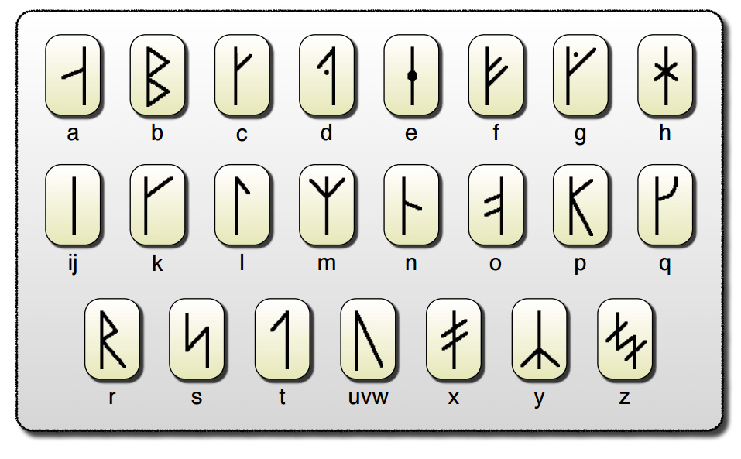
Vikings lived in Denmark from around 793 – 1066 and they’ve made their mark on Danish culture and history. The Viking alphabet is made up of letters called runes. Use the key below to see if you can write your name in Viking!

For a free print out of this resource, at www.teachingideas.co.uk/vikings/the-viking-alphabet

GET BUILDING WITH LEGO

Sections: Rainbows, Brownies, Guides, Senior Section
Time: 15 mins
What You Will Need: LEGO

Denmark is the home of LEGO - the now-famous plastic bricks were first manufactured there in 1947. Can you build something Girlguiding-themed? What about a Trefoil? Or a Rainbow? If you are feeling extra ambition, why not attempt to build a full a World Centre?

If you want to make it more of challenge, set a time and see who can build the biggest and best creation while racing against the clock!

BE INSPIRED BY HANS CHRISTIAN ANDERSEN

Sections: Brownies, Guides
Time: 30 mins
What you will need: Your imagination

Hans Christian Andersen is a famous children’s author and while your girls might not recognise the name they’re sure to have heard of some of his best-loved stories like the Ugly Duckling, Emperor’s New Clothes, Thumbelina and the Little Mermaid.

His stories have gone onto inspire ballets, films and plays. You read some of his best-known stories for free at www.eastoftheweb.com/short-stories/index.php?p=web/author/HansChristianAndersen

Have your girls to choose a Hans Christian Andersen story to bring to life by making up a short play. If you want to be extra creative, see if they can put a modern twist on it!

