The Scottish Learning and Development Team is part of the Girlguiding Scotland Guiding Development Team. Our role is to provide learning and development opportunities to members.

Libby Spence
Chair – Learning and Development Team

As Chair of Learning and Development I lead the Learning and Development Team. We promote learning and development across Scotland particularly for for trainers and prospective trainers but encompass all leaders.

I am also a Rainbow leader and trainer.

Julie Johnston
Becoming A Trainer Co-ordinator

As ‘becoming a trainer’ co-ordinator, I support leaders in the first stages of progressing to become a prospective trainer.
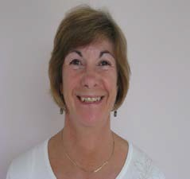 | Sine Creagmile  Adviser for Trainings and Bookings  As the adviser for trainings and bookings, I am the contact for anyone wishing to book a training session in Scotland. I co-ordinate the trainers and prospective trainers to deliver these trainings. I am also a trainer.
Erin Fulton
Peer Education Representative

I'm the Peer Education Representative on the Scottish Learning and Development Team. I support links between the peer educators and the Learning Development Team, and keep them posted on all the awesome stuff that is happening in Peer Education.
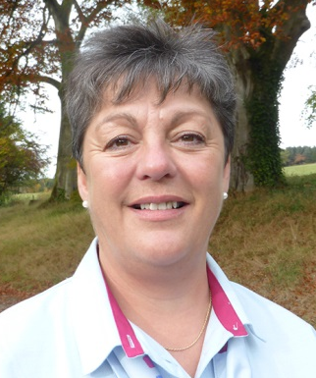 | Anne Andrew  County Commissioner Representative  As county commissioner representative, I am the link between the Learning & Development Team and the county commissioners. I advise on any learning and development needs and requests from around the counties.
Evelyn Dick
Trainer Co-ordinator

As trainer co-ordinator, I advise and support all the trainers across Scotland, ensuring that we are achieving excellence and good quality across Scotland, and meeting the national objectives and standards in a consistent manner.

I am also a trainer, tutor and reviewer.

