The International Team is part of Girlguiding Scotland’s Guiding Development team. Their role is to facilitate amazing international adventures for members.

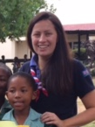 | Alison Coyle  International Adviser  I am very passionate about international travel and love working with leaders and girls on their plans to go away. I have previously taken part in trips to Ghana and various other overseas destinations and been a participant on a GOLD trip.  If you have any questions regarding INTOPS or any international travel, please get in touch.
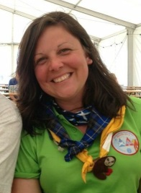 | Emma Ritchie  Assistant International Adviser  International for me is such an exciting part of Girlguiding and I’m lucky to have been able to participate, lead and facilitate opportunities for Girlguiding Scotland members to open the doors to the world. For me hearing what a wonderful time the members had and the new friendships made is fantastic! No international opportunity is too small and I would love to help you have an adventure. There is a vast array of opportunities within the international remit and I am more than happy to share them with you or help you promote your own. If you would like any support or have any questions about opportunities please get in touch.
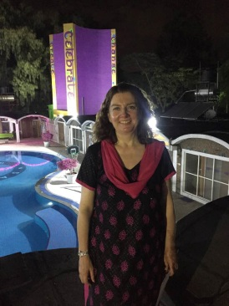 | Sandie Macdonald  ICE Co-ordinator  International trips are my most favourite part of Girlguiding as they give members the chance to explore new countries and cultures while making friends from all over the world. As ICE Coordinator I provide opportunities for Guides to combine community action projects with international adventure to help them understand how their actions can make a difference to the lives of others and hopefully inspire them to become responsible global citizens.
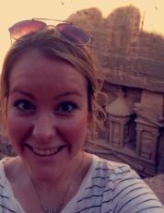 | Emma Guthrie  Girl Project Co-ordinator  One of my favourite things about Girlguiding is the international experiences it can provide. In 2013 I went on a GOLD project to Armenia and then led a project to The Gambia. These trips were two of the best things I have ever done and I want to give as many girls as possible similar opportunities. We are really excited to be offering volunteer service projects to girls from Girlguiding Scotland and are kicking this off with Mexico 2016. If you want to find out more about these or have an idea for a partnership with another country, please get in touch!

