

Here are some handy hints help complete the challenges!
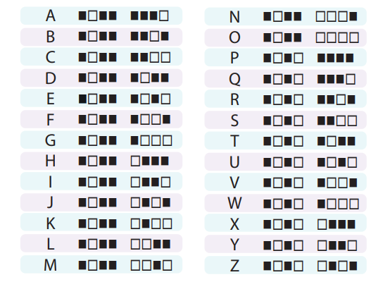
Binary Bling
Design a bracelet with a secret message using binary code, a computer coding system, using the secret code sheet (there’s a bracelet template that can be used below the binary decoder key).
If you’re doing this at home you can encourage siblings to get involved or girls can reach out to friends via video call or email. To find out more about this activity check out this video.
Rainbow 2.0
This is all about taking things to the next level! Instead of drawing your rainbow, use items you can find around the house to make one. For example, you could use different coloured cups, old towels, cereal boxes, shoe boxes etc. Encourage girls to get creative, how big can they make it? What are the most unusual items they can use? Maybe add a scientific twist by putting Skittles sweets round a plate and add some water to make a round rainbow?
In an online meeting scenario, you could message girls beforehand and ask them to gather items in time for your video call. Then discuss all the different ways they can create their Rainbow while the meeting is taking place. Parents/carers can group together to make their rainbow creation a family effort!
3D Delicious
Encourage girls to decorate a Scottish-themed 3D character cake. No need to bake it, this is all about decorating, but you can if you want! In a virtual meeting you could explain the concept in more detail, chat about different Scottish themes (from Highland Cows to the national animal of Scotland, the unicorn) to help get their creative juices flowing. Then it’s time to let girls loose on their own creations and girls can share their pictures at the next meeting.
Just as with the Rainbow 2.0 challenge, if you’re doing this at home and not as part of a meeting, why not try and make this activity another fun-filled family effort?
What’s needed: a readymade cake from the shops, cake decorating equipment (fruit will work too). Younger kids may need supervision but older children and teens may wish to bake the cake themselves!

#Uniform4Uniforms
The Girlguiding Advocates have been spreading the word about #Uniforms4Uniforms, a great way for members to send a big thank you to all the key workers, NHS and care sector staff for their incredible job they’re doing right now. To get involved, members wear their guiding uniform while taking part in the nationwide clap for carers nationwide, every Thursday evening at 8pm.
A lot of units have been sharing pictures and videos of their members taking for in the #ClapForOurCarers effort, and older members are encouraged to share their own pictures and videos if they can. Non-members can still take part, but your challenge is to make as much noise as you can, so pots and pans at the ready!
Get Ready for the Launch
Make your own rockets from paper, using a straw as your rocket launcher. Take a look at the links below for a better idea of how this works, younger kids might need this explained to them before they can start building their own rockets. All family members are welcome to have a go and see whose rocket flies the furthest. Here’s a video to help you get started.
To make the rockets, wrap paper round a pencil the same size as your straw or print a template from NASA. Once you’ve made one, pop it on your paper straw and you’re ready for lift off! How far can you make your rocket fly? Try different designs – does the rocket fly better or worse with different shapes of fins?
Shall We Dance?
Don’t forget to put on your dancing shoes for this challenge! The aim is to get girls talking with (or calling up) older relatives to find out more about dance crazes from back in the day so they can give them a go too! If someone in your household knows some Highland Dancing moves, or tried their hand at the Slosh or the Twist, then this is their time to shine. Families can work on this together.
Parents, carers and leaders may need to do a little online research before chatting to girls about famous dances. You may wish to use YouTube dance tutorial videos that are appropriate for young people (this could be done by sharing your screen if you’re using Zoom to hold online meetings) or you might want to demonstrate a dance yourself.
Keep an eye out for our new set of challenges coming your way on Friday 8 May!

